Press Release

RAFI receives gold medal for sustainability

In 2024, the assessment agency EcoVadis awarded the RAFI Group with a gold medal for its outstanding commitment to sustainability and corporate social responsibility (CSR). The company specializing in human-machine interaction solutions has thus been ranked in the top five percent of companies evaluated by EcoVadis.

The global rating platform EcoVadis has conducted over two million sustainability assessments so far, evaluating approximately 130,000 companies across more than 220 sectors. These assessments are based on leading standards such as the Global Reporting Initiative (GRI), the UN Global Compact (UNGC), and ISO 26000.

EcoVadis emphasizes the advanced management system in the areas of environment and ethics as well as the implementation of additional measures as factors affecting RAFI’s success in achieving gold status. The company made significant efforts to enhance the sustainability of its supply chains in compliance with legal regulations and became a member of the UN Global Compact in early 2024. RAFI was also recognized for its excellent internal training programs and favorable employment conditions.

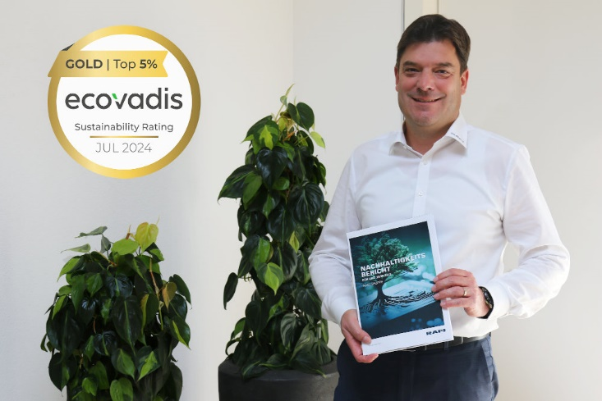

Image: Lothar Arnold, CFO of the RAFI Group, with the Sustainability Report 2023
Source: RAFI Group

Lothar Arnold, CFO of the RAFI Group, is dedicated to consistently raising the bar and ensuring accountability for products, projects, and the company’s impact on the environment and society. “Sustainability is deeply ingrained in our organizational and management systems and is a fundamental aspect of our international corporate culture. We are therefore thrilled to have been presented with this award. First and foremost, I want to express my gratitude to our employees for their unwavering dedication and commitment to advancing our ESG goals,” says Arnold.

For years, the RAFI Group has been dedicated to advancing its strategy for sustainable development and enhancing its focus on resource-efficient, emissions-reducing production. RAFI has implemented an environmental management system that complies with the DIN EN ISO 14001:2015 standard at all of its major production facilities. Furthermore, a certified energy management system compliant with DIN EN ISO 50001:2018 has been implemented at the German sites located in Berg, Überlingen, and Bad Waldsee, as well as at the RAFI factory in Hungary.

The Group is investing a sum in the high two-digit millions in a renovation and energy-saving modernization project. It is successively upgrading the business premises with new, climate-friendly roofs, façades, and glazing. In 2023, construction began on a new factory in Bad Waldsee that will feature energy-efficient and low-consumption building infrastructure. You can download the RAFI Group’s latest sustainability report here: www.rafi-group.com/nachhaltigkeit/

Image/s: | ecovadis-gold_l-arnold_2000.jpg | Characters: | 2,700
File name: | 202407017_pm_ecovadis_gold_en.docx | Date: | 07-11-2024
About the RAFI group
Founded in 1900, RAFI today develops and produces electromechanical components and systems for human-machine interaction. The range of products includes key switches, switches, touchscreens, control systems and electronic assemblies. RAFI products are employed in many industries including automation, medical technology, machine and plant engineering, road and railway vehicles, household appliances and telecommunication. The RAFI group operates internationally with more than 2,000 employees at sites in Germany, Europe, China, and the USA. Its headquarters are in Berg, Germany.
Contact:  RAFI GmbH & Co. KG  Tatjana Schweitzer  Ravensburger Str. 128–134  88276 Berg, Germany  Phone: +49 751 89-1468  Email: tatjana.schweitzer@rafi-group.com  Web: www.rafi-group.com |  | gii die Presse-Agentur GmbH  Christburger Str.41  10405 Berlin, Germany  Phone: +49 30 53 89 65-0  Email: info@gii.de  Web: www.gii.de

