Press Release

90° cable entry for sealed, flexible cable management

Conta-Clip’s new angled screw frames KDS-SR90 allow cables, wires and hoses to be routed into housings at a 90° angle. The cable entries fit the bending angles of typical conduits and provide effective protection against dust and deposits. KDS-SR90 allows for easy arrangement of pre-assembled and plain cables and hoses in just a few simple steps. Two angled frames in size 10/24 and 8/16 can be mounted with M5 screws on standard housing openings for KDS cable entries or heavy plug connectors. The regular inlays and sealing elements from the modular KDS series are used for arranging and sealing the conduits. The system also facilitates later changes like swapping, shortening or adding conduits. The snap-on cover can be removed quickly and easily, and the sealing elements and holding frame can be accessed without the use of tools. Assembly times are significantly reduced. Due to the high protection class IP66, fire classification V-0 “self-extinguishing” according to UL 94 as well as strain relief and sealing secured by inlays and sealing elements, KDS-SR90 meets all requirements for safe and comfortable cable management.
Product page: https://conta-clip.com/en/products/cable-management/cable-glands-for-cables-with-and-without-plugs/angled-cable-entry/

Conta-Clip at SPS
Stuttgart, Germany, 12 – 14 November 2024
Hall 10, Booth 122

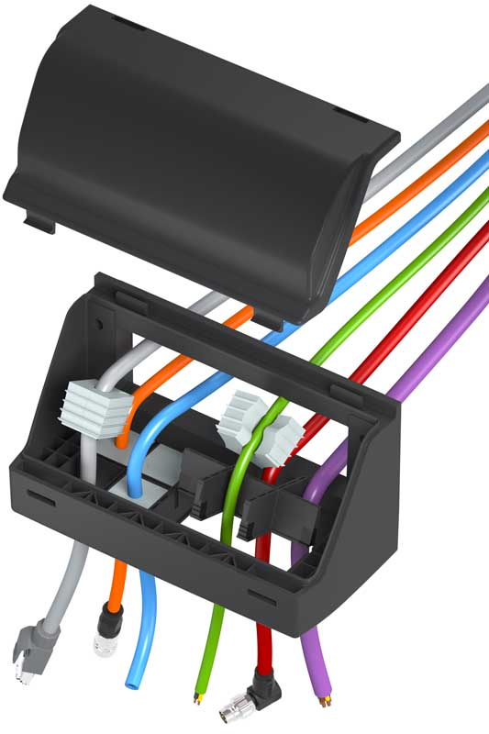
Caption: The 90° cable entry KDS-SR90 supports easy, flexible cable routing with strain relief

Image/s: | kds-sr90_angled_cable_entry_explo | Characters: | 1136
File name: | 202407021_pm_kds-sr90_angled_cable_entry_en | Date: | 10-16-2024
Tags: | cable entry, cable management, strain relief
About CONTA-CLIP
CONTA-CLIP is one of Europe’s leading manufacturers of electrical and electronic connection elements and cable management solutions. Based in Hövelhof, Germany, the medium-sized, family-run company has been producing electric and electronic connection systems for the process and automation industries since 1978. CONTA-CLIP supplies all industry sectors, focusing on railroad industries, shipbuilding, building automation, conveyor technology, machine and plant engineering and construction, instrumentation and control technology, control panel manufacturing, transformer manufacturing, and environmental technology. The company consists of many specialized branches: CONTA-CONNECT for electric connection technology, CONTA-CABLE for cable management systems, CONTA-ELECTRONICS for electronics and CONTA-CON for PCB edge connectors. Additionally, CONTA-CLIP provides services such as customizing housings and mounting rails, labeling and supplying user-specific electronic components.
Contact:  CONTA-CLIP  Verbindungstechnik GmbH  Christian Quade  Otto-Hahn-Str. 7  33161 Hövelhof  Germany  Phone: +49 . 5257 . 9833 - 172  Email: christian.quade@conta-clip.de  Internet: www.conta-clip.com |  | gii die Presse-Agentur GmbH  Christburger Str. 41  10405 Berlin  Germany  Phone: +49 . 30 . 538 965 - 0  Email: info@gii.de  Internet: www.gii.de

