Press Release

Two-component sealing elements with advanced strain relief

Conta-Clip has launched a new generation of sealing elements for its successful KDS cable entries, extending the comprehensive system’s application range. The new KDS-DE-Z2K sealing elements, manufactured using two-component technology, consist of hard plastic for secure strain relief and a seal made of elastic TPE. They ensure reliable sealing with a protection rating of IP66. The novel design achieves complete strain relief for cables and tubes in dynamic and static applications. On the other hand, individual sealing elements and conduits can be removed and swapped without tools at any time, if the installation requirements change. The sealing elements can be reused without sacrificing functionality. This makes them a dependable, easy-to-install alternative to conventional cable glands also suitable for pre-assembled cables with plugs. Due to the two-part design with separate strain relief, the sealing area is increased to up to 2 mm, so that just five KDS-DE-Z2K sizes cover all conductor diameters from 1 mm to 8.7 mm, reducing storage costs. The new combination sealing elements made of UL-listed plastics feature a UL 94 V-0 flammability rating (“self-extinguishing”).

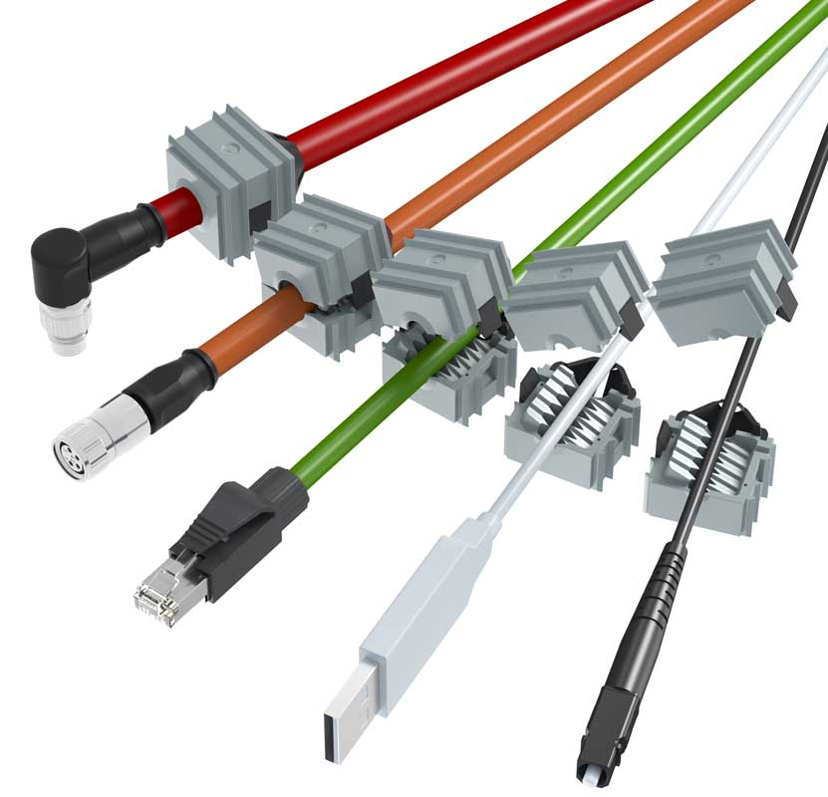
Caption: Conta-Clip achieves superior strain relief thanks to an innovative combination of materials

Image/s: | kds-de-z2k_sealing_elements | Characters: | 1188
File name: | 202407022_pm_kds-de-z2k_sealing_elements_en | Date: | 07-25-2024
Tags: | cable entries, strain relief, cable glands
About CONTA-CLIP
CONTA-CLIP is one of Europe’s leading manufacturers of electrical and electronic connection elements and cable management solutions. Based in Hövelhof, Germany, the medium-sized, family-run company has been producing electric and electronic connection systems for the process and automation industries since 1978. CONTA-CLIP supplies all industry sectors, focusing on railroad industries, shipbuilding, building automation, conveyor technology, machine and plant engineering and construction, instrumentation and control technology, control panel manufacturing, transformer manufacturing, and environmental technology. The company consists of many specialized branches: CONTA-CONNECT for electric connection technology, CONTA-CABLE for cable management systems, CONTA-ELECTRONICS for electronics and CONTA-CON for PCB edge connectors. Additionally, CONTA-CLIP provides services such as customizing housings and mounting rails, labeling and supplying user-specific electronic components.
Contact:  CONTA-CLIP  Verbindungstechnik GmbH  Christian Quade  Otto-Hahn-Str. 7  33161 Hövelhof  Germany  Phone: +49 . 5257 . 9833 - 172  Email: christian.quade@conta-clip.de  Internet: www.conta-clip.com |  | gii die Presse-Agentur GmbH  Christburger Str. 41  10405 Berlin  Germany  Phone: +49 . 30 . 538 965 - 0  Email: info@gii.de  Internet: www.gii.de

