Press Release

Heavy-duty motors for ball mill

Menzel Elektromotoren has configured two modular slip ring motors from its extensive stock for a ball mill in a gold mine in Kazakhstan and shipped them at short notice. The robust motor pair provides the necessary high starting torques for the heavy-duty application and ensures reliable operation under impact loads and voltage fluctuations. The MEBSSL motor series allows for swift individual modifications and the implementation of different features, such as various cooling and protection classes or mounting options. The series is characterized by high efficiencies, minimal operating costs, great robustness and a long service life. The two identical mill motors in size 800 are designed in the increased protection class IP55 and in cooling class IC 611 with an air-to-air heat exchanger. The nominal power is 4750 kW, the nominal voltage is 10000 V, the nominal torque is 45682 Nm, with permissible maximum torques of 290 %. Menzel has manufactured and fitted new shaft ends, added new foot holes, shortened and moved the rotor terminal boxes and added additional auxiliary terminal boxes for the slip ring chamber. The motors reached the customer within a very short time, thus preventing extended, costly mill downtime. Menzel accompanied and supported the installation and commissioning. The German family-run company supplies the mining industry with suitable motors for a wide range of applications.
More reference projects: https://www.menzel-motors.com/mining-motors/

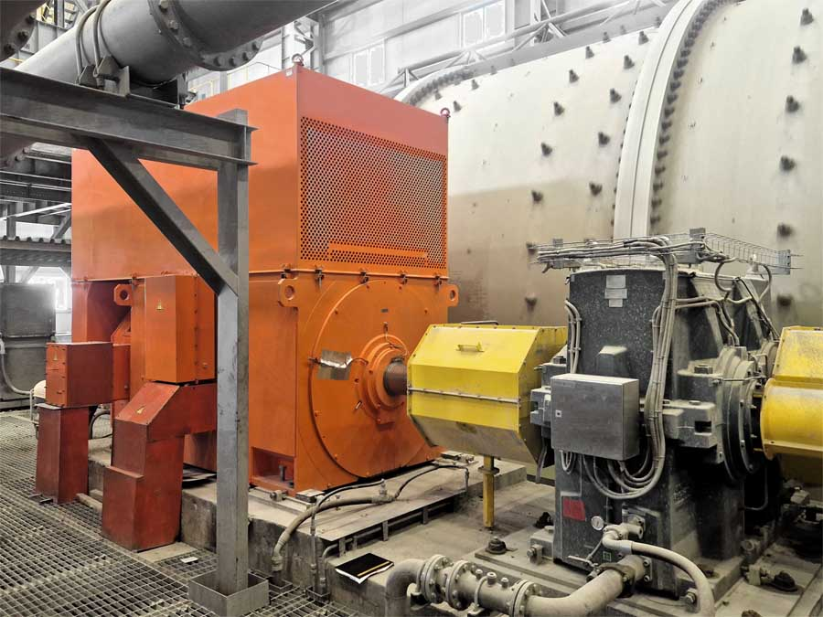
Caption: Alchemist secret revealed – this is how to make gold from iron and copper: a pair of heavy-duty motors propel the ball mill of a gold mine

Image/s: | ball_mill_drive_gold_mine | Characters: | 1414
File name: | 202407028_pm_ball_mill_motors_en | Date: | 07-25-2024
Tags: | slip ring motor, mill motor, ball mill, mining
About Menzel Elektromotoren
Menzel Elektromotoren GmbH has been manufacturing and distributing electric motors since 1927. The German family-run company based in Hennigsdorf near Berlin specializes in the delivery of large electric motors, including special models, within the shortest time possible. The product range comprises high and low voltage motors, DC motors, transformers, and frequency inverters. Services include motor production up to and beyond 25 MW and short-term adaptation of stock motors to application-specific requirements. In order to ensure short delivery times, Menzel maintains a large inventory with over 20,000 motors up to 15 MW. Qualified engineering, experienced staff, and state-of-the-art production and testing facilities help the manufacturer provide excellent reliability. Menzel operates subsidiaries in the UK, France, Italy, Spain, and Sweden, and cooperates with numerous partners worldwide.
Contact:  Menzel Elektromotoren GmbH  Mathis Menzel  Am Alten Walzwerk 2  16761 Hennigsdorf  Germany  Phone: +49 30 349 922-0  Email: info@menzel-motors.com  Internet: www.menzel-motors.com |  | gii die Presse-Agentur GmbH  Christburger Str. 41  10405 Berlin  Germany  Phone: +49 30 538 965-0  Email: info@gii.de  Internet: www.gii.de

