Press Release

High packing density in M20 to M50 cable entries

The KES-E-R cable entry system from Conta-Clip is suitable for many cables and wires without connectors and can be fitted in standard metric housing openings without tools. This makes it an eminently practical alternative to conventional cable glands. The cable entries in a distinct dodecagonal design admits conductors with diameters from 1.0 mm to 22.5 mm to be inserted into metric cut-outs in a very small space. All it takes, is piercing the selected diaphragm at the marked centering point with a screwdriver and feeding the conductor through. Once pierced, diaphragms can be sealed with a blind plug if necessary. Made of the halogen- and silicone-free material TPE and featuring a sophisticated design, the cable entries ensure tight sealing and protection class IP54. The hygienic and well-thought-out design avoids cavities where dirt can collect and offers a high packing density. KES-E-R is available in 32 variants and two type ranges for different wall thicknesses from 1.5 mm to 2.5 mm (type A) and from 2.5 mm to 4.0 mm (type B). The ambient temperature range is -40 °C to 90 °C (static), and the cable entries are certified non-flammable according to UL 94 V-0.

Versatile cable entry family
KES cable entry systems from Conta-Clip enable a fast, tool-less and reliable routing of non-assembled cables and pneumatic hoses into control cabinets or housings. Various variants for up to 35 cables increase installation efficiency. Round, square and FDA-compliant cable entries are available.

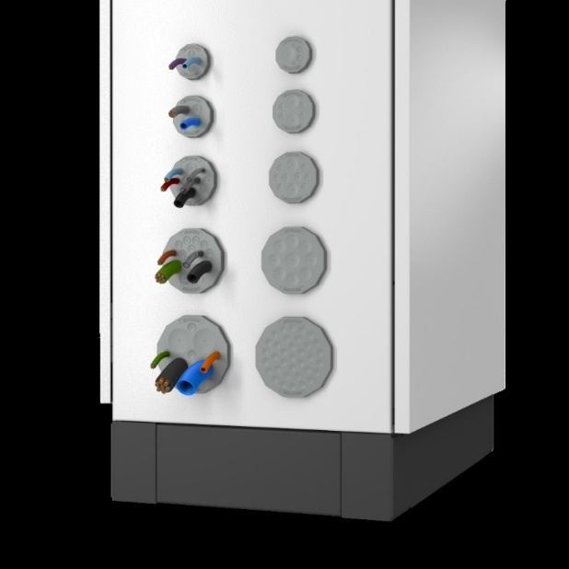
Caption: Conta-Clip’s KES-E-R cable entry system for tool-free installation ensures tight sealing and allows for high packing density

Image/s: | KES-E-R_Modellvielfalt | Characters: | 1503
File name: | 202407034_pm_kes-e-r_cable_entries_en | Date: | 08-13-2024
Tags: | cable management, cable entries, KES, round cable entry, packing density
About CONTA-CLIP
CONTA-CLIP is one of Europe’s leading manufacturers of electrical and electronic connection elements and cable management solutions. Based in Hövelhof, Germany, the medium-sized, family-run company has been producing electric and electronic connection systems for the process and automation industries since 1978. CONTA-CLIP supplies all industry sectors, focusing on railroad industries, shipbuilding, building automation, conveyor technology, machine and plant engineering and construction, instrumentation and control technology, control panel manufacturing, transformer manufacturing, and environmental technology. The company consists of many specialized branches: CONTA-CONNECT for electric connection technology, CONTA-CABLE for cable management systems, CONTA-ELECTRONICS for electronics and CONTA-CON for PCB edge connectors. Additionally, CONTA-CLIP provides services such as customizing housings and mounting rails, labeling and supplying user-specific electronic components.
Contact:  CONTA-CLIP  Verbindungstechnik GmbH  Christian Quade  Otto-Hahn-Str. 7  33161 Hövelhof  Germany  Phone: +49 . 5257 . 9833 - 172  Email: christian.quade@conta-clip.de  Internet: www.conta-clip.com |  | gii die Presse-Agentur GmbH  Christburger Str. 41  10405 Berlin  Germany  Phone: +49 . 30 . 538 965 - 0  Email: info@gii.de  Internet: www.gii.de

