Press Release

50-year-old pump motor replaced

Menzel Elektromotoren manufactures identical replacements for old motors, thus ensuring the smooth running of industrial plants without long downtimes and elaborate construction work. Recently, a 50-year-old pump motor in a combined heat and power (CHP) plant was to be replaced. While the original motor had still been performing reliably, the utility company already looked for a future-proof replacement as a preemptive measure and found no suitable standard motor on the market. The German manufacturer Menzel has a more flexible offer and is set up to provide all electrical and mechanical modifications to suit the individual application requirements. Menzel configured a three-phase squirrel cage motor in size 630 for the cooling tower pump of a CHP plant in Cologne, equipping it for vertical flange mounting and implementing protection class IP23 and cooling type IC 01 (open-circuit ventilation). The design boasts high power density, a low weight and low purchase and operating costs. The MEBKSD-type squirrel cage motor features 1650 kW rated power, 6000 V rated voltage and a rated torque of 31897 Nm. Menzel copied all the main connection dimensions, terminal box locations and instrumentation of the original motor in its own custom-configuration, which meets the latest standards and offers higher efficiency. In addition, Menzel installed the coupling supplied by the customer, thus ensuring an easy motor replacement and speedy recommissioning of the cooling tower pump. As with this follow-up order from an existing customer, the motor manufacturer has already served many electric companies to their full satisfaction.
More reference projects: https://www.menzel-motors.com/power-plants/

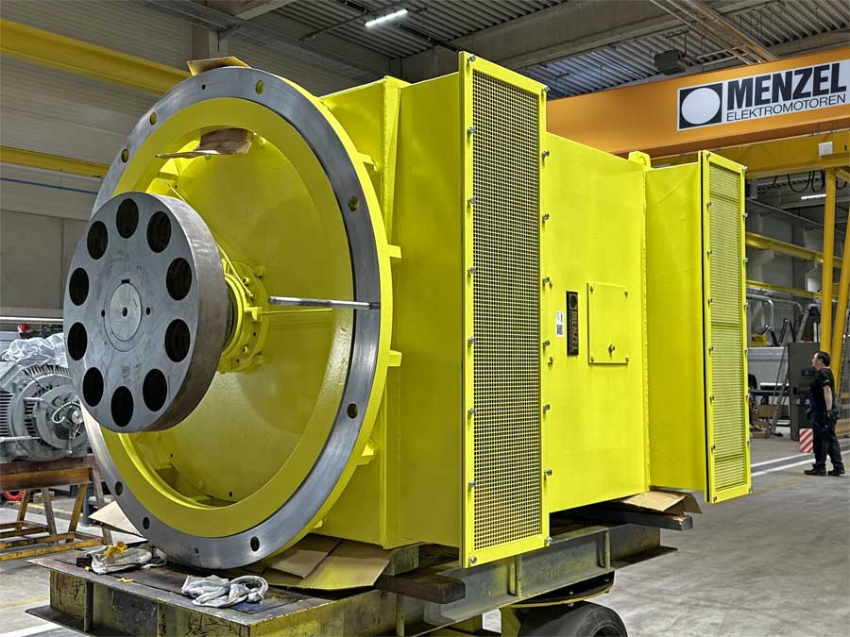
Caption: Menzel has tailored a squirrel cage motor based on its modular motor range, creating a one-to-one replacement for a 50-year-old pump motor in a combined heat and power plant

Image/s: | pump_motor_cooling_tower | Characters: | 1639
File name: | 202408007_pm_pump_motor_cooling_tower_en | Date: | 08-13-2024
Tags: | pump motor, squirrel cage motor, CHP plant, power plant, energy industry
About Menzel Elektromotoren
Menzel Elektromotoren GmbH has been manufacturing and distributing electric motors since 1927. The German family-run company based in Hennigsdorf near Berlin specializes in the delivery of large electric motors, including special models, within the shortest time possible. The product range comprises high and low voltage motors, DC motors, transformers, and frequency inverters. Services include motor production up to and beyond 25 MW and short-term adaptation of stock motors to application-specific requirements. In order to ensure short delivery times, Menzel maintains a large inventory with over 20,000 motors up to 15 MW. Qualified engineering, experienced staff, and state-of-the-art production and testing facilities help the manufacturer provide excellent reliability. Menzel operates subsidiaries in the UK, France, Italy, Spain, and Sweden, and cooperates with numerous partners worldwide.
Contact:  Menzel Elektromotoren GmbH  Mathis Menzel  Am Alten Walzwerk 2  16761 Hennigsdorf  Germany  Phone: +49 30 349 922-0  Email: info@menzel-motors.com  Internet: www.menzel-motors.com |  | gii die Presse-Agentur GmbH  Christburger Str. 41  10405 Berlin  Germany  Phone: +49 30 538 965-0  Email: info@gii.de  Internet: www.gii.de

