Press Release

Fan motor for cement plant as express custom configuration

“Have your cake and eat it too” – impossible? German motor manufacturer Menzel Elektromotoren is used to customers who want to have everything nice without compromise. In many cases, plant operators need an industrial motor immediately, which would normally require six months of production time. On top of that, the motor also needs to be customized. Menzel would not be Menzel if they did not take on such challenges willingly, as recently happened with a fan motor for a privately run Algerian cement plant. Within 13 weeks, the Berlin-based family-run company built a robust replacement for a failed slip ring motor, which was then flown out to the customer.

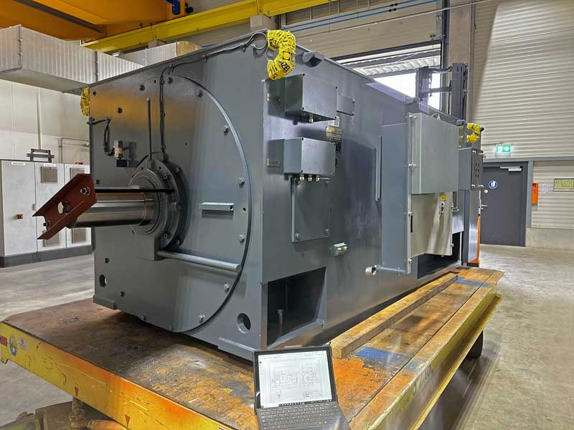
Caption: Customized and fully tested: Menzel delivered the individually adapted motor within 13 weeks according to exact customer specifications

A number of individual adjustments were required so that the new motor could smoothly replace the existing model. Menzel was able to reduce manufacturing time to a minimum by using components in stock and adjusting them accordingly. The highly robust MEBSSL-type 6-pole slip ring motor in frame size 630 has a rated output of 1950 kW, an operating voltage of 11000 V and a rated torque of 18754 Nm. It is suitable for operation in both directions of rotation and features protection class IP55 with IC 611 cooling (air-to-air heat exchanger). Menzel replicated the dimensions of the original motor that were crucial for interchangeability – shaft dimensions, foot mounting holes and terminal box positions – and also manufactured special terminal boxes to customer specifications. Despite the urgency, Menzel even implemented other special requests, such as the installation of a filter monitoring system and vibration sensors of a particular brand, which must fit into the existing monitoring architecture. The motor manufacturer won over the customer with expert and continuous advice, including on-site support during commissioning. The cement manufacturer had initially sent several representatives to visit the new Menzel motor plant, where senior management received them, showed them around the plant and discussed the project with them in detail. This welcoming reception was rewarded with the contract.
Menzel’s offer for international companies in the cement industry: https://www.menzel-motors.com/article/cement-plant-motor/

Image/s: | fan_motor_cement | Characters: | 2073
File name: | 202408008_pm_fan_motor_cement_en | Date: | 09-04-2024
Tags: | fan motor, cement, express, customized
About Menzel Elektromotoren
Menzel Elektromotoren GmbH has been manufacturing and distributing electric motors since 1927. The German family-run company based in Hennigsdorf near Berlin specializes in the delivery of large electric motors, including special models, within the shortest time possible. The product range comprises high and low voltage motors, DC motors, transformers, and frequency inverters. Services include motor production up to and beyond 25 MW and short-term adaptation of stock motors to application-specific requirements. In order to ensure short delivery times, Menzel maintains a large inventory with over 20,000 motors up to 15 MW. Qualified engineering, experienced staff, and state-of-the-art production and testing facilities help the manufacturer provide excellent reliability. Menzel operates subsidiaries in the UK, France, Italy, Spain, and Sweden, and cooperates with numerous partners worldwide.
Contact:  Menzel Elektromotoren GmbH  Mathis Menzel  Am Alten Walzwerk 2  16761 Hennigsdorf  Germany  Phone: +49 30 349 922-0  Email: info@menzel-motors.com  Internet: www.menzel-motors.com |  | gii die Presse-Agentur GmbH  Christburger Str. 41  10405 Berlin  Germany  Phone: +49 30 538 965-0  Email: info@gii.de  Internet: www.gii.de

