Press release

Secure touch operation at performance level d

RAFI has developed a new technology platform for the market-ready series production of touch systems for safety-critical applications at performance level d. Based on reliable, durable hardware components, redundant sensor architecture and comprehensive diagnostic software, the safety concept offers far more flexibility than hard-wired safety functions.

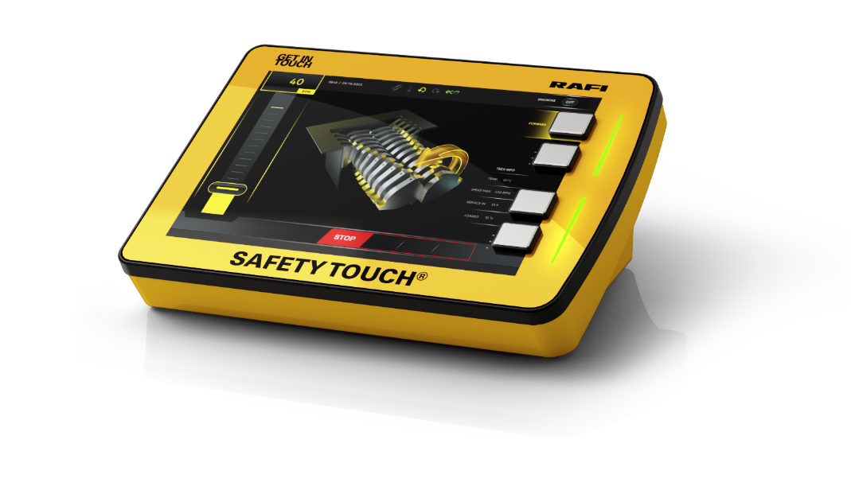
Caption: Reference touchscreen in performance level d developed by RAFI according to industry standards

More and more functions of stationary and mobile machines are being controlled via touch operation. This also increases the demands on the functional safety of touch-operated control systems. As a specialist in human-machine interaction, RAFI has designed a reliable system architecture based on high-quality, fail-safe components, which is protected by a high level of diagnostic coverage on the software side. In order to monitor all potential sources of error with safety-critical effects, a specific safety controller with its own logic was implemented in addition to the new touch controller. As the monitoring instance, the safety CPU controls all safety-relevant factors from the touch sensors and display to the plausibility of the command inputs and outputs and the cyclical function test every millisecond. Parameterizable filter functions cancel sensor signals triggered by unintentional contact, liquids or other unwanted touch effects. Permanent display monitoring ensures that the user interface is displayed without errors. To further safeguard against incorrect entries, the touchscreens can optionally be equipped with force detection based on TWIN-TOUCH technology. In addition to touch operation, functionally safeguarded electromechanical actuators can also be applied directly to the touch surface. The new RAFI touch display received a “New Products Award” from the US trade magazine OEM Off Highway for its innovative safety concept.

Image/s: | safety-touch_2000px.jpg | Characters: | 1,811
File name: | 202408023_pm_safety-touch_en.docx | Date: | 09-24-2024
Tags: | RAFI, touch display, safety touch, safety CPU, PL d, performance level d, operating safety, diagnostic coverage, filter function, force detection

About the RAFI Group
Founded in 1900, RAFI today develops and produces electromechanical components and systems for human–machine interaction. The range of products includes key switches, switches, touchscreens, control systems and electronic assemblies. RAFI products are employed in many industries including automation, medical technology, machine and plant engineering, road and railway vehicles, household appliances and telecommunication. The RAFI Group operates internationally with more than 2,000 employees at sites in Germany, Europe, China, and the USA. Its headquarters are in Berg, Germany.

Contact:
RAFI GmbH & Co. KG

Patrick Müller
Product Marketing Manager

Ravensburger Straße 128-134
88276 Berg, Germany
Phone: +49 751 89-1634
Email: patrick.mueller@rafi-group.com
Web: www.rafi-group.com

