Press Release

Directional object detection with soundpipes

In order to limit the sound beam of ultrasonic sensors, sensor specialist PiL Sensoren, which is part of the Inelta Group, offers special cylindrical sound reduce pipes for some of its ultrasonic sensors. These reduce the sound beam of the ultrasonic waves and reduce the scanning range at the same time. By limiting the sound waves using a defined hollow cylinder, interfering objects in the boundary area of the sound beam are masked out. This enables targeted focusing on the target object. To avoid scattering or absorption losses, the manufacturer matches the material and dimensions to the acoustic properties of the sound pipe. The shape and length of the attachment are adapted by PiL to the ultrasonic frequency of the transducer of an ultrasonic sensor in order to ensure precise and reliable measurements even in very narrow detection ranges through targeted frequency selection and alignment of the sensor in combination with the soundpipe. Typical areas of application for sound pipes include level measurement in pipes with very small diameters – for example in medical technology, in filling or capsule closing systems. In the case of sensors arranged very close together – such as in arrays for height profile monitoring – sound pipes are used not only to synchronize the sensors on the control side but also to suppress interference-related disturbances. PiL supports its customers in selecting and equipping the sensor technology with appropriate noise reduction pieces and also manufactures customer-specific special solutions on request.

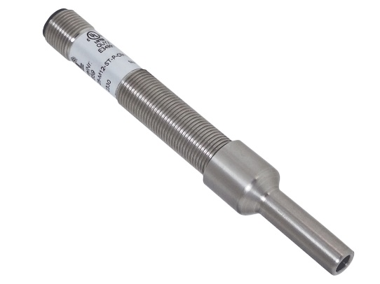
Caption: Compact ultrasonic distance sensor from the P43-25-M12 series with small M12 diameter and BS-M12-ST sound reducer

Image/s: | schallreduzierstueck-m12_2000.jpg | Characters: | 1,566
File name: | 202408024_pm_sound_reducer_en.docx | Date: | 08-27-2024
Tags:
About PIL
PiL Sensoren GmbH, with its headquarters in Erlensee near Frankfurt/Main is a pioneer of ultrasonic technology and has been developing, producing, and selling standard and customized sensor solutions for industrial applications since 1990. Together with Inelta Sensorsystem GmbH & Co. KG (Taufkirchen near Munich) and VYPRO s.r.o. (Trenčín, Slovakia), PiL offers a wide range of products for measuring displacement and position as well as force, pressure, and inclination. The range of products we offer includes force sensors, sensor signal amplifiers, pressure switches, capacitive sensors, and ultrasonic sensors. Our portfolio is nicely rounded off with cable and connector assembly services.
Most of the group of companies’ customers are in industrial automation, mechanical engineering, hydraulics, medical technology as well as the aerospace industry. We especially focus on industry and customer-specific sensor solutions and are constantly expanding this focus with interdisciplinary know-how.
Contact:

PIL Sensoren GmbH
Zweigstelle Süd
Reinhard Koch
Ludwig-Boelkow-Allee 22
82024 Taufkirchen
Germany
Phone: +49 89 / 452 245-0
Fax: +49 89 / 452 245-744
Email: marketing@pil.de
Internet: www.pil.de

