Press Release

Pump drives in special configuration

Menzel Elektromotoren has manufactured two pump drives with extra-long piping for water supply in Angola. The German company thus once again proved to be a reliable one-stop partner for drive solutions. The pumps draw water from the Kwanza River and transport it over a distance of 17 km, climbing 135 meters to a water treatment plant just outside the capital Luanda. The existing pumps are installed inside the pipework and cannot be removed. The operator therefore ordered complete pump systems including drive and connection pipework. Menzel had already assisted this customer in the past, supplying replacement motors at short notice. However, in this case, the motor manufacturer further impressed with tailor-made pump systems that could easily replace the existing structures. Production of the units took place at Pawils Elektromaschinenbau. The Menzel subsidiary with great craftsmanship and engineering expertise procured pumps of the right performance class, adapted the mechanical interfaces to the installation on site and fitted them with pipes and motors, which were also designed specifically for the application. The entire units are each about 12 meters long. The pump systems have a flow rate of 900 m³/min each. The motors have a nominal power of 500 kW, an operating voltage of 6000 V and a speed of 1475 rpm. Initially, two out of three identical pump systems were replaced, while the third ensured the continued operation of the water supply. After successful commissioning, Menzel also expects the order for the third system.
More reference projects for large pump motors: https://www.menzel-motors.com/pump-drive/

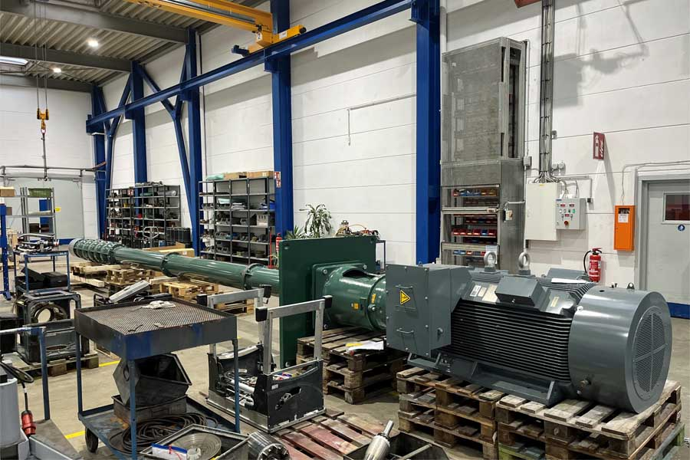
Caption: Menzel supplied complete pump systems with drive and connection pipes from a single source

Image/s: | pump_motor_w_xl_pipework | Characters: | 1550
File name: | 202409003_pm_pump_motor_xl_pipework_en | Date: | 09-24-2024
Tags: | pump motors, special motors, pump drives, replacement motors, one stop, single source
About Menzel Elektromotoren
Menzel Elektromotoren GmbH has been manufacturing and distributing electric motors since 1927. The German family-run company based in Hennigsdorf near Berlin specializes in the delivery of large electric motors, including special models, within the shortest time possible. The product range comprises high and low voltage motors, DC motors, transformers, and frequency inverters. Services include motor production up to and beyond 25 MW and short-term adaptation of stock motors to application-specific requirements. In order to ensure short delivery times, Menzel maintains a large inventory with over 20,000 motors up to 15 MW. Qualified engineering, experienced staff, and state-of-the-art production and testing facilities help the manufacturer provide excellent reliability. Menzel operates subsidiaries in the UK, France, Italy, Spain, and Sweden, and cooperates with numerous partners worldwide.
Contact:  Menzel Elektromotoren GmbH  Mathis Menzel  Am Alten Walzwerk 2  16761 Hennigsdorf  Germany  Phone: +49 30 349 922-0  Email: info@menzel-motors.com  Internet: www.menzel-motors.com |  | gii die Presse-Agentur GmbH  Christburger Str. 41  10405 Berlin  Germany  Phone: +49 30 538 965-0  Email: info@gii.de  Internet: www.gii.de

