Press release

LUMOTAST illuminated pushbuttons with 5V supply voltage

RAFI is now offering twelve additional versions of the LUMOTAST 16 series illuminated pushbuttons with only 5V operating voltage for LED control. This makes these actuators, which are designed for standard installation openings of 16.2mm, particularly suitable for mobile applications. There is a choice of five variants with translucent white, red, yellow, green or blue bezels and a black or metallic silver front ring. In addition, RAFI also supplies two basic versions that can be individually customized in terms of bezel and ring color and marked for specific applications using freely printable C-LAB marking sheets. The illuminated pushbuttons, which are manufactured with an IP65/67 degree of protection on the front and are approved for operating temperatures from -25°C to +70°C, are designed for at least 500,000 actuation cycles. Contact is made by means of a gold snap-action contact. A threaded ring is used to fasten the push-buttons, which only require 18.2mm of installation space. The LUMOTAST series also includes illuminated pushbuttons with 10V operating voltage, pushbuttons with gold or silver contacts and various emergency stop and mushroom pushbuttons. The product family is rounded off by narrow illuminated pushbuttons and key-operated switches from the LUMOTAST 75 series with round or rectangular collar.

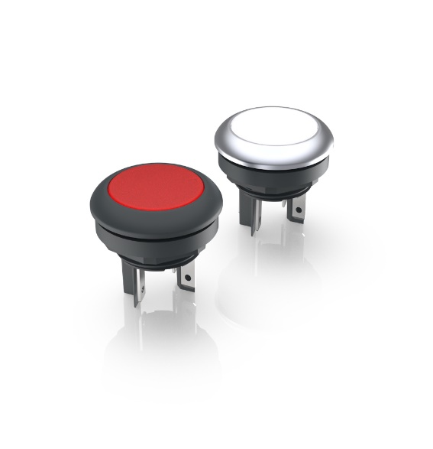
Caption: New LUMOTAST 16 illuminated pushbuttons with 5V supply voltage in two front ring designs and five aperture colors

Image/s: | lumotast_5v_2000.jpg | Characters: | 1,334
File name: | 202409007_pm_lumotast-5v_en.docx | Date: | 09-04-2024

About the RAFI Group
Founded in 1900, RAFI today develops and produces electromechanical components and systems for human–machine interaction. The range of products includes key switches, switches, touchscreens, control systems and electronic assemblies. RAFI products are employed in many industries including automation, medical technology, machine and plant engineering, road and railway vehicles, household appliances and telecommunication. The RAFI Group operates internationally with more than 2,000 employees at sites in Germany, Europe, China, and the USA. Since 2020, it has been owned by the US investment company Oaktree. Its headquarters are in Berg, Germany.

Contact:  RAFI GmbH & Co. KG  Patrick Müller  Product Marketing Manager  Ravensburger Straße 128-134  88276 Berg, Germany  Phone: +49 751 89-1634  Email: patrick.mueller@rafi-group.com  Web: www.rafi-group.com |  | gii die Presse-Agentur GmbH  Christburger Str. 41  10405 Berlin, Germany  Phone: +49 30 53 89 65-0  Email: info@gii.de  Web: www.gii.de

