Press Release

New 3-phase current adapters for test instruments and CEE sockets

Gossen Metrawatt has launched new 3-phase current adapters for connecting test instruments to 5-pole CEE sockets. The series comprises three variants: METRALINE A3-16, A3-32 and A3-63 for corresponding CEE sockets. The adapters, which are specified to test the effectiveness of protective measures via five contact-protected 4-mm sockets, are characterized by easy handling. They are designed in accordance with measuring category CAT IV (415 V AC) and can be connected to test instruments from various PROFITEST series as well as the METRALINE MF from Gossen Metrawatt. Due to their robust, compact design, the lightweight adapters, which weigh only 320 g, are also suitable for use in harsh environments at operating temperatures from 0 °C to 60 °C. The series complies with the safety regulations for handheld measuring accessories for electrical measurement and testing according to EN 61010-031+A1, Part 031.

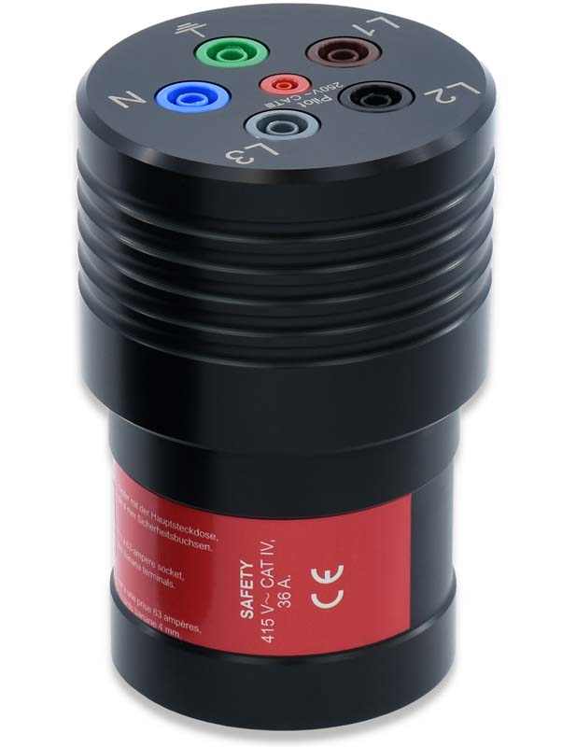
Caption: New METRALINE adapter for testing the effectiveness of protective measures for CEE sockets

Image/s: | drehstrom-adapter_2000.jpg | Characters: | 913
File name: | 202409012_pm_3-phase_current_adapter_en | Date: | 09-11-2024
Tags:
About Gossen Metrawatt
Gossen Metrawatt, one of the world’s leading suppliers of measurement systems, develops and distributes a wide range of high-quality measuring and test devices for electrical trade, various industries and the public sector.
The Gossen Metrawatt brand has been synonymous with safety and quality “Made in Germany” for decades. Its product range includes measurement and test technology for the electrical safety of plants, devices and machines as well as for the e-mobility and medical technology industries. Additional key areas of interest are power quality, battery testing technology, multimeters, calibrators, power supply technology and energy management systems. For a truly comprehensive electrical safety portfolio, Gossen Metrawatt also offers a continuously growing range of digital services and cloud services and supports its customers with a versatile training program and a wide range of after-sales services.
Gossen Metrawatt is part of the GMC Instruments Group, which also includes other specialized manufacturers for measurement and testing technology – notably, Camille Bauer Metrawatt, Dranetz, Prosys, Seaward and Rigel and Kurth Electronic. The Camille Bauer and Rigel brands add to the portfolio various transducers, display instruments and detection systems for heavy-current engineering as well as special measuring, testing and functional testing devices for the medical sector. The GMC-I Group runs its own DAkkS-certified calibration center that performs DAkkS, ISO and factory calibrations for virtually all electrical measured quantities. The GMC-I Group has development and production sites in Germany, Switzerland, England and the USA and a worldwide sales network of its own companies as well as sales partners.
Contact:  Gossen Metrawatt GmbH  Christian Widder  Head of Marketing Communication  Suedwestpark 15  90449 Nuremberg  Germany  Phone: +49 . 911 . 8602-572  Email: christian.widder@gossenmetrawatt.com  Internet: www.gossenmetrawatt.com |  | gii die Presse-Agentur GmbH  Christburger Str. 41  10405 Berlin  Germany  Tel.: +49 . 30 . 538 9650  Email: info@gii.de  Internet: www.gii.de

