Press Release

LOXrail transport system for packaging machines

LOSYCO’s floor-level LOXrail system is used in numerous industries for production logistics, machine feeding and material flow. In addition, LOSYCO also designs and installs application-specific solutions for precise positioning of systems and machining centers weighing several tons. The German intra-logistics specialist has recently installed three-track LOXrail lines in three plants of the globally active Klingele Paper & Packaging Group. The transport platforms are geometrically adapted to the plant layouts. Designed for a payload of 5.2 tons, the platforms carry packaging machines, allowing for precise positioning at the transfer points for various product lines. Thanks to the low-friction rail profiles and wheelsets, the entire load can be moved by hand by just one person. However, LOSYCO has also equipped the system for one Klingele plant with an automatic underfloor drive unit. Locking bolts cemented in the hall floor allow for secure fixation of the platforms in place. The floor-level rail system requires no additional safeguards. The transport platforms themselves also feature criss-cross rails for automatic alignment of the belt stations and bundling machines. In this way, packaging from 400 mm to 1 m in size can be fitted without time-consuming changeovers. The new system has enabled Klingele to significantly reduce setup times and workload and increase flexibility in the production process.

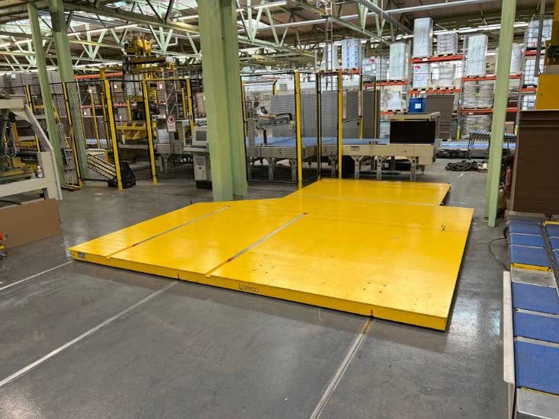
Caption: Klingele significantly reduced setup times and workload thanks to the new LOXrail solution for transporting and positioning their packaging machines
(Image: Klingele)

Image/s: | plattform-solo_2000.jpg | Characters: | 1425
File name: | 202409016_pm_klingele_loxrail_lines_en | Date: | 09-18-2024
Tags: | intra-logistics, production logistics, material flow, floor-level rail system, positioning, alignment, LOXrail
About Losyco
LOSYCO designs, builds, and installs intra-logistics systems for the manufacturing industry. The company based in Bielefeld, Germany, was founded by experienced engineers in 2016. LOSYCO’s core product is the LOXrail® floor rail system for easy transport and precise positioning of loads weighing several tons. LOXrail transport platforms can be operated manually or with auxiliary drives. LOSYCO also supplies handling equipment such as chain and roller conveyors, material management and storage systems, as well as sound-proof cabins and machine covers. LOSYCO supports customers wishing to transform their production processes to lean manufacturing and continuous flow production. LOSYCO is a member of the DRECKSHAGE Family.
Contact:  LOSYCO GmbH  Tim Schneider  Walter-Werning-Str. 7  33699 Bielefeld  Germany  Phone +49 . 521 . 945 643-0  Email: info@losyco.com  Internet: www.losyco.com |  | gii die Presse-Agentur GmbH  Christburger Str. 41  10405 Berlin  Germany  Phone: +49 . 30 . 538 965-0  Email: info@gii.de  Internet: www.gii.de

