Press Release

Cable entries for high packing density on a small footprint

Time is money – the versatile KES-R M cable entry system from Conta-Clip saves valuable installation time, allowing for control cabinets and enclosures to be equipped in seconds. The sealing membrane is simply pierced with a screwdriver at one of the marked centering points; then, 1.5 mm to 22.2 mm wide pneumatic tubes and electric cables without plugs are inserted. This enables much higher packing density than conventional cable glands. The KES-R M system with the distinctive dodecagonal design is mounted without tools in standardized metric openings from M25 to M63. It ensures reliable sealing up to IP54. To achieve IP66 protection and for enclosure walls thicker than 2.5 mm, the entries can also be screwed tight with a lock nut. The silicone- and halogen-free material mix of TPE and fiberglass reinforced polyamide 6.6 ensures tightness and stability. The KES-R M range includes 16 different variants in the sizes M25, M32, M40, M50 and M63.

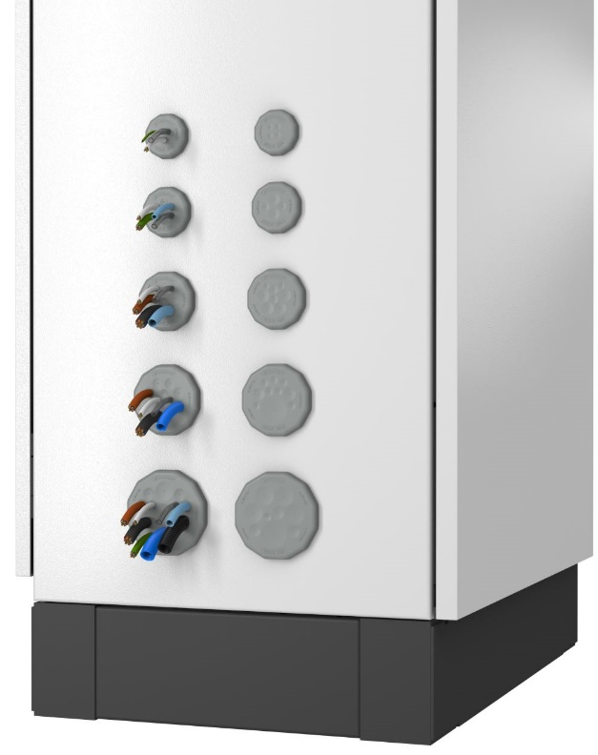
Caption: The KES-R M cable entry system from Conta-Clip comes in many variants, each ensuring high packing density on a small footprint

Versatile cable entry family
KES cable entry systems from Conta-Clip enable fast, tool-less and reliable routing of non-assembled electric cables and pneumatic tubes into control cabinets or housings. Various different designs for up to 68 cables increase installation efficiency. Round, rectangular and FDA-compliant cable entries are available.

Image/s: | KES-R_M_R_Gruppenbild | Characters: | 1300
File name: | 202409019_pm_kes-r_m_cable_entries_en | Date: | 11-07-2024
Tags: | cable entry, cable entries, electric cables, pneumatic hoses, packing density, FDA-compliant
About CONTA-CLIP
CONTA-CLIP is one of Europe’s leading manufacturers of electrical and electronic connection elements and cable management solutions. Based in Hövelhof, Germany, the medium-sized, family-run company has been producing electric and electronic connection systems for the process and automation industries since 1978. CONTA-CLIP supplies all industry sectors, focusing on railroad industries, shipbuilding, building automation, conveyor technology, machine and plant engineering and construction, instrumentation and control technology, control panel manufacturing, transformer manufacturing, and environmental technology. The company consists of many specialized branches: CONTA-CONNECT for electric connection technology, CONTA-CABLE for cable management systems, CONTA-ELECTRONICS for electronics and CONTA-CON for PCB edge connectors. Additionally, CONTA-CLIP provides services such as customizing housings and mounting rails, labeling and supplying user-specific electronic components.
Contact:  CONTA-CLIP  Verbindungstechnik GmbH  Christian Quade  Otto-Hahn-Str. 7  33161 Hövelhof  Germany  Phone: +49 . 5257 . 9833 - 172  Email: christian.quade@conta-clip.de  Internet: www.conta-clip.com |  | gii die Presse-Agentur GmbH  Christburger Str. 41  10405 Berlin  Germany  Phone: +49 . 30 . 538 965 - 0  Email: info@gii.de  Internet: www.gii.de

