Press Release

New current-voltage tester with 7-segment display

Gossen Metrawatt has developed a new handy current-voltage tester for non-contact single-pole voltage measurement from >90 V to 1000 V L-L. The METRALINE VC SENSE features an integrated display window, a power fork, two measurement cables and test probes. The versatile device offers a wide functional range for voltage testing, resistance measurement, continuity testing and diode testing. The measuring instrument’s vibration motor and sound generator ensure reliable feedback for precise test results. The METRALINE VC SENSE is certified according to measurement category CAT IV 600 V, CAT III 1000 V. It performs voltage measurements from 1 to 1000 V AC TRMS and from 1 to 1500 V DC as well as inductive current measurements from 0.1 to 200 A AC at 40 to 65 Hz. The functional scope also includes resistance measurements from 0 to 100 kΩ, frequency measurements between 0 and 800 Hz as well as continuity and diode tests. The power fork with an integrated transducer has a 14 mm wide opening.

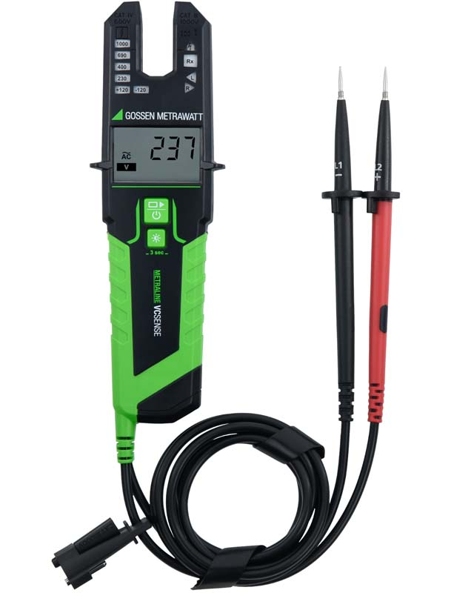
Caption: The handy METRALINE VC SENSE current-voltage tester can also be used for resistance and frequency measurements as well as continuity and diode tests

Image/s: | metraline-vc-sense_2000.jpg | Characters: | 996
File name: | 202410005_pm_metraline_vc_sense_en | Date: | 10-01-2024
Tags: | current-voltage tester, METRALINE VC SENSE, power fork, voltage measurement, voltage testing, resistance measurement, continuity testing, diode testing
About Gossen Metrawatt
Gossen Metrawatt, one of the world’s leading suppliers of measurement systems, develops and distributes a wide range of high-quality measuring and test devices for electrical trade, various industries and the public sector.
The Gossen Metrawatt brand has been synonymous with safety and quality “Made in Germany” for decades. Its product range includes measurement and test technology for the electrical safety of plants, devices and machines as well as for the e-mobility and medical technology industries. Additional key areas of interest are power quality, battery testing technology, multimeters, calibrators, power supply technology and energy management systems. For a truly comprehensive electrical safety portfolio, Gossen Metrawatt also offers a continuously growing range of digital services and cloud services and supports its customers with a versatile training program and a wide range of after-sales services.
Gossen Metrawatt is part of the GMC Instruments Group, which also includes other specialized manufacturers for measurement and testing technology – notably, Camille Bauer Metrawatt, Dranetz, Prosys, Seaward and Rigel and Kurth Electronic. The Camille Bauer and Rigel brands add to the portfolio various transducers, display instruments and detection systems for heavy-current engineering as well as special measuring, testing and functional testing devices for the medical sector. The GMC-I Group runs its own DAkkS-certified calibration center that performs DAkkS, ISO and factory calibrations for virtually all electrical measured quantities. The GMC-I Group has development and production sites in Germany, Switzerland, England and the USA and a worldwide sales network of its own companies as well as sales partners.
Contact:  Gossen Metrawatt GmbH  Christian Widder  Head of Marketing Communication  Suedwestpark 15  90449 Nuremberg  Germany  Phone: +49 . 911 . 8602-572  Email: christian.widder@gossenmetrawatt.com  Internet: www.gossenmetrawatt.com |  | gii die Presse-Agentur GmbH  Christburger Str. 41  10405 Berlin  Germany  Tel.: +49 . 30 . 538 9650  Email: info@gii.de  Internet: www.gii.de

