Press Release

Compact earthing resistance and low-resistance measuring instrument

Gossen Metrawatt expands its METRALINE product family, adding the new METRALINE EARTH for professional measurement of earthing resistance and for low-resistance measurements with a test current of ≥200 mA according to EN 61557-4 / VDE 0413-4. The safe device, certified according to measuring category CAT III 600 V / CAT IV 300 V, is used for the easy and reliable application of all conventional earthing measurement methods. Functional highlights are professional earthing analysis according to Wenner and high-precision testing of earthing and lightning protection systems using 3- and 4-wire circuits. Due to its compact design, METRALINE EARTH, which features protection class IP40, is ideal for mobile applications and can be easily used in any environment. The 3.5″ TFT color display clearly displays menus, help images and measurement results. Pushbutton arrays on both sides of the display allow for convenient and user-friendly navigation. Data transfer via USB interface facilitates the documentation of test results. Up to 1000 measured values can be stored in the device memory. Gossen Metrawatt supplies the new METRALINE EARTH with a wide range of accessories for all common earthing measurements. In addition to three measurement cables (5 m, 20 m, 40 m), the scope of delivery includes three alligator clips, a USB cable and a carrying pouch.

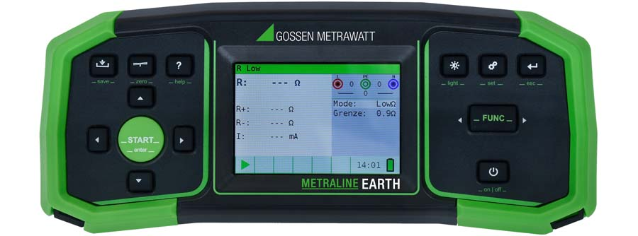
Caption: The new METRALINE EARTH covers a wide functional range including earthing analysis according to Wenner as well as testing of earthing and lightning protection systems using 3- and 4-wire circuits

Image/s: | metraline-earth_2000px.jpg | Characters: | 1360
File name: | 202410006_pm_metraline_earth_en | Date: | 10-16-2024
Tags: | earthing resistance, low-resistance, measuring instrument, earthing measurement, lightning protection, METRALINE EARTH
About Gossen Metrawatt
Gossen Metrawatt, one of the world’s leading suppliers of measurement systems, develops and distributes a wide range of high-quality measuring and test devices for electrical trade, various industries and the public sector.
The Gossen Metrawatt brand has been synonymous with safety and quality “Made in Germany” for decades. Its product range includes measurement and test technology for the electrical safety of plants, devices and machines as well as for the e-mobility and medical technology industries. Additional key areas of interest are power quality, battery testing technology, multimeters, calibrators, power supply technology and energy management systems. For a truly comprehensive electrical safety portfolio, Gossen Metrawatt also offers a continuously growing range of digital services and cloud services and supports its customers with a versatile training program and a wide range of after-sales services.
Gossen Metrawatt is part of the GMC Instruments Group, which also includes other specialized manufacturers for measurement and testing technology – notably, Camille Bauer Metrawatt, Dranetz, Prosys, Seaward and Rigel and Kurth Electronic. The Camille Bauer and Rigel brands add to the portfolio various transducers, display instruments and detection systems for heavy-current engineering as well as special measuring, testing and functional testing devices for the medical sector. The GMC-I Group runs its own DAkkS-certified calibration center that performs DAkkS, ISO and factory calibrations for virtually all electrical measured quantities. The GMC-I Group has development and production sites in Germany, Switzerland, England and the USA and a worldwide sales network of its own companies as well as sales partners.
Contact:  Gossen Metrawatt GmbH  Christian Widder  Head of Marketing Communication  Suedwestpark 15  90449 Nuremberg  Germany  Phone: +49 . 911 . 8602-572  Email: christian.widder@gossenmetrawatt.com  Internet: www.gossenmetrawatt.com |  | gii die Presse-Agentur GmbH  Christburger Str. 41  10405 Berlin  Germany  Tel.: +49 . 30 . 538 9650  Email: info@gii.de  Internet: www.gii.de

