Press release

RAFIX FS short-stroke adapter with 2.5mm switching travel

RAFI has introduced a second version of RAFIX FS short-stroke adapters. In addition to the version with 1mm switching travel, the manufacturer now also offers a 2.5mm version with identical dimensions. By using the adapter, the stroke is reduced from 4.0mm to 2.5mm or 1.0mm. In conjunction with the RAFIX FS pushbuttons, the short-stroke adapters are an efficient alternative to conventional PCB switching elements. The illuminated, 20x20mm small adapters are designed for at least 1 million switching cycles and have a 12mm installation diameter for LEDs with a maximum height of 2.4mm. The adapter is fully compatible with all MICON 5 pushbuttons. The micro switches are characterized by their concise tactility and a wide range of actuating forces from 1.5N to 7.0N. For safety-relevant applications, RAFI offers the MICON 5 SAFETY variant with two potential-free NC and NO contacts that are separated from each other. The compact MICON pushbutton design allows several SMT LEDs to be integrated into the installation space. It is also easy to place two MICON 5 pushbuttons next to each other. All MICON 5 variants are also available in SMT versions for use in control devices with SMT connection technology.

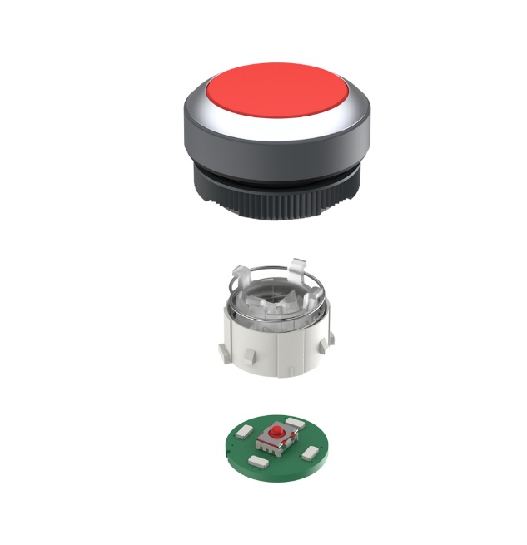
Caption: New 2.5mm adapter solution from RAFI for highly compact MICON 5 switching elements in RAFIX FS pushbuttons

Image/s: | rafix_kurzhubadapter_2000.jpg | Characters: | 1,214
File name: | 202410009_pm_rafix-adapter_en.docx | Date: | 10-28-2024
Tags: | RAFI, short-stroke adapter, pushbutton, actuator, RAFIX FS, MICON 5, short-stroke pushbutton, micro pushbutton, SMT

About the RAFI Group
Founded in 1900, RAFI today develops and produces electromechanical components and systems for human-machine interaction. The range of products includes key switches, switches, touchscreens, control systems, and electronic assemblies. RAFI products are employed in many industries including automation, medical technology, machine and plant engineering, road and railway vehicles, household appliances, and telecommunication. The RAFI Group operates internationally with more than 2,000 employees at sites in Germany, Europe, China, and the USA. Its headquarters are in Berg, Germany.

Contact:  RAFI GmbH & Co. KG  Patrick Müller  Product Marketing Manager  Ravensburger Straße 128-134  88276 Berg, Germany  Phone: +49 751 89-1634  Email: patrick.mueller@rafi-group.com  Web: www.rafi-group.com |  | gii die Presse-Agentur GmbH  Christburger Str. 41  10405 Berlin, Germany  Phone: +49 30 53 89 65-0  Email: info@gii.de  Web: www.gii.de

