Press Release

Certified and safe:
Control cabinet sockets from Conta-Clip

The use of a certified and approved socket in electrical cabinets is crucial to ensuring the safety of people and equipment. Conta-Clip offers STD-TS/CFL/LED control cabinet sockets with screw connection and a green LED as mains voltage indicator for this purpose. As can be expected from the German manufacturer, the sockets are of course approved for use in control cabinets and comply with the relevant international standards and regulations. This ensures the reliability of electrical systems. STD-TS models are designed as combination sockets featuring a CF-type grounding outlet and an L-type Italian mating face. The combination sockets made in Europe are 45 mm wide and can be mounted directly or attached to 35 mm mounting rails (EN 60715). STD-TS/CFL/LED control cabinet sockets are available in grey (standard) or yellow (permanently live). The sockets are suitable for up to 250 V AC and 16 A.

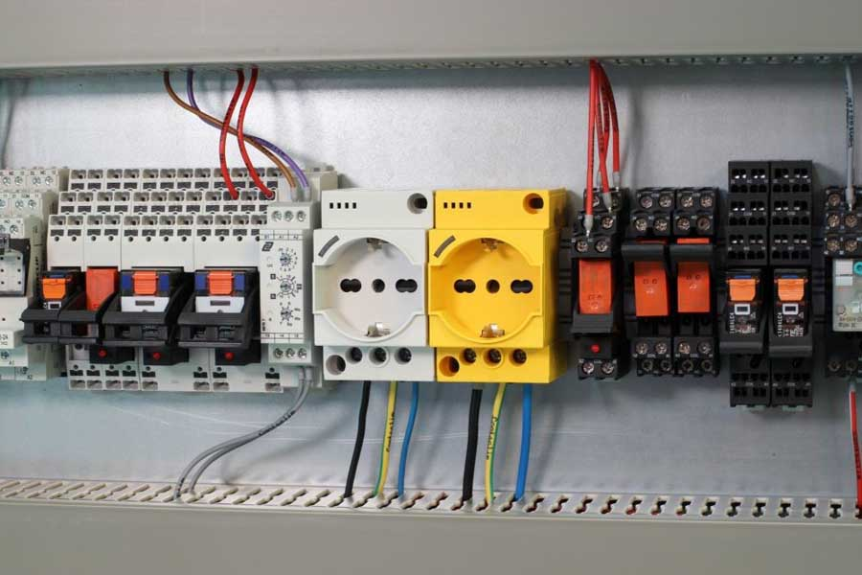
Caption: Control cabinet sockets from Conta-Clip

Well thought-out solutions right from the start
The industry is placing increasingly specific demands on electronics, especially when it comes to complex production systems. These requirements must be taken into account at the very beginning of planning machines and systems when determining the electronic components. Conta-Clip offers the Conta-Electronics program for this purpose, including a wide range of active and passive components for the transfer and conversion of analog and digital signals at the coupling level. The offer comprises power supplies, coupling and multifunctional timer relays, digital switching and transfer modules, optocouplers, signal converters, GSM communication modules and much more. The quality, variety and, last but not least, the manufacturer’s know-how ensure individual and smart solutions for each use. The Conta-Clip specialists develop prototypes in direct consultation with the customer, taking into account their particular wishes from design and component procurement to production and delivery to after-sales. From problem solving to production, everything comes from a single source, regardless of series size and complexity of the product.

Image/s: | Schaltschranksteckdose | Characters: | 2094
File name: | 202410011_pm_control_cabinet_socket_en | Date: | 10-28-2024
Tags: | control cabinet sockets, mains voltage indicator, electrical systems, combination sockets, grounding outlet, CF
About CONTA-CLIP
CONTA-CLIP is one of Europe’s leading manufacturers of electrical and electronic connection elements and cable management solutions. Based in Hövelhof, Germany, the medium-sized, family-run company has been producing electric and electronic connection systems for the process and automation industries since 1978. CONTA-CLIP supplies all industry sectors, focusing on railroad industries, shipbuilding, building automation, conveyor technology, machine and plant engineering and construction, instrumentation and control technology, control panel manufacturing, transformer manufacturing, and environmental technology. The company consists of many specialized branches: CONTA-CONNECT for electric connection technology, CONTA-CABLE for cable management systems, CONTA-ELECTRONICS for electronics and CONTA-CON for PCB edge connectors. Additionally, CONTA-CLIP provides services such as customizing housings and mounting rails, labeling and supplying user-specific electronic components.
Contact:  CONTA-CLIP  Verbindungstechnik GmbH  Christian Quade  Otto-Hahn-Str. 7  33161 Hövelhof  Germany  Phone: +49 . 5257 . 9833 - 172  Email: christian.quade@conta-clip.de  Internet: www.conta-clip.com |  | gii die Presse-Agentur GmbH  Christburger Str. 41  10405 Berlin  Germany  Phone: +49 . 30 . 538 965 - 0  Email: info@gii.de  Internet: www.gii.de

