Press Release

SABorganic: Sustainable cable design in an eco-jacket

SAB Bröckskes, an established expert in the development and production of special cables Made in Germany, is responding to the trend and increasing demand for products made from renewable raw materials. Now, the manufacturer has introduced a new, CO₂-reduced series of data and control cables. The SABorganic S 1000 cable, which can be twisted by 60° per meter, has an outer sheath made of polyurethane based on organic materials. The new material is sourced from short, local supply chains and consists of 45% renewable raw materials. This reduces the carbon footprint by an average of 25% versus comparable fossil-dependent products. The new, more climate-friendly cable measures up to conventional SAB drag chain cables such as the S 200 in all relevant product properties. The SABorganic S 1000, offered by SAB Bröckskes as Control and Data versions, is available by default in various unshielded and shielded types with 3 to 20 wires in cross-sections between 0.14 mm² and 10.0 mm². According to the manufacturer, additional sizes can be realized on request. The new sheath material is halogen-free and flame-retardant according to IEC 60332-1-2, thus minimizing potential fire hazards. In addition, SABorganic S 1000 is resistant to mineral-oil-based lubricants and many chemicals.

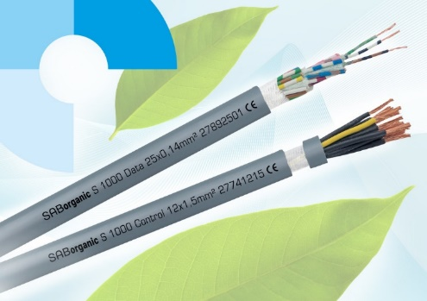
Caption: New SABorganic product line: ecologically sustainable data and control cables in a CO₂-reduced outer sheath made of polyurethane based on 45% organic materials

The new series is ozone-resistant in accordance with EN 50396, UV and weather-resistant in accordance with HD 605 and free of substances that interfere with paint wetting. SAB’s CO₂-reduced sheath material concept is transferable to other products. Determining factors are the customer requirements and the individual application area for the cable. Energy savings due to comparatively low processing temperatures and low cable weights, which reduce transport costs, also contribute to the improved life cycle assessment of the new series. Not included in the CO₂ reduction of the SABorganic S 1000 series is the steadily growing share of self-generated electricity from renewable energies. In recent years, the company has pushed ahead with the expansion of renewable energies. SAB now covers around a fourth of its electricity consumption from its own photovoltaics systems.

The SABorganic S 1000 will be presented at this year's SPS at the SAB stand in Hall 2/330.

Image/s: | sab_organic_2024_2000.jpg | Characters: | 2163
File name: | 202410014_pm_saborganic_en | Date: | 10-28-2024
Tags: | SAB Bröckskes, SABorganic S 1000, data cable, control cable, CO2 reduction, bio-based PU, climate-friendly polyurethane, cable sheath material, ecological cable design
About SAB Bröckskes
Founded in Viersen, Germany, in 1947 by Peter Bröckskes as a one-man operation for electrical system design, SAB Bröckskes GmbH & Co. KG has grown into one of the world’s leading special cable manufacturers, now employing a staff of more than 550 who generate a turnover of over €134 million euros in over 100 countries. The portfolio includes cables and wires manufactured from a wide variety of materials as well as cable assembly and measurement solutions. All products are developed and manufactured exclusively at the Viersen headquarters. The company supplies various industries from industrial automation and communication technology to manufacturers of construction and agricultural machinery, railway and shipping technology and medical technology. SAB Bröckskes has a global presence with international subsidiaries and sales offices.
Contact:  SAB BRÖCKSKES GmbH & Co. KG  Sacir Adrovic  Grefrather Str. 204 – 212b  41749 Viersen  Germany  Phone: +49 2162 898-146  Email: s.adrovic@sab-cable.com  Internet: www.sab-cable.com |  | gii die Presse-Agentur GmbH  Christburger Str. 41  10405 Berlin  Germany  Phone: +49 30 538 965-0  Email: info@gii.de  Internet: www.gii.de

