Press Release

Slim multi-touch panel for all machine types

RAFI has developed and produced a state-of-the-art display system with capacitive touch functionality for the UNITED GRINDING Group, one of the world’s leading manufacturers of grinding machines, eroding machines, laser machines, measuring machines, and machine tools for additive manufacturing. The 23.8" full HD multi-touch display serves as a standardized solution for the entire machine range across all brands within the Group, offering an intuitive and user-friendly touch interface alongside enhanced functionality. Based on the RAFI GLASSCAPE technology platform, the input and display system provides operating comfort akin to that of smartphones. It also received a “Special Mention” at the UX Design Awards for its exceptional user and customer experience. The extensive range of features is complemented by editable role profiles, individual user customization, and compatibility with digital networking at the IIoT level. The HDBaseT standard gateway developed by RAFI allows for a sleek device design, eliminating the need for extra control units and cooling systems within the display panel. This is achieved by offloading signal control and data transmission to the machine’s CPU through HDBaseT technology. The HDBaseT interface ensures lossless real-time transmission of video and audio signals, user input, and USB communication, as well as internet and network protocols. Data rates of up to 8 Gbit/s also support video transmissions with 4K resolution. The large display diagonal provides ample room for intuitive user interfaces featuring customizable, self-explanatory icons. RAFI has incorporated ultra-flat actuators from its RAFIX 30 FS⁺ series into the console of the swiveling and tilting panel located beneath the display. RAFIX actuators paired with MICON 5S micro-switches provide precise tactile feedback, exceptional switching reliability, and minimized space requirements. A USB feed-through from the RAFIX 22 FS⁺ series is used for data transmission. The LUMOTAST 16, known for its reliability in mechanical and plant engineering, is used as an emergency stop key switch. One operating highlight is the inductive rotary switch with override function, which enables all machine movements to be limited in a coordinated and infinitely variable manner via rotary input. The system now features automatic radar user recognition along with an integrated front camera, enabling direct video calls with the Customer Care team of the UNITED GRINDING Group.

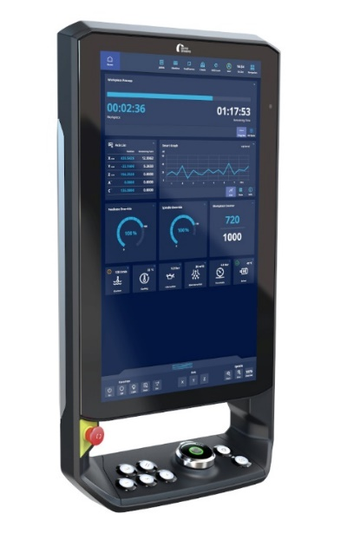
Caption 1: The award-winning multi-touch display from RAFI, recognized for its exceptional user experience, offers a standardized operating solution compatible with various machines within the UNITED GRINDING Group

Image: UNITED GRINDING Group

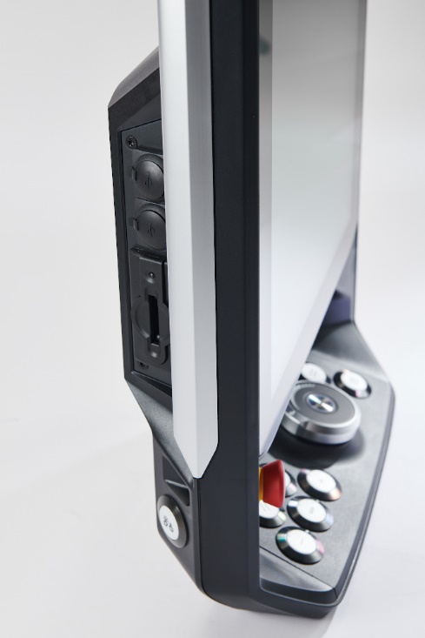

Caption 2: Slim, lightweight device design thanks to outsourced controller unit and loss-free HDBaseT real-time transmission between machine and control panel

Image: RAFI GmbH

Image/s: | core-panel_2000.jpg  corepanel_schnittstellen_2000.jpg | Characters: | 2,483
File name: | 202410015_pm_core-panel_en.docx | Date: | 12-10-2024
Tags: | RAFI, United Grinding, Mechanical Engineering, Multitouch Display, Touchscreen, Glasscape, Touch Operation, HDBaseT, User Experience, UX Award, Rafix, Micon, Lumotast

About the RAFI group
Founded in 1900, RAFI today develops and produces electromechanical components and systems for human-machine interaction. The range of products includes key switches, switches, touchscreens, control systems, and electronic assemblies. RAFI products are employed in many industries including automation, medical technology, machine and plant engineering, road and railway vehicles, household appliances, and telecommunication. The RAFI Group operates internationally with more than 2,000 employees at sites in Germany, Europe, China, and the USA. Its headquarters are in Berg, Germany.

Contact:  RAFI GmbH & Co. KG  Fred Nemitz  Head of Corporate Marketing  Ravensburger Str. 128–134  88276 Berg, Germany  Phone: 0160 92048569  Email: fred.nemitz@rafi-group.com  Web: www.rafi-group.com |  | gii die Presse-Agentur GmbH  Christburger Str. 41  10405 Berlin, Germany  Phone: +49 30 53 89 65-0  Email: info@gii.de  Web: www.gii.de

