Press Release

Protective camera enclosure with “flexible” tube for various lens sizes

autoVimation’s new protective camera enclosure Lizard provides tool-free access to the lens settings. The IP67-rated enclosure is based on the established Salamander series, but has a lens tube instead of a screw-down front lid. Thereby, the lens can protrude up to 40 mm from the enclosure body. Conventional tubes, such as those used in IP-protected cameras or other enclosures, are usually either too short or too long in applications with a fixed sensor or camera position. Either the lens does not fit or the front lens sits so far behind the window that corner shading cannot be avoided with wide-angle lenses. Some manufacturers therefore offer a dozen different tube lengths. The Lizard, on the other hand, allows for completely flexible lengthwise camera positioning, as is typical for autoVimation protective enclosures. This allows short lenses, 30 – 40 mm in length, to be mounted directly behind the front window. To accommodate 60 – 70 mm long lenses, the camera is simply moved back a bit. As with the smaller lenses, the focus and aperture rings can usually be easily reached.

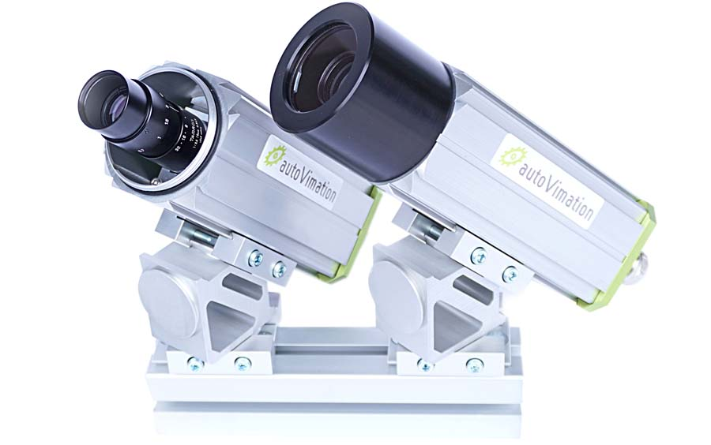
Caption: Thanks to flexible camera positioning in the protective camera enclosure Lizard, lenses of different sizes can be mounted directly behind the front window - for shading-free imaging even with wide-angle lenses

Featuring an internal length of 191 mm, the Lizard offers the same space as a Salamander M. The new camera enclosure thus provides flexible protection for the majority of machine vision installations. The tube is robust, as usual for autoVimation, with thick walls and a 2-mm O-ring. Users can easily exchange the window or swapped it for filters with a 2″ or 50 mm diameter in different thicknesses. The new Lizard of course also features all the advantages of the Salamander enclosures, such as excellent heat dissipation.
autoVimation at VISION
Stuttgart, Germany, 8 – 10 October 2024
Hall 10, Booth D02

Image/s: | lizard_camera_enclosures_2000px-2.jpg | Characters: | 1616
File name: | 202410021_pm_lizard_camera_enclosure_en | Date: | 10-09-2024
Tags: | protective camera enclosure, protective enclosures, machine vision, lens tube, optics tube
About autoVimation
Founded in 2008, autoVimation is a pioneer in the design and production of industrial-grade protective camera enclosures and a complete building kit for the simple, cost- and time-saving installation of image processing components. Vision system integrators, OEMs, plant manufacturers and operators worldwide find the German manufacturer a trusted source for enclosures in various sizes as well as a huge modular range of dovetail profiles, clamps and brackets for flexible positioning and adjustment of cameras, lasers and other components above production lines and in all kinds of industrial and other settings. Once aligned, all connectors ensure permanently stable fixation, resisting linear displacement with up to 2000 N and torsion with up to 90 Nm. The patented Quick-Lock/Heat-Guide camera mount provides excellent heat dissipation and enables flexible camera positioning inside the protective enclosure. autoVimation’s powerful LED ring lighting with a flash controller also stays cool thanks to good heat coupling to the outer enclosure and, mounted directly behind the window, is protected according to IP67. An extensive range of accessories enables camera technology to be used under challenging conditions: protective flaps and wind curtains for particularly dirty installation environments and temperature control solutions for ambient temperatures from -40 °C to 250 °C. A complete hygienic modular building kit in accordance with strict EHEDG specifications enables the legally compliant installation of image processing components in food or pharmaceutical processes.
Contact:  autoVimation GmbH  Peter Neuhaus  Roemerweg 1  76287 Rheinstetten  Germany  Phone: +49 . 721 . 627 6756  Email: sales@autovimation.com  Internet: www.autovimation.com |  | gii die Presse-Agentur GmbH  Christburger Str. 12  10405 Berlin  Germany  Phone: +49 . 30 . 538 9650  Email: info@gii.de  Internet: www.gii.de

