Press Release

Powerful low-budget camera protection

The new IP66-rated protective camera enclosure Sparrow from autoVimation provides cost-effective protection with the accustomed quality for typical machine vision cameras with cross sections of 29 mm x 29 mm or 30 mm x 30 mm and maximum lens diameters of 40 mm. The enclosure body has an inner length of 160 mm. With a flat front lid and the 40-mm enclosure extension included in delivery, users can easily access the lens settings. Without the extension, the flat lid is perfect for cameras with S-mount lenses. The cable gland allows one or more cables and plugs with diameters up to 21 mm to be fed through. The sealing insert is closed; users drill the holes for the cables themselves. In keeping with the straightforward enclosure concept, the manufacturer also offers a stripped-down swivel/tilt mount, which is less robust than the conventional milled versions, but is fully sufficient for applications with lighter mechanical load.

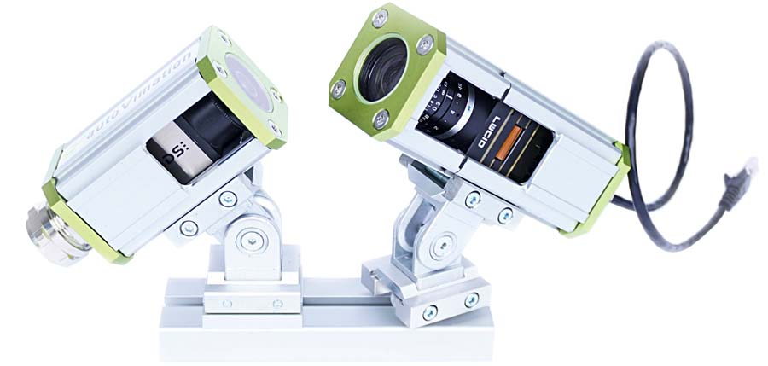
Caption: The cost-effective Sparrow enclosures can be adapted to typical compact vision systems in different lengths and offer flexible access to the lens settings (cutaway image only for demonstration)

Image/s: | sparrow_camera_enclosures | Characters: | 939
File name: | 202410026_pm_sparrow_camera_enclosure_en | Date: | 11-11-2024
Tags: | protective camera enclosure, cost-effective
About autoVimation
Founded in 2008, autoVimation is a pioneer in the design and production of industrial-grade protective camera enclosures and a complete building kit for the simple, cost- and time-saving installation of image processing components. Vision system integrators, OEMs, plant manufacturers and operators worldwide find the German manufacturer a trusted source for enclosures in various sizes as well as a huge modular range of dovetail profiles, clamps and brackets for flexible positioning and adjustment of cameras, lasers and other components above production lines and in all kinds of industrial and other settings. Once aligned, all connectors ensure permanently stable fixation, resisting linear displacement with up to 2000 N and torsion with up to 90 Nm. The patented Quick-Lock/Heat-Guide camera mount provides excellent heat dissipation and enables flexible camera positioning inside the protective enclosure. autoVimation’s powerful LED ring lighting with a flash controller also stays cool thanks to good heat coupling to the outer enclosure and, mounted directly behind the window, is protected according to IP67. An extensive range of accessories enables camera technology to be used under challenging conditions: protective flaps and wind curtains for particularly dirty installation environments and temperature control solutions for ambient temperatures from -40 °C to 250 °C. A complete hygienic modular building kit in accordance with strict EHEDG specifications enables the legally compliant installation of image processing components in food or pharmaceutical processes.
Contact:  autoVimation GmbH  Peter Neuhaus  Roemerweg 1  76287 Rheinstetten  Germany  Phone: +49 . 721 . 627 6756  Email: sales@autovimation.com  Internet: www.autovimation.com |  | gii die Presse-Agentur GmbH  Christburger Str. 12  10405 Berlin  Germany  Phone: +49 . 30 . 538 9650  Email: info@gii.de  Internet: www.gii.de

