Press Release

Ex p motor configuration from stock components

Menzel Elektromotoren fills a gap in the market with its range of pressurized Ex p motors, configuring them from stock components in the shortest possible time. Menzel recently built an Ex p compressor motor for an internationally active Austrian chemical company within three weeks. The squirrel cage motor from the MEBKSW series was modified in various ways to suit the application and site-specific requirements. The motor case was fitted with an air purge system that allows the motor to be flushed with an inert gas mixture before startup in order to remove potentially explosive atmospheres and to maintain a constant positive pressure during operation, thus preventing ingress of hazardous gases. The motor was labeled II 3G Ex pzc IIB T3 Gc. Additional works included: conversion to cooling type IC 81W (water-cooled), mechanical adjustment from size 560 to size 630, repositioning the terminal boxes, preparation of the neutral box for the installation of current transformers, adjustment of the flanges for the slide bearings and installation of vibration sensors. Menzel visited the customer’s plant even before the order was placed to discuss details and observe the installation situation and eventually also installed and commissioned the drive system.

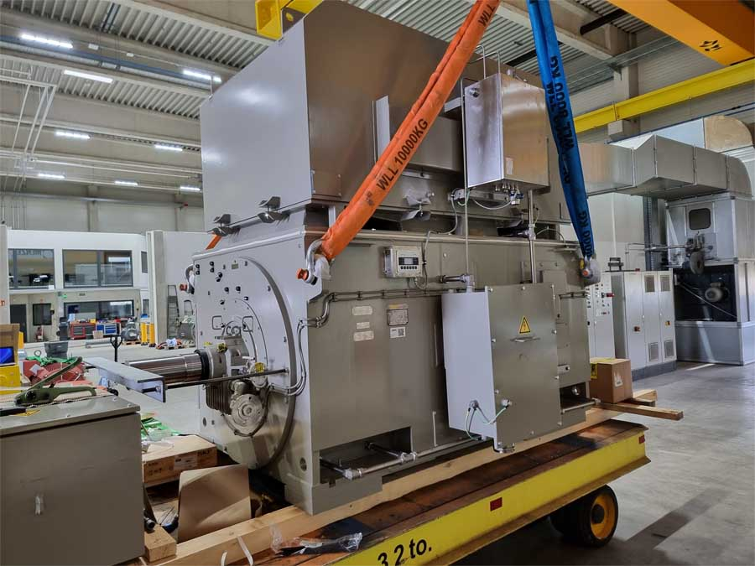
Caption: Menzel quickly configures squirrel cage motors in ignition protection type Ex p pressurization in device categories 2G and 3G in a wide output range from stock

In 2023, Menzel received the TÜV certification for the manufacture of squirrel cage motors in ignition protection type Ex p, pressurization for Zone 1. The German motor builder can apply the manufacturing procedure to stock motors in a wide output range and is thus able to quickly and flexibly provide competitively priced Ex p motors featuring the product categories 2G and 3G. This type of construction is available for all voltage ranges as well as with air-to-air or air-to-water cooling (cooling types IC 611, IC 616 or IC 81W). At the 2023 AEMT Awards, these motors were named Product of the Year.
Product website: https://www.menzel-motors.com/pressurized-exp-motors-zone1-operation/

Image/s: | ex_p_compressor_motor | Characters: | 1870
File name: | 202410028_pm_ex_p_compressor_motor_en | Date: | 10-23-2024
Tags: | Ex p, pressurization, compressor motor, squirrel cage motor
About Menzel Elektromotoren
Menzel Elektromotoren GmbH has been manufacturing and distributing electric motors since 1927. The German family-run company based in Hennigsdorf near Berlin specializes in the delivery of large electric motors, including special models, within the shortest time possible. The product range comprises high and low voltage motors, DC motors, transformers, and frequency inverters. Services include motor production up to and beyond 25 MW and short-term adaptation of stock motors to application-specific requirements. In order to ensure short delivery times, Menzel maintains a large inventory with over 20,000 motors up to 15 MW. Qualified engineering, experienced staff, and state-of-the-art production and testing facilities help the manufacturer provide excellent reliability. Menzel operates subsidiaries in the UK, France, Italy, Spain, and Sweden, and cooperates with numerous partners worldwide.
Contact:  Menzel Elektromotoren GmbH  Mathis Menzel  Am Alten Walzwerk 2  16761 Hennigsdorf  Germany  Phone: +49 30 349 922-0  Email: info@menzel-motors.com  Internet: www.menzel-motors.com |  | gii die Presse-Agentur GmbH  Christburger Str. 41  10405 Berlin  Germany  Phone: +49 30 538 965-0  Email: info@gii.de  Internet: www.gii.de

