Press Release

New compact and modular cable entries for confined spaces

The new KDS-SR Compact cable entries from Conta-Clip are ideal for the fast and secure feed-through of cables and tubes with or without connectors in confined spaces. The halogen-free, silicone-free system allows users to equip control cabinets and housings from the inside to the outside in a highly flexible manner in just a few simple steps – even with high packing density. The frame is fixed in the housing opening with M5 screws. Servicing or modifications are possible at any time without tools and without removing the frame. The compact, black screw-down frames securely hold the multi-resistant sealing elements, thereby providing IP66 protection and reliable strain relief. The modular system is suitable for the temperature range from -40 °C to +120 °C (static). The cable entries made of glass-fiber reinforced polyamide PA 6.6 / TPE have an UL 94 V-0 flammability classification. The entries go with the small sealing elements from Conta-Clip’s KDSClick cable management system. KDS-SR Compact with its captive injected gasket is based on the proven KDS-SR FB series for flat cables. The German manufacturer offers the system in four compact frame sizes for two to five sealing elements.

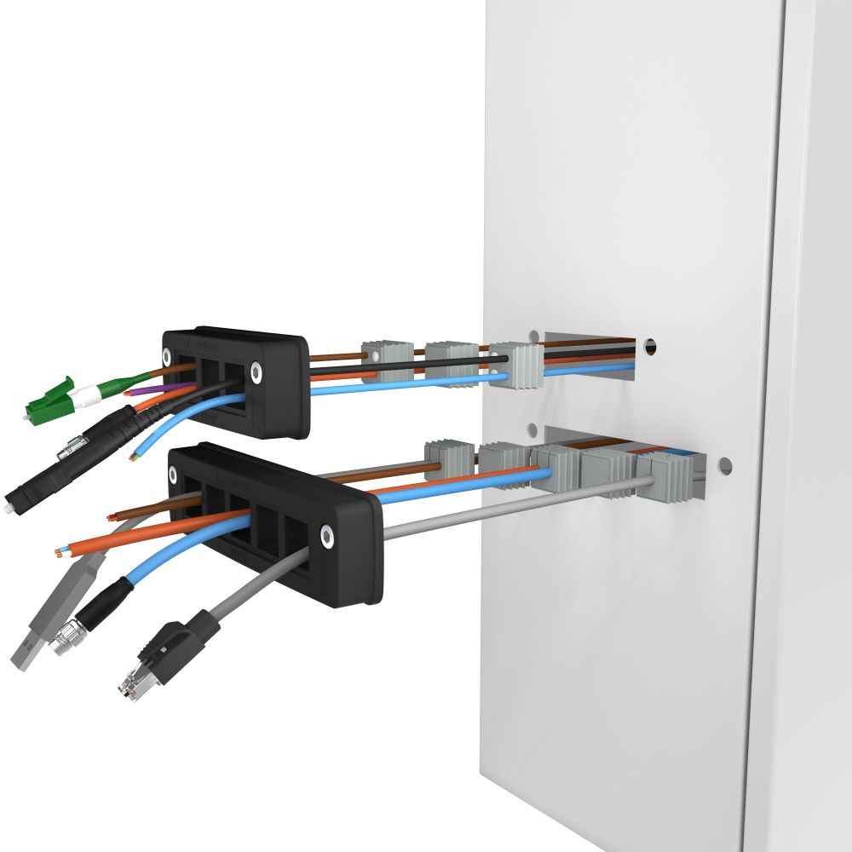
Caption: KDS-SR Compact cable entries are ideal for confined spaces

Innovative cable management solutions
Conta-Clip has developed the KDS cable entry systems for prefabricated and non-prefabricated cables and tubes with a special focus on tight sealing, good handling, modularity, variability and flexibility. KDS comprises various frame geometries, inlay sizes and sealing elements to meet different requirements. Depending on their needs, users have a choice of different shapes and installation methods. The common parts principle facilitates warehousing.

Image/s: | kds_sr_click_explosion | Characters: | 1691
File name: | 202410031_pm_kds-sr_compact_cable_entries_en | Date: | 11-07-2024
Tags: | cable entries, cable management, strain relief, compact
About CONTA-CLIP
CONTA-CLIP is one of Europe’s leading manufacturers of electrical and electronic connection elements and cable management solutions. Based in Hövelhof, Germany, the medium-sized, family-run company has been producing electric and electronic connection systems for the process and automation industries since 1978. CONTA-CLIP supplies all industry sectors, focusing on railroad industries, shipbuilding, building automation, conveyor technology, machine and plant engineering and construction, instrumentation and control technology, control panel manufacturing, transformer manufacturing, and environmental technology. The company consists of many specialized branches: CONTA-CONNECT for electric connection technology, CONTA-CABLE for cable management systems, CONTA-ELECTRONICS for electronics and CONTA-CON for PCB edge connectors. Additionally, CONTA-CLIP provides services such as customizing housings and mounting rails, labeling and supplying user-specific electronic components.
Contact:  CONTA-CLIP  Verbindungstechnik GmbH  Christian Quade  Otto-Hahn-Str. 7  33161 Hövelhof  Germany  Phone: +49 . 5257 . 9833 - 172  Email: christian.quade@conta-clip.de  Internet: www.conta-clip.com |  | gii die Presse-Agentur GmbH  Christburger Str. 41  10405 Berlin  Germany  Phone: +49 . 30 . 538 965 - 0  Email: info@gii.de  Internet: www.gii.de

