Press Release

New brush sealing cable entries for effective protection against dust and drafts

What to do if cable management in network and control cabinets or raised floors requires effective protection against dust and drafts, but not high tightness? Conta-Clip's new KDS-BS and KDS-BC brush sealing cable entries offer the ideal solution for these requirements. The two-piece interlocking cable entries from the German manufacturer are halogen-free and silicone-free. Their brushes ensure efficient thermal insulation and create a visible barrier in openings for guiding through cables and wires with and without connectors. In addition, the black cable entries made of glass-fiber reinforced polyamide PA 6.6 are an ideal buffer for edges. The versatile system has a UL 94 V-0 flammability classification and is suitable for the temperature range from -40 °C to +90 °C (static). The frames can be mounted on control cabinets before or after feeding through the conductors. KDS-BS is a screw-down frame, while KDS-BC is affixed via integrated plastic expansion rivets. Both these brush sealing cable entries can use standard cut-outs for 24, 16 and 10-pole heavy-duty connectors. The easy-to-install and easy-to-handle cable entries are available in three frame sizes.

Innovative cable management solutions
Conta-Clip has developed the KDS cable entry systems for prefabricated and non-prefabricated cables and tubes with a special focus on tight sealing, good handling, modularity, variability and flexibility. KDS comprises various frame geometries, inlay sizes and sealing elements to meet different requirements. Depending on their needs, users have a choice of different shapes and installation methods. The common parts principle facilitates warehousing.

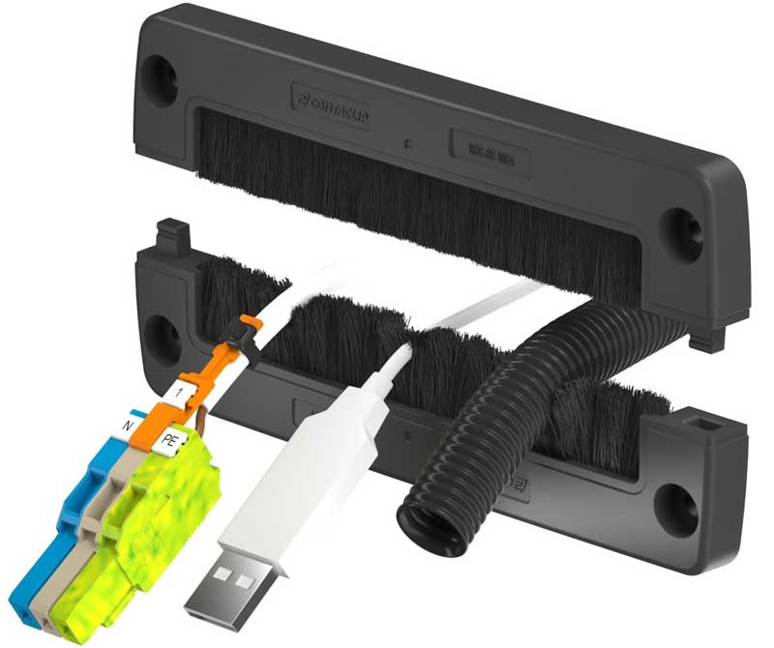
Caption: The new KDS-BC and KDS-BS brush-sealing cable entries from Conta-Clip are ideal for keeping out dust and drafts

Image/s: | KDS-BC_BS_geteilt |  | Characters: | 1667
File name: | 202410032_pm_kds-bc_bs_brush_sealing_cable_entries_en |  | Date: | 02-12-2025
Tags: | cable entries, cable management, brush sealing
About CONTA-CLIP
CONTA-CLIP is one of Europe’s leading manufacturers of electrical and electronic connection elements and cable management solutions. Based in Hövelhof, Germany, the medium-sized, family-run company has been producing electric and electronic connection systems for the process and automation industries since 1978. CONTA-CLIP supplies all industry sectors, focusing on railroad industries, shipbuilding, building automation, conveyor technology, machine and plant engineering and construction, instrumentation and control technology, control panel manufacturing, transformer manufacturing, and environmental technology. The company consists of many specialized branches: CONTA-CONNECT for electric connection technology, CONTA-CABLE for cable management systems, CONTA-ELECTRONICS for electronics and CONTA-CON for PCB edge connectors. Additionally, CONTA-CLIP provides services such as customizing housings and mounting rails, labeling and supplying user-specific electronic components.
Contact:  CONTA-CLIP  Verbindungstechnik GmbH  Christian Quade  Otto-Hahn-Str. 7  33161 Hövelhof  Germany  Phone: +49 . 5257 . 9833 - 172  Email: christian.quade@conta-clip.de  Internet: www.conta-clip.com |  | gii die Presse-Agentur GmbH  Christburger Str. 41  10405 Berlin  Germany  Phone: +49 . 30 . 538 965 - 0  Email: info@gii.de  Internet: www.gii.de

