Press Release

Patented AllRounder wheelsets for transport platforms

Losyco, expert for intra-logistics on rails, introduces patented AllRounder wheelsets, an easy-to-install solution for taking heavy loads around corners on the floor-level LOXrail system. Two rollers mounted at an angle can be rotated in opposite directions in order to realize effortless 90° turns at junction points. This enables rail layouts with linking and crisscrossing lines without the need for additional, high-maintenance shunting equipment. The time-saving and cost-efficient solution reduces the installation effort, even in halls with complex floor plans. Barriers like supporting pillars are simply avoided. The wheelset design ensures minimal friction due to the very small contact area between the rollers and the guide rail. Thereby, even loads weighing several tons can be easily moved across the rails and around corners by hand. The new solution is also useful for re-routing transport platforms back to the start of the line. Fitted with four wheelsets, the new AllRounder transport platforms for flexible maneuvering carry payloads up to 10 tons on the LOXrail 25 system. LOSYCO will adapt them to customer requirements in terms of dimensions and track widths.

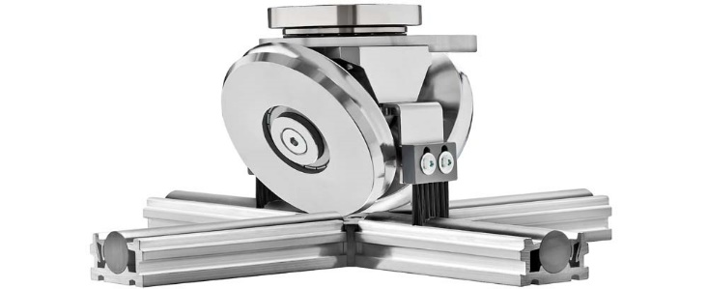
Caption 1: Patented AllRounder wheelset for switching direction on LOXrail intra-logistics rails

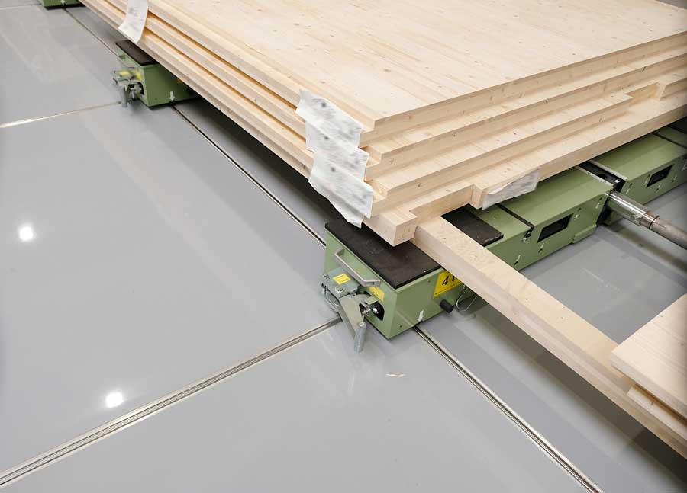
Caption 2: Transport platforms fitted with AllRounder wheelsets can move around corners without any additional shunting equipment

Image/s: | allrounder-radsatz_schiene_2000.jpg  loxrail_ausschnitt_2000.jpg | Characters: | 1182
File name: | 202410034_pm_allrounder_wheelset_en | Date: | 10-23-2024
Tags: | Losyco, LOXrail, AllRounder, AllRounder wheelsets, intra-logistics, transport platforms, heavy loads
About Losyco
LOSYCO designs, builds, and installs intra-logistics systems for the manufacturing industry. The company based in Bielefeld, Germany, was founded by experienced engineers in 2016. LOSYCO’s core product is the LOXrail® floor rail system for easy transport and precise positioning of loads weighing several tons. LOXrail transport platforms can be operated manually or with auxiliary drives. LOSYCO also supplies handling equipment such as chain and roller conveyors, material management and storage systems, as well as sound-proof cabins and machine covers. LOSYCO supports customers wishing to transform their production processes to lean manufacturing and continuous flow production. LOSYCO is a member of the DRECKSHAGE Family.
Contact:  LOSYCO GmbH  Tim Schneider  Walter-Werning-Str. 7  33699 Bielefeld  Germany  Tel.: +49 . 521 . 945 643-0  Email: info@losyco.com  Internet: www.losyco.com |  | gii die Presse-Agentur GmbH  Christburger Str. 41  10405 Berlin  Germany  Tel.: +49 . 30 . 538 965-0  Email: info@gii.de  Internet: www.gii.de

