Press Release

GMC-I Group at SPS trade fair:
Brand diversity under one umbrella

Gossen Metrawatt, Camille Bauer along with all the other internationally established brands of the GMC-Instruments Group will take part in this year’s SPS trade fair in Nuremberg, Germany. From 12 to 14 November 2024, the group of companies will be showcasing its wide range of brands and products with a new exhibition concept at booth 7A/420. Showcases address measurement and testing technology, energy management, power quality monitoring, data and communication technology, medical technology, photo technology and photometry. The product series from the US-American manufacturer Dranetz Technologies and the British subsidiaries Seaward Electronic and Rigel Medical will also be presented with the GMC-I brand’s typical design for the first time. The exhibition program will focus on system solutions for integrated energy management developed by Gossen Metrawatt as well as mobile and stationary power quality analyzers from Dranetz and Camille Bauer.

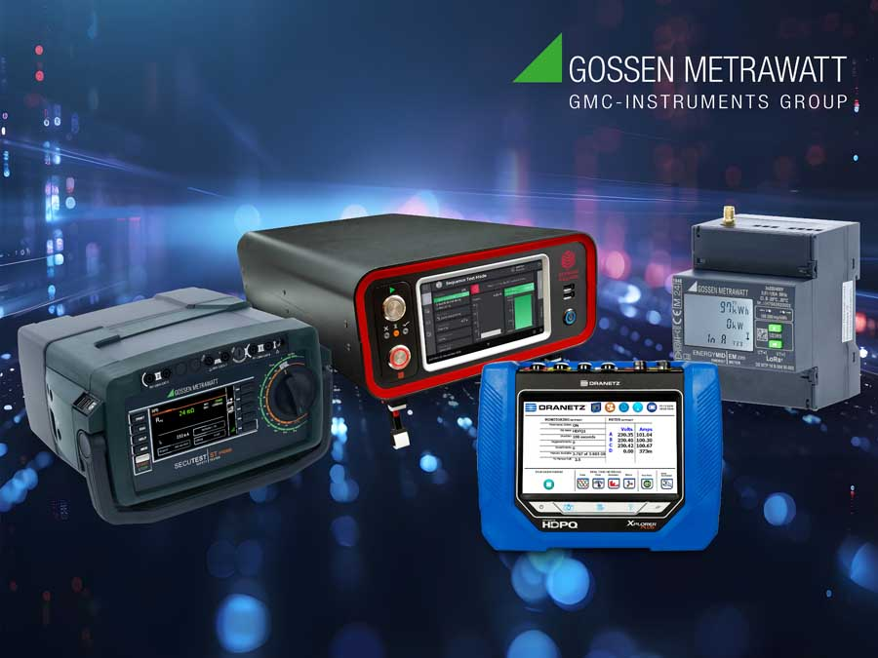
Caption: The GMC-I Group will be showcasing its wide range of brands and products in measurement and testing technology, energy management, PQ monitoring and more at the SPS trade fair

Safety testers from Seaward and Gossen Metrawatt will have their trade fair premiere. The new HAL series and the recently introduced SECUTEST ST PRIME are ideal for performing routine and type tests of electrical equipment in the production process before shipping or after repairs. Both test instruments integrate all necessary measurement and test functions for standards-compliant testing of the effectiveness of protective measures for electrical equipment. In addition, SECUTEST ST PRIME enables high-voltage tests with up to 6 kV DC in the manufacture of electrical equipment. Another showcase will highlight the GMC-Instruments Group’s system solutions for testing the electrical safety of photovoltaic systems and electric vehicle charging infrastructure. The exhibition program is rounded off by a selection of measurement and testing technology from the KURTH ELECTRONIC telecommunications brand. The competent GMC-I team welcomes all interested parties and is looking forward to the professional exchange at the SPS booth.

Image/s: | collage_sps24_2000.jpg | Characters: | 1991
File name: | 202410041_pm_sps_tradeshow_preview_en | Date: | 10-29-2024
Tags: | GMC-Instruments, GMC-I Group, Gossen Metrawatt, Camille Bauer, Seaward, Dranetz, Kurth Electronic, SPS, SPS trade fair, measurement and testing technology, energy management, power quality monitoring, data and communication technology, photovoltaic systems, electric vehicle charging
About Gossen Metrawatt
Gossen Metrawatt, one of the world’s leading suppliers of measurement systems, develops and distributes a wide range of high-quality measuring and test devices for electrical trade, various industries and the public sector.
The Gossen Metrawatt brand has been synonymous with safety and quality “Made in Germany” for decades. Its product range includes measurement and test technology for the electrical safety of plants, devices and machines as well as for the e-mobility and medical technology industries. Additional key areas of interest are power quality, battery testing technology, multimeters, calibrators, power supply technology and energy management systems. For a truly comprehensive electrical safety portfolio, Gossen Metrawatt also offers a continuously growing range of digital services and cloud services and supports its customers with a versatile training program and a wide range of after-sales services.
Gossen Metrawatt is part of the GMC Instruments Group, which also includes other specialized manufacturers for measurement and testing technology – notably, Camille Bauer Metrawatt, Dranetz, Prosys, Seaward and Rigel and Kurth Electronic. The Camille Bauer and Rigel brands add to the portfolio various transducers, display instruments and detection systems for heavy-current engineering as well as special measuring, testing and functional testing devices for the medical sector. The GMC-I Group runs its own DAkkS-certified calibration center that performs DAkkS, ISO and factory calibrations for virtually all electrical measured quantities. The GMC-I Group has development and production sites in Germany, Switzerland, England and the USA and a worldwide sales network of its own companies as well as sales partners.
Contact:  Gossen Metrawatt GmbH  Christian Widder  Head of Marketing Communication  Suedwestpark 15  90449 Nuremberg  Germany  Phone: +49 . 911 . 8602-572  Email: christian.widder@gossenmetrawatt.com  Internet: www.gossenmetrawatt.com |  | gii die Presse-Agentur GmbH  Christburger Str. 41  10405 Berlin  Germany  Tel.: +49 . 30 . 538 9650  Email: info@gii.de  Internet: www.gii.de

