Press Release

Special motor with 10-ton rotor for steel mill

By provisioning in good time, plant operators can avoid costly downtimes. This is all the more important for non-standard configurations. An Argentinian steel mill operator commissioned Menzel Elektromotoren to build a special motor based on an existing motor with the type of construction IM 7311. For future-proofing and since this is a considerable investment, the old, still operational motor is to be stored as backup. Therefore, the new machine must replicate it in every detail, although Menzel implemented a performance increase at the customer’s request. The German, family-run company counts special motors among its core business and also designed the starter in such a way that it caters for the new motor and the original one equally. The new slip ring motor provides a nominal torque of 43245 Nm at 6600 V rated voltage and 1345 kW rated power. The format is unusual: at a total weight of 21.9 tons, the rotor alone weighs full 10.4 tons. Various accessories were installed, including HALL effect current transformers to measure the rotor current, customer-specified accelerometers on the bearings, and a level sensor for the electrolyte in the starter. The motor features IP23 protection and IC 01 cooling (open-circuit ventilation). It has to withstand ambient temperatures up to 45 °C in the rolling mill. Before shipping, the motor underwent a complete type test with additional tests according to customer specifications, including partial discharge and dissipation factor measurement (tan δ). Menzel will also handle the mill drive commissioning, which the operator will schedule to suit production planning.
More information about customized motors: https://www.menzel-motors.com/modification/

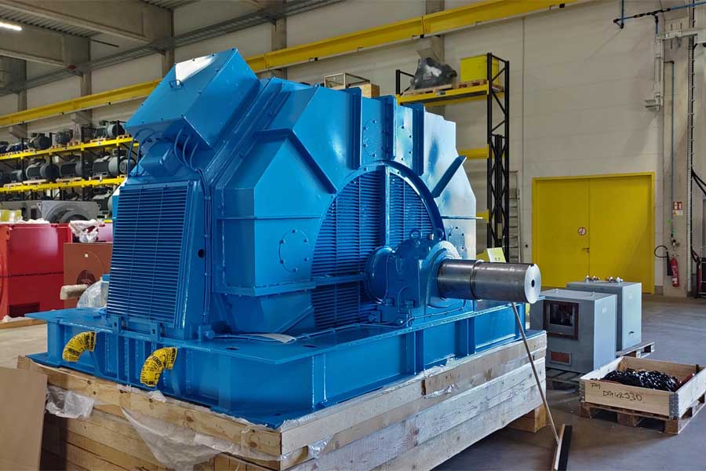
Caption: The customized motor replaces an old model in the steel mill

Image/s: | steel_roller_motor | Characters: | 1628
File name: | 202411004_pm_special_motor_steel_mill_en | Date: | 12-03-2024
Tags: | special motor, steel mill, rolling mill, mill drive, provisioning, future-proofing
About Menzel Elektromotoren
Menzel Elektromotoren GmbH has been manufacturing and distributing electric motors since 1927. The German family-run company based in Hennigsdorf near Berlin specializes in the delivery of large electric motors, including special models, within the shortest time possible. The product range comprises high and low voltage motors, DC motors, transformers, and frequency inverters. Services include motor production up to and beyond 25 MW and short-term adaptation of stock motors to application-specific requirements. In order to ensure short delivery times, Menzel maintains a large inventory with over 20,000 motors up to 15 MW. Qualified engineering, experienced staff, and state-of-the-art production and testing facilities help the manufacturer provide excellent reliability. Menzel operates subsidiaries in the UK, France, Italy, Spain, and Sweden, and cooperates with numerous partners worldwide.
Contact:  Menzel Elektromotoren GmbH  Anja Leipold  Corporate Communications  Am Alten Walzwerk 2  16761 Hennigsdorf  Germany  Phone: +49 30 349 922-0  Email: info@menzel-motors.com  Internet: www.menzel-motors.com |  | gii die Presse-Agentur GmbH  Christburger Str. 41  10405 Berlin  Germany  Phone: +49 30 538 965-0  Email: info@gii.de  Internet: www.gii.de

