Press release

More choice for symbol printing on pushbutton panels

RAFI has developed the FLEXLAB labeling system for the flexible labeling of its RAFIX and RAMO pushbuttons or illuminated attachment panels. In addition to transparent, pre-punched labeling sheets in printed or unprinted versions that can be designed by the customer, RAFI also offers symbol printing on the pushbutton panels in black font color. RAFI has expanded the range of labeling options for FLEXLAB pushbuttons and illuminated attachments for printing standard symbols on the cover. In addition to transparent panels, translucent green or red-colored panels are also available for the distinctive marking of on and off or start and stop functions. The manufacturer marks the reset button on transparent and blue-colored bezels as standard. In addition, transparent bezels can be printed with numerous standard symbols. The round, 22.15mm apertures are designed for working temperatures from -25°C to +70°C and are attached to FLEXLAB pushbuttons and illuminated attachments by latching.

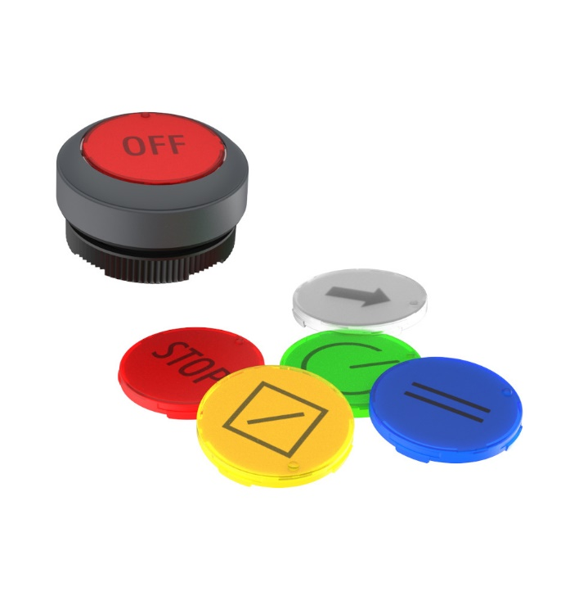
Caption: RAFI expands the selection of standard symbols for printing on stylus covers for its RAFIX and RAMO model series

Image/s: | rafix_flexlab_2000.jpg | Characters: | 994
File name: | 202411005_flexlab-symbole_en.docx | Date: | 11-11-2024
Tags: | RAFI, RAMO, RAFIX, FLEXLAB, marking system, labeling, bezel, panel, aperture printing, symbol printing, pushbuttons, illuminated attachments

About the RAFI Group
Founded in 1900, RAFI today develops and produces electromechanical components and systems for human-machine interaction. The range of products includes key switches, switches, touchscreens, control systems, and electronic assemblies. RAFI products are employed in many industries including automation, medical technology, machine and plant engineering, road and railway vehicles, household appliances, and telecommunication. The RAFI Group operates internationally with more than 2,000 employees at sites in Germany, Europe, China, and the USA. Its headquarters are in Berg, Germany.

Contact:  RAFI GmbH & Co. KG  Patrick Müller  Product Marketing Manager  Ravensburger Straße 128-134  88276 Berg  Tel.: 0751 89-1634  E-Mail: patrick.mueller@rafi-group.com  Internet: www.rafi-group.com |  | gii die Presse-Agentur GmbH  Christburger Str. 41  10405 Berlin, Germany  Phone: +49 30 53 89 65-0  Email: info@gii.de  Web: www.gii.de

