Press Release

Explosion-proof mill motor configured from stock

Menzel Elektromotoren has built a dust-explosion-protected motor in ignition protection type Ex tc (protection by housing) and provided it with the ATEX label II 3D Ex tc IIIB T125 °C Dc for use in zone 22 hazardous areas. The German motor manufacturer application-tailored the 1120-kW squirrel cage motor for a leading Italian operator’s flour mill. Menzel used a machine from its extensive stock, upgraded it for converter operation, adapted the dimensions to the existing motor to enable a smooth replacement, and manufactured an oversized terminal box according to customer specifications. The mill motor with a nominal voltage of 690 V provides a nominal torque of 11575 Nm. It is suitable for operation in both directions of rotation and features protection class IP55 with IC 611 cooling (CACA air-to-air heat exchanger). Through its Italian subsidiary, Menzel has been the mill operator’s trusted motor supplier for many years. Thanks to its large motor warehouse, application-specific configurations and ATEX certification capability, Menzel can meet virtually any demand from a single source.
More about low, medium and high-voltage motors in ignition protection types Ex ec and Ex tc for zone 2 and zone 22 hazardous areas with a risk of gas or dust explosions: https://www.menzel-motors.com/ex-na/

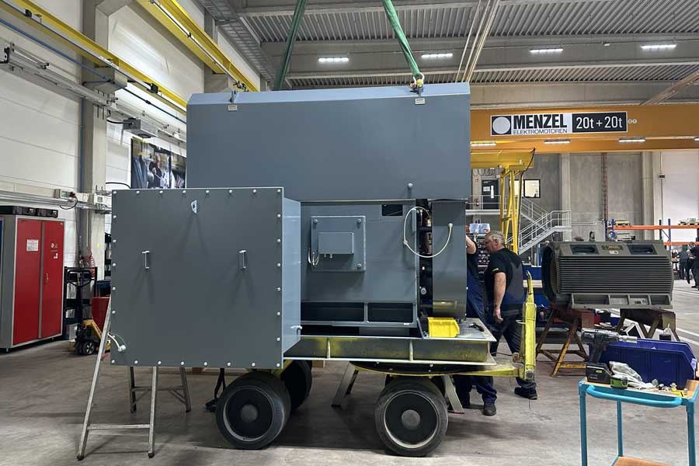
Caption: Menzel configured a squirrel cage motor from stock for use in zone 22 hazardous areas with potentially explosive dust atmospheres and for converter operation, designing it for an efficient smooth replacement in the customer’s plant

Image/s: | ex_tc_mill_motor | Characters: | 1102
File name: | 202411006_pm_ex_tc_mill_motor_en | Date: | 11-11-2024
Tags: | ATEX, Ex tc, zone 22, mill motor, flour mill, squirrel cage motor, inverter operation
About Menzel Elektromotoren
Menzel Elektromotoren GmbH has been manufacturing and distributing electric motors since 1927. The German family-run company based in Hennigsdorf near Berlin specializes in the delivery of large electric motors, including special models, within the shortest time possible. The product range comprises high and low voltage motors, DC motors, transformers, and frequency inverters. Services include motor production up to and beyond 25 MW and short-term adaptation of stock motors to application-specific requirements. In order to ensure short delivery times, Menzel maintains a large inventory with over 20,000 motors up to 15 MW. Qualified engineering, experienced staff, and state-of-the-art production and testing facilities help the manufacturer provide excellent reliability. Menzel operates subsidiaries in the UK, France, Italy, Spain, and Sweden, and cooperates with numerous partners worldwide.
Contact:  Menzel Elektromotoren GmbH  Anja Leipold  Corporate Communications  Am Alten Walzwerk 2  16761 Hennigsdorf  Germany  Phone: +49 30 349 922-0  Email: info@menzel-motors.com  Internet: www.menzel-motors.com |  | gii die Presse-Agentur GmbH  Christburger Str. 41  10405 Berlin  Germany  Phone: +49 30 538 965-0  Email: info@gii.de  Internet: www.gii.de

