Press Release

Heavy-duty rail trolleys with adjustable width

LOSYCO designs and builds customized heavy-duty transport solutions based on its floor-level LOXrail system. Now, the intra-logistics specialist has expanded the system to include new transport trolleys with a telescopic loading area. Heavy-duty LOXrail trolleys manufactured for a modular timber construction company are designed for load capacities of up to four tons and can be extended from 2.5 m to 4 m wide in six increments. This allows users to pick up payloads in different sizes without changing the track width and to move them manually. The trolleys, which also serve as working platforms, feature floor brakes attached to the side of the platforms that are engaged via a pedal to ensure a secure hold. The trolleys travel on rails with a 25-mm shaft diameter. LOSYCO has equipped them with two patented AllRounder wheelsets each to facilitate lane changes between different production lines. Two rollers mounted at an angle can be rotated in opposite directions in order to realize effortless 90° turns at junction points. Locking bolts attached to the carriages ensure secure positioning on the turning point. This enables rail layouts with linking and crisscrossing lines without the need for additional, high-maintenance shunting equipment. Up to seven of the new heavy-duty trolleys can be connected by coupling rods to form a transport train of around 14 m in length, which employees can move by hand. At the end of the route, the 300-kg trolleys are returned by forklift.

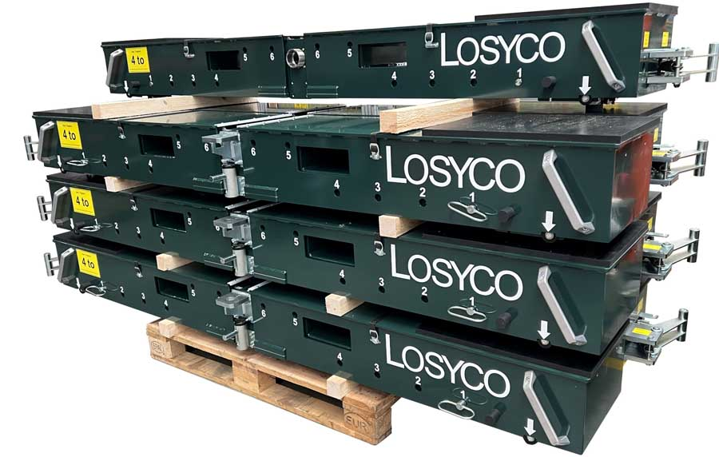
Caption 1: Incrementally extendable heavy-duty trolleys with widths from 2.5 m to 4 m carry loads weighing several tons

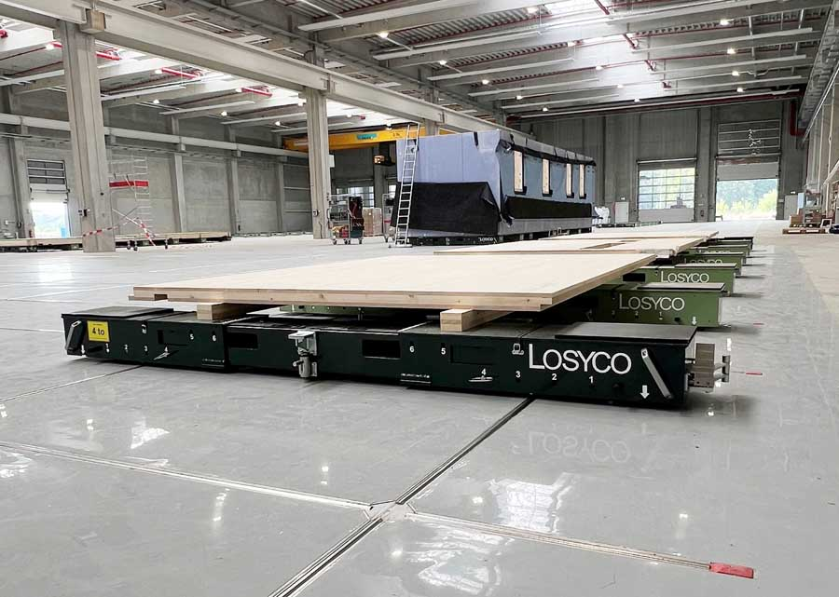
Caption 2: The individual, width-adjustable trolleys can be connected with coupling rods to form 14 m long transport trains

Image/s: | schwerlasttraverse_2000.jpg  transportzug_2000.jpg | Characters: | 1490
File name: | 202411010_pm_telescopic_trolleys_en | Date: | 11-11-2024
Tags: | LOSYCO, LOXrail, intra-logistics, floor-level, AllRounder, heavy-duty, transport trolleys
About Losyco
LOSYCO designs, builds, and installs intra-logistics systems for the manufacturing industry. The company based in Bielefeld, Germany, was founded by experienced engineers in 2016. LOSYCO’s core product is the LOXrail® floor rail system for easy transport and precise positioning of loads weighing several tons. LOXrail transport platforms can be operated manually or with auxiliary drives. LOSYCO also supplies handling equipment such as chain and roller conveyors, material management and storage systems, as well as sound-proof cabins and machine covers. LOSYCO supports customers wishing to transform their production processes to lean manufacturing and continuous flow production. LOSYCO is a member of the DRECKSHAGE Family.
Contact:  LOSYCO GmbH  Tim Schneider  Walter-Werning-Str. 7  33699 Bielefeld  Germany  Tel.: +49 . 521 . 945 643-0  Email: info@losyco.com  Internet: www.losyco.com |  | gii die Presse-Agentur GmbH  Christburger Str. 41  10405 Berlin  Germany  Tel.: +49 . 30 . 538 965-0  Email: info@gii.de  Internet: www.gii.de

