Press Release

New two-part screw frame for more flexible cable management

Conta-Clip is continuously optimizing its portfolio and now presents the new inverted modular cable entry system KDSI-SR-G, a two-part screw frame for simple and service-friendly assembly from the outside to the inside. The system for cables with and without connectors shows high adaptability in terms of cable management for control cabinets, enclosures and machines and significantly reduces the time required for assembly. The screwless, horizontally latching frame halves made of glass-fiber reinforced polyamide PA 6.6 feature dovetail profiles and thus do not have to be screwed but simply lock in place. Their double, overlapping integrated and captive TPE gasket ensures tight sealing according to protection type IP66. The black cable entry fits in standard cut-outs for 4, 10, 16 and 24-pin heavy-duty connectors. Furthermore, the 8/16 frame has a fixed partition and can be equipped with two 4-piece inlays. KDSI-SR-G is suitable for cables of all connector sizes and allows the greatest possible variability in the order of assembly. The frame can either be screwed directly to the housing or partially assembled or fully pre-assembled externally for later mounting on the housing. Customers can choose whichever frames and mounting methods best fit their particular application. The system offers maximum flexibility with optimized warehousing by using the proven modular KDS system for accessories such as inlays and sealing elements. KDSI-SR-G will be commercially available in the first quarter of 2025.

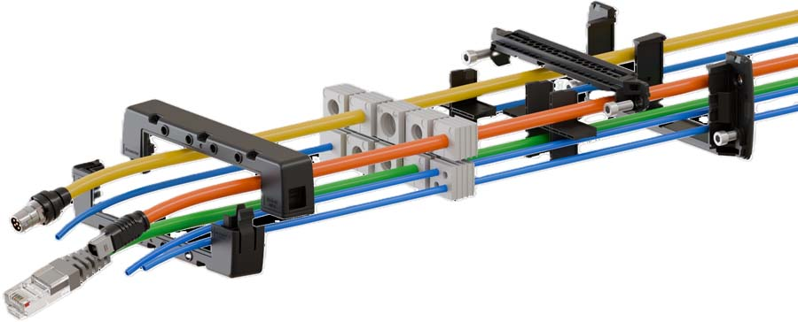
Caption: KDSI-SR-G cable entries can be installed from the outside to the inside of a housing and can also be pre-assembled externally for maximum flexibility

Innovative cable management solutions
Conta-Clip has developed the KDS cable entry systems for prefabricated and non-prefabricated cables and tubes with a special focus on tight sealing, good handling, modularity, variability and flexibility. KDS comprises various frame geometries, inlay sizes and sealing elements to meet different requirements. Depending on their needs, users have a choice of different shapes and installation methods. The common parts principle facilitates warehousing.

Image/s: | kdsi-sr-g | Characters: | 2010
File name: | 202411013_pm_kdsi-sr-g_cable_entry_en | Date: | 04-08-2025
Tags: | cable management, modular cable entry, cable entries, screwless, IP66
About CONTA-CLIP
CONTA-CLIP is one of Europe’s leading manufacturers of electrical and electronic connection elements and cable management solutions. Based in Hövelhof, Germany, the medium-sized, family-run company has been producing electric and electronic connection systems for the process and automation industries since 1978. CONTA-CLIP supplies all industry sectors, focusing on railroad industries, shipbuilding, building automation, conveyor technology, machine and plant engineering and construction, instrumentation and control technology, control panel manufacturing, transformer manufacturing, and environmental technology. The company consists of many specialized branches: CONTA-CONNECT for electric connection technology, CONTA-CABLE for cable management systems, CONTA-ELECTRONICS for electronics and CONTA-CON for PCB edge connectors. Additionally, CONTA-CLIP provides services such as customizing housings and mounting rails, labeling and supplying user-specific electronic components.
Contact:  CONTA-CLIP  Verbindungstechnik GmbH  Christian Quade  Otto-Hahn-Str. 7  33161 Hövelhof  Germany  Phone: +49 . 5257 . 9833 - 172  Email: christian.quade@conta-clip.de  Internet: www.conta-clip.com |  | gii die Presse-Agentur GmbH  Christburger Str. 41  10405 Berlin  Germany  Phone: +49 . 30 . 538 965 - 0  Email: info@gii.de  Internet: www.gii.de

