Press Release

Quick, safe and reliable:
Terminal blocks with push-in connection

The range of terminal blocks with push-in connection from Conta-Clip includes feed-through, protective earth, transformer, fuse, multi-level, motor connection and initiator terminals in a wide variety for conductor cross-sections from 0.25 mm² to 25 mm² as well as comprehensive accessories. The extensive portfolio boasts a number of design improvements on conventional push-in terminals and satisfies even very demanding requirements regarding ease of use and mechanical robustness. The push-in connection allows for safe, tool-less insertion of rigid wires or wires with ferrules and significantly reduces the time spent on wiring.

Portfolio
The feed-through and protective earth terminals of the PRK and PSL series are available in six nominal cross-section ranges: 1.5 mm², 2.5 mm², 4 mm², 6 mm², 10 mm² and 16 mm². PRK feed-through and PSL protective earth terminals have two, three or four connections and are suitable for conductor cross-sections from 0.25 mm² to 25 mm². The two-level versions PRKD and PSLD are available with the nominal cross-section ranges 2.5 mm² and 4 mm². Conta-Clip offers eight variants of PIKD three-level initiator terminals and PVMAK motor connection terminals with a nominal cross-section of 2.5 mm². The transformer and transformer fuse terminals of the PTKS series are available with a nominal cross-section of 4 mm².

Push it!
The tool-less push-in connection is a perfect example of the ease of use as well as time and cost savings Conta-Clip is known for. The integrated pusher for quickly releasing inserted wires requires only light pressure and no special tools, yet provides high contact force for the push-in spring. The push-in spring for the conductor connection is held securely by the busbar. Accidental insertion of conductors in the wrong channel is ruled out by the clear separation of insertion channels and pushers, thus ensuring correct connection and reliable contacting. The completely new internal layout with large contact surfaces and fixed metal parts ensures high current-carrying capacity with low temperature rise, mechanical robustness and an absolutely secure fit of the compact terminals on the mounting rail. All potentials have a test point for easy measurement.

In detail
The protective earth terminals have screwless clip-on foot contacts on both sides to ensure maximum electrical and mechanical reliability. In addition, Conta-Clip offers the plug-in cross-connection system PQI for quick and convenient potential distribution. In the case of the standard terminals with nominal cross-sections between 1.5 mm² and 10 mm², two potentials can also be routed within the two cross-connection channels. The group 1 insulating materials are all made of polyamide PA 6.6 and free of harmful substances such as halogen or phosphorus. They meet the fire classification “V-0 self-extinguishing” according to UL 94, have a tracking resistance above CTI 600 and are temperature-resistant from -40 °C to 120 °C. There are three marking options per terminal, allowing for clear labeling with various marking systems.

Accessories
Conta-Clip offers users an effective and complete terminal portfolio with a comprehensive range of accessories. This includes mounting rails, end supports and brackets, group shield holders, assembly tools for screws, end plates, cross connections, terminal markers and test plugs.

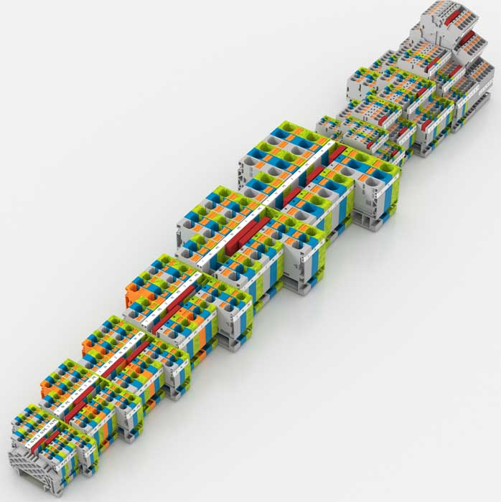
Caption: Conta-Clip offers a comprehensive terminal range with easy, time-saving push-in connection

Image/s: | PRK_gesamt_Klemmleiste | Characters: | 3363
File name: | 202411014_pm_prk_terminal_range_en | Date: | 03-11-2025
Tags: | terminal blocks, push-in connection, feed-through, protective earth terminals, initiator terminals, motor connection terminals, transformer fuse terminals, wiring
About CONTA-CLIP
CONTA-CLIP is one of Europe’s leading manufacturers of electrical and electronic connection elements and cable management solutions. Based in Hövelhof, Germany, the medium-sized, family-run company has been producing electric and electronic connection systems for the process and automation industries since 1978. CONTA-CLIP supplies all industry sectors, focusing on railroad industries, shipbuilding, building automation, conveyor technology, machine and plant engineering and construction, instrumentation and control technology, control panel manufacturing, transformer manufacturing, and environmental technology. The company consists of many specialized branches: CONTA-CONNECT for electric connection technology, CONTA-CABLE for cable management systems, CONTA-ELECTRONICS for electronics and CONTA-CON for PCB edge connectors. Additionally, CONTA-CLIP provides services such as customizing housings and mounting rails, labeling and supplying user-specific electronic components.
Contact:  CONTA-CLIP  Verbindungstechnik GmbH  Christian Quade  Otto-Hahn-Str. 7  33161 Hövelhof  Germany  Phone: +49 . 5257 . 9833 - 172  Email: christian.quade@conta-clip.de  Internet: www.conta-clip.com |  | gii die Presse-Agentur GmbH  Christburger Str. 41  10405 Berlin  Germany  Phone: +49 . 30 . 538 965 - 0  Email: info@gii.de  Internet: www.gii.de

