Press Release

New safety tester with DC high-voltage testing

Gossen Metrawatt has launched a new safety tester for testing the electrical safety of devices in the manufacturing process and after repair. SECUTEST ST PRIME offers all necessary measurement and test functions for standard-compliant testing of the effectiveness of protective measures for electrical devices. As a new highlight, it enables high-voltage testing with up to 6 kV DC for use in the production of electrical equipment. The functional range includes measurement of protective conductor resistance, insulation resistance, various leakage currents as well as safety extra-low voltage (SELV and PELV). The tester measures the time-to-trip of portable residual current devices (PRCDs) and performs function tests of U, I, P, S, LF and f as well as cable tests for continuity, short circuits and polarity by means of test adapters. In addition to the standard-compliant testing of electrical equipment according to DIN VDE 0701 (EN 50678) / DIN VDE 0702 (EN 50699), including extension cables and PRCDs, the SECUTEST ST PRIME enables the testing of medical electrical equipment according to DIN VDE 0751-1 (IEC/EN 62353) and arc welding equipment according to DIN VDE 0544-4 (IEC/EN 60974-4).

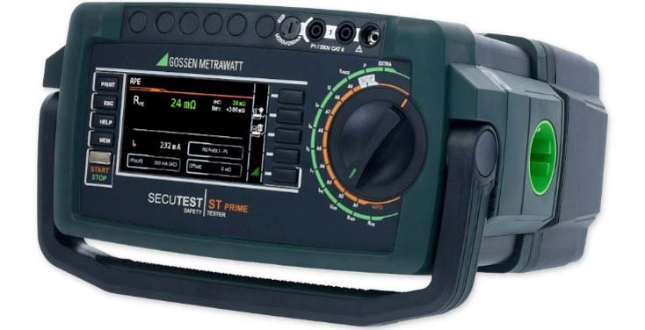
Caption: The new SECUTEST ST PRIME offers DC high-voltage testing in addition to all necessary measurement functions for electrical safety tests

Users can perform routine tests of electrical equipment under the safety requirements for measuring, control and laboratory equipment in accordance with IEC 61010 and for electrical household appliances in accordance with IEC 60335. Audio, video and information technology devices can be tested according to IEC 62911 and equipment for audio/video, information and communication technology according to IEC 62368. Automatic as well as individual test sequences contribute to an effective and safe test practice. A practical rotary switch, direct selection buttons and soft keys ensure quick, intuitive access to all test functions. A high-resolution, 4.3″ color TFT display is used for visualization. Multiple measurements enable convenient documentation of several measuring points. The device memory can store up to 50,000 data records for automatic test sequences and individual measurements. Furthermore, the tester is equipped with a USB interface for bidirectional data transfer and, optionally, with direct remote control. For international use, numerous settings for language, keyboard layout, character set, date and time format as well as country-specific test socket configurations are included in the device. Upon request, the manufacturer configures the tester with a connection for an external HV test pistol for measurements at electrical components or between two freely selectable test points.

Image/s: | secutest-st-prime_2000.jpg | Characters: | 2610
File name: | 202411018_pm_secutest_st_prime_en | Date: | 11-05-2024
Tags: | Gossen Metrawatt, GMC-Instruments, SECUTEST ST PRIME, safety tester, electrical safety, high-voltage testing, DIN VDE 0701, EN 50678, DIN VDE 0702, EN 50699, DIN VDE 0751-1, IEC/EN 62353, DIN VDE 0544-4, IEC/EN 60974-4, IEC 61010, IEC 60335
About Gossen Metrawatt
Gossen Metrawatt, one of the world’s leading suppliers of measurement systems, develops and distributes a wide range of high-quality measuring and test devices for electrical trade, various industries and the public sector.
The Gossen Metrawatt brand has been synonymous with safety and quality “Made in Germany” for decades. Its product range includes measurement and test technology for the electrical safety of plants, devices and machines as well as for the e-mobility and medical technology industries. Additional key areas of interest are power quality, battery testing technology, multimeters, calibrators, power supply technology and energy management systems. For a truly comprehensive electrical safety portfolio, Gossen Metrawatt also offers a continuously growing range of digital services and cloud services and supports its customers with a versatile training program and a wide range of after-sales services.
Gossen Metrawatt is part of the GMC Instruments Group, which also includes other specialized manufacturers for measurement and testing technology – notably, Camille Bauer Metrawatt, Dranetz, Prosys, Seaward and Rigel and Kurth Electronic. The Camille Bauer and Rigel brands add to the portfolio various transducers, display instruments and detection systems for heavy-current engineering as well as special measuring, testing and functional testing devices for the medical sector. The GMC-I Group runs its own DAkkS-certified calibration center that performs DAkkS, ISO and factory calibrations for virtually all electrical measured quantities. The GMC-I Group has development and production sites in Germany, Switzerland, England and the USA and a worldwide sales network of its own companies as well as sales partners.
Contact:  Gossen Metrawatt GmbH  Christian Widder  Head of Marketing Communication  Suedwestpark 15  90449 Nuremberg  Germany  Phone: +49 . 911 . 8602-572  Email: christian.widder@gossenmetrawatt.com  Internet: www.gossenmetrawatt.com |  | gii die Presse-Agentur GmbH  Christburger Str. 41  10405 Berlin  Germany  Tel.: +49 . 30 . 538 9650  Email: info@gii.de  Internet: www.gii.de

