Press Release

Proximity switches with enhanced resistance to water vapor

EGE-Elektronik offers robust inductive proximity switches that are resistant to high-pressure cleaning and water vapor. The IGMW series was specifically designed for use in processes with regular high-pressure cleaning as well as in washing bays and cooking processes. The climate-change-resistant, specially sealed sensors have a stainless-steel housing and a PTFE cap and are suitable for food processes. Featuring an IP68/IP69k rating, they can withstand both submersion and repeated high-pressure cleaning with water or steam. The sensors operate reliably at ambient temperatures between -25 °C and 120 °C, even with frequent temperature fluctuations combined with high humidity. They are available in M12, M18 and M30 designs with a 2-meter FEP cable and in customized designs.

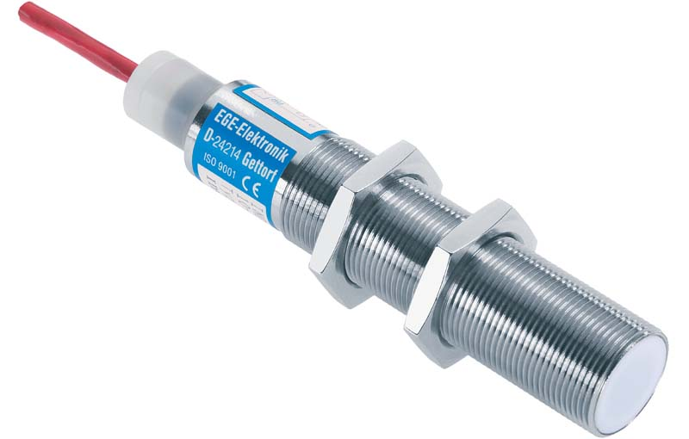
Caption: The specially sealed IGMW proximity switches are water vapor resistant and climatic proofed and withstand regular high-pressure cleaning

EGE also supplies climatic proofed inductive proximity switches for cleaning processes, washing bays, food and paper manufacturing processes (IGMF tropical series) and applications where sensors are repeatedly flushed with roller emulsion (IGFW, INFW). The series has proven itself for over 40 years and has been constantly improved and adapted. For example, the manufacturer has recently added a sensor in M8 design with an increased sensing distance (IGMF 202 GSP). The proximity switches withstand frequent temperature changes, flooding, vibrations and high-pressure cleaning without any problems. Their chemical resistance and tightness exceed the requirements in industry standards.

More information about IGMW proximity switches with increased resistance to water vapor: https://www.ege-elektronik.com/products/inductive-proximity-switches/specially-sealed-sensors-climatic-proofed-for-use-in-a-temperature-range-up-to-120c/igmw

Image/s: | igmw_m18_proximity_switch | Characters: | 1469
File name: | 202411019_pm_igmw_proximity_switches_en | Date: | 02-17-2025
Tags: | proximity switches, sensors, water vapor resistant, climatic proofed, high-pressure cleaning, suitable for food processes, customized
About EGE
EGE-Elektronik Spezial-Sensoren GmbH has been developing and manufacturing special purpose sensors for automation applications since 1976. The company serves leading international producers from a wide range of industries. Its product portfolio includes flow controllers, infrared, opto and ultrasonic sensors, capacitive proximity switches, light barriers and inductive proximity switches. EGE also provides sensors for highly sensitive applications, e.g. hazardous areas. The development department's highly qualified staff cooperates closely with all customers, ensuring continuous product updates and enhancement. A total of 130 employees, including 20 engineers and technicians, generate gross sales of approx. 19.5 million Euros worldwide.
Contact:  EGE-Elektronik Spezial-Sensoren GmbH  Sven-Eric Hiss  Ravensberg 34  24214 Gettorf  Germany  Phone: +49 4346 4158-0  Email: info@ege-elektronik.com  Internet: www.ege-elektronik.com |  | gii die Presse-Agentur GmbH  Christburger Str. 41  10405 Berlin  Germany  Phone: +49 30 538 965-0  Email: info@gii.de  Internet: www.gii.de

