Press Release

Explosion-proof compressor motor for oil refinery

Producing a customized explosion-proof high-voltage motor within just 12 calendar days, Menzel Elektromotoren saved an oil refinery a considerable amount of money. The failure of the previously installed compressor motor was causing enormous financial damage. The team of the German family business Menzel worked on this project with considerable commitment, including weekend shifts, and thus completed all necessary works in record time. An in-stock MEBKSW-type three-phase squirrel-cage induction motor in size 710 was enabled for ignition protection type Ex ec, increased safety, with purging. Menzel’s certified explosion protection experts gave it the ATEX marking II 3G Ex ec IIA T3 Gc and prepared the extensive documentation required by the customer within the tight time frame. The motor generates an output of 10 MW and 64132 Nm rated torque at 6600 V rated voltage. It features IP55 protection and IC 81W cooling (air-to-water heat exchanger) and is suitable for outdoor installation and the increased ambient temperature range of -20 °C ... 48 °C. To ensure a smooth installation in the existing plant environment, Menzel made various mechanical adaptations such as machining the motor shaft, manufacturing a new base frame and providing flanges for the purging device.
More about electric motors with ignition protection type Ex ec, increased safety: https://www.menzel-motors.com/ex-na/

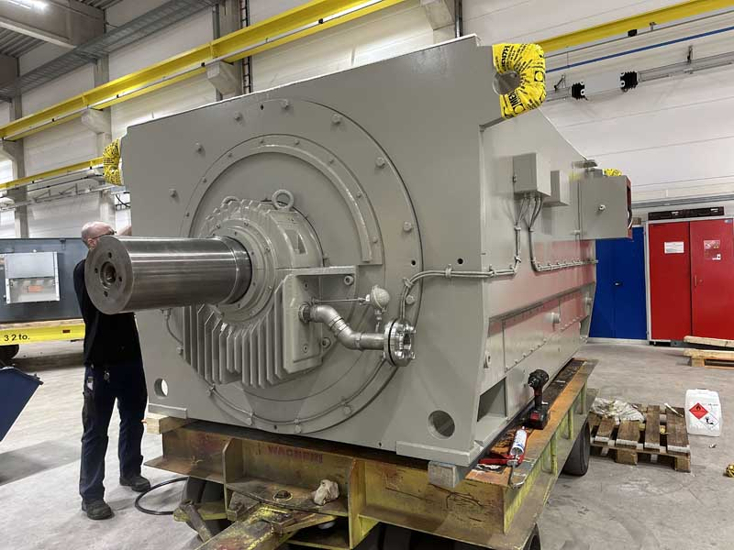
Caption: The family-run motor manufacturer Menzel completed the explosion-proof compressor motor in just 12 calendar days

Image/s: | 10-mw_ex_ec_compressor_motor | Characters: | 1282
File name: | 202412008_pm_ex_ec_compressor_motor_en | Date: | 02-12-2025
Tags: | explosion-proof, Ex ec, increased safety, compressor motor, high-voltage motor, squirrel-cage induction motor, oil refinery
About Menzel Elektromotoren
Menzel Elektromotoren GmbH has been manufacturing and distributing electric motors since 1927. The German family-run company based in Hennigsdorf near Berlin specializes in the delivery of large electric motors, including special models, within the shortest time possible. The product range comprises high and low voltage motors, DC motors, transformers, and frequency inverters. Services include motor production up to and beyond 25 MW and short-term adaptation of stock motors to application-specific requirements. In order to ensure short delivery times, Menzel maintains a large inventory with over 20,000 motors up to 15 MW. Qualified engineering, experienced staff, and state-of-the-art production and testing facilities help the manufacturer provide excellent reliability. Menzel operates subsidiaries in the UK, France, Italy, Spain, and Sweden, and cooperates with numerous partners worldwide.
Contact:  Menzel Elektromotoren GmbH  Anja Leipold  Corporate Communications  Am Alten Walzwerk 2  16761 Hennigsdorf  Germany  Phone: +49 30 349 922-0  Email: info@menzel-motors.com  Internet: www.menzel-motors.com |  | gii die Presse-Agentur GmbH  Christburger Str. 41  10405 Berlin  Germany  Phone: +49 30 538 965-0  Email: info@gii.de  Internet: www.gii.de

