Press Release

Menzel’s largest low-voltage motor at 20 tons

Menzel Elektromotoren has delivered its largest low-voltage motor to date – it weighs a total of 19800 kg. The motor drives a cooling water pump in a combined heat and power plant in Venice. Previously, several motors had failed in a short time in this application, probably due to unsuitable designs. Menzel customized its new motor specifically for the pump application and proved in load tests that it provides the required output power at the various load points. The MEBKSL-type three-phase squirrel-cage motor is designed as a vertical motor in construction type IM 3011 (IM V1) with a 710 mm shaft height. It boasts 650 kW rated power, 690 V rated voltage and 16731 Nm rated torque.

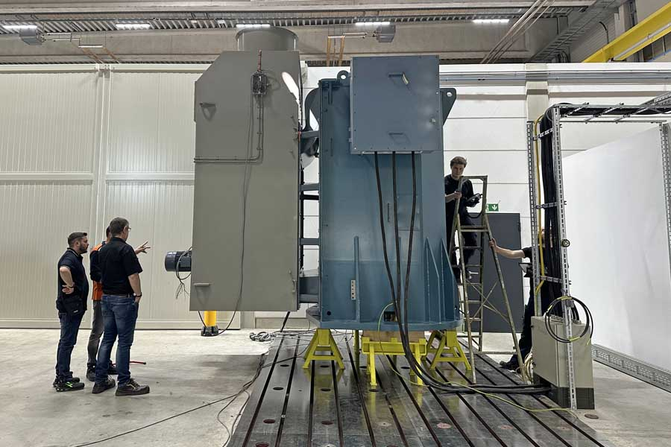
Caption: Menzel Elektromotoren has manufactured its largest low-voltage motor to date: a 20-ton pump motor

The family-run German motor manufacturer had a suitable 12-pole converter motor with 31-Hz star winding in stock and therefore could complete the order very quickly – only seven weeks passed between first inquiry and the motor’s arrival at the installation site. The motor’s electrical data were perfectly suited to the application, needing only minor changes to the converter parameterization on site. The mechanical adjustments were all the greater. The motor’s cooling type IC 86W (water-cooled) had to be converted to IC 666 (air-cooled). Menzel built an adapter for an in-stock air cooler and modified the air flow in the motor casing. Menzel also manufactured an individual adapter flange for mounting on the pump and adapted the shaft dimensions. The pump motor features IP55 protection. In its new energy-efficient paint shop, Menzel also finished it with a special coat of paint against aggressive climatic conditions.
More about Menzel’s application-specific squirrel-cage motors: https://www.menzel-motors.com/squirrel-cage-motor/

Image/s: | cooling_water_pump_motor | Characters: | 1616
File name: | 202412009_pm_20-ton_lv_motor_en | Date: | 01-14-2025
Tags: | low-voltage motor, pump motor, vertical motor, squirrel-cage motor, converter motor, cooling water pump, combined heat and power plant
About Menzel Elektromotoren
Menzel Elektromotoren GmbH has been manufacturing and distributing electric motors since 1927. The German family-run company based in Hennigsdorf near Berlin specializes in the delivery of large electric motors, including special models, within the shortest time possible. The product range comprises high and low voltage motors, DC motors, transformers, and frequency inverters. Services include motor production up to and beyond 25 MW and short-term adaptation of stock motors to application-specific requirements. In order to ensure short delivery times, Menzel maintains a large inventory with over 20,000 motors up to 15 MW. Qualified engineering, experienced staff, and state-of-the-art production and testing facilities help the manufacturer provide excellent reliability. Menzel operates subsidiaries in the UK, France, Italy, Spain, and Sweden, and cooperates with numerous partners worldwide.
Contact:  Menzel Elektromotoren GmbH  Anja Leipold  Corporate Communications  Am Alten Walzwerk 2  16761 Hennigsdorf  Germany  Phone: +49 30 349 922-0  Email: info@menzel-motors.com  Internet: www.menzel-motors.com |  | gii die Presse-Agentur GmbH  Christburger Str. 41  10405 Berlin  Germany  Phone: +49 30 538 965-0  Email: info@gii.de  Internet: www.gii.de

