Press Release

Multifunctional control console for UNIMOG implement carriers

On behalf of Daimler Truck AG, RAFI has developed a compact control console with touchscreen and optional joystick operation for the implement carriers of the new UNIMOG model series. The variably adjustable multi-touch system for controlling attachments and the working hydraulics is now in series production. The core of the control system is the ergonomic center console with integrated switching elements, which can be optimally positioned for various operating scenarios, including a driver seat side change in conjunction with a switchable steering system. Easily customizable function keys allow for convenient access to commonly used features and the ability to flexibly adjust control options to various attachable and mountable implements. In addition to up to four linear joysticks with capacitive finger detection for controlling the working hydraulics, the console also features additional control wheels and memory key switches for operating attachable implements. Inside, a high-performance embedded control unit from RAFI’s ECU range ensures rapid signal and data communication. The 10.5" touchscreen mounted at the head end ensures user-friendly menu navigation for accessing function and status indications, as well as for configuring and customizing profiles, sequences, and operating elements using touch controls. The display can be rotated and tilted for optimal viewing and can also be folded down for storage when not in use. As an additional operating option, RAFI has designed an ergonomic joystick especially for the right hand. The new control lever, built on the JOYSCAPE joystick platform, features four splitters and wear-free 3D Hall sensors. It includes three customizable key switches, two rotary encoders, a sensor panel, and capacitive hand detection to prevent operating errors. The plug-in control lever can be positioned on the right-hand armrest of the driver or front passenger, as well as in the parking position on the storage compartment.

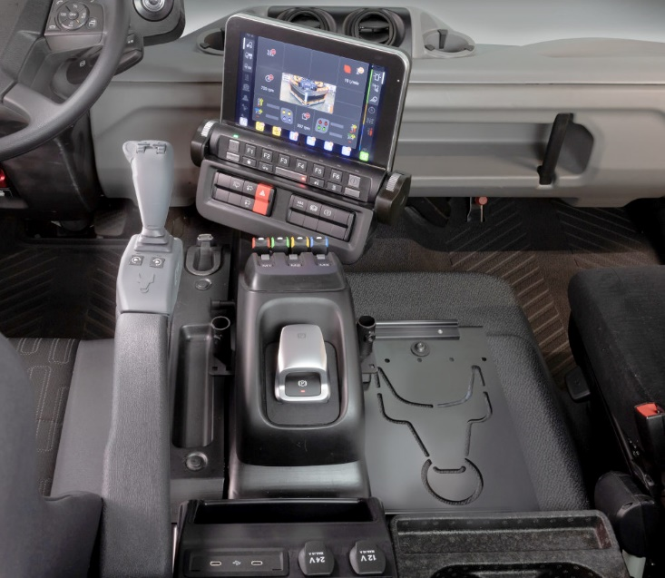

Caption: RAFI’s new Smarttouch center console featuring a touchscreen, control console, and optional multifunction joystick

Image: Daimler Truck AG

Image/s: | unimog-armrest_2000.jpg | Characters: | 1,982
File name: | 202412050_pm_unimog-konsole-en.docx | Date: | 01-07-2025
Tags: | RAFI, Daimler Truck, Unimog, HMI, control console, Embedded Control Unit, Ultimate ECU, Joyscape, Joystick, Touchscreen, multitouch system, capacitive finger detection, 3D Hall sensor

About the RAFI Group
Founded in 1900, RAFI today develops and produces electromechanical components and systems for human-machine interaction. The range of products includes key switches, switches, touchscreens, control systems, and electronic assemblies. RAFI products are employed in many industries including automation, medical technology, machine and plant engineering, road and railway vehicles, household appliances, and telecommunication. The RAFI Group operates internationally with more than 2,000 employees at sites in Germany, Europe, China, and the USA. Its headquarters are in Berg, Germany.

Contact:  RAFI GmbH & Co. KG  Fred Nemitz  Head of Corporate Marketing  Ravensburger Straße 128-134  88276 Berg  Germany  Phone: +49 160 92048569  Email: fred.nemitz@rafi-group.com  Web: www.rafi-group.com |  | gii die Presse-Agentur GmbH  Christburger Str. 41  10405 Berlin, Germany  Phone: +49 30 53 89 65-0  Email: info@gii.de  Web: www.gii.de

