Press release

RAFIX 30 FS⁺ Illuminated pushbutton with protruding cover

RAFI has extended its RAFIX 30 FS⁺ model series with an elegant, particularly flat design to include illuminated pushbuttons with a protruding bezel in six different bezel colors. Available with a stainless steel front ring, round collar and protruding translucent cover in black, white, yellow, green, blue or red, the control devices are dimensioned for installation openings of 30.3mm. With a collar diameter of 34.5mm, the actuators are suitable for a grid dimension of 35x35mm and above. The pushbutton series has IP65 protection on the front, can be used in temperature ranges from -25°C to +70°C and offers clear tactile feedback even when operated with gloves. Their durable design is designed for actuating forces of up to 100N and a service life of at least 1 million actuating cycles. The illuminated pushbuttons, which are optimized for applications in electrical engineering, industrial robotics as well as in vehicle, machine and plant construction, can be combined with PCB switching elements for PCB applications as well as with QC switching elements for classic wiring. In the PCB version, the push-buttons achieve an installation depth of just 15.7mm. The QC switching elements are connected individually via 2.8x0.8mm flat plugs with an installation depth of 31.9mm. A plug-in LED clip is used for lighting. Both switching element variants are available in versions with gold contacts for a maximum of 35V and 100mA or with silver contacts for up to 250V and 4A. MICON 5 series micro switches can also be used as switching elements using a short-stroke adapter.

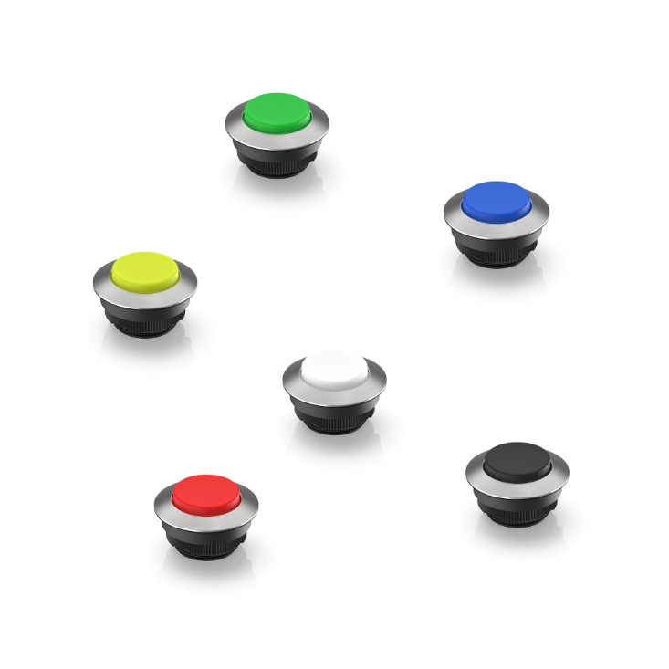
Caption: New RAFI illuminated pushbuttons from the RAFIX 30 FS⁺ series with protruding translucent cover in six different colors

Image/s: | 30fs_blendevorstehend_2000.jpg | Characters: | 1,580
File name: | 202502010_pm_leuchtdrucktaster_en.docx | Date: | 04-08-2025
Tags: | RAFI, RAFIX 30FS, illuminated pushbutton, actuator, MICON 5

About the RAFI group
Founded in 1900, the company develops and produces electromechanical components and systems for human-machine communication. These include buttons, switches, touchscreens and operating systems as well as electronic assemblies. RAFI products are employed in many industries including automation, medical technology, machine and plant engineering, road and railway vehicles, household appliances and telecommunication. The RAFI group operates internationally with more than 2,000 employees at sites in Germany, Europe, China, and the USA. The headquarters of the RAFI Group is located in Berg near Ravensburg.

Contact:
RAFI GmbH & Co. KG

Patrick Müller
Product Marketing Manager

Ravensburger Straße 128-134
88276 Berg
Germany

Phone: +49 751 89-1634
Email: patrick.mueller@rafi-group.com
Web: www.rafi-group.com

