Press release

RAFIX key-operated switches in E2, E7 and E22 versions

RAFI is expanding its RAFIX 22 FS⁺ control device series with three new key-operated switches in E2, E7 and E22 versions. The latching key switches, which are dimensioned for installation openings with a diameter of 22.3 mm, are supplied as standard in a dark gray housing and with a round collar. All three versions have a locking mechanism with a 90° angle of rotation at trigger position 0. In addition to PCB contacting with an installation depth of just 9.2 mm, the tool-free QC plug-in connection for wired solutions is also available as a connection option. Switching elements with silver contacts up to 250V / 4A or gold contacts up to 35V / 100mA can be used for contacting. Designed for a service life of 30,000 to 43,000 switching cycles, the key switches offer IP65 on the front and are approved for operating temperatures between -25°C and +70°C. The keys are not included in the scope of delivery.

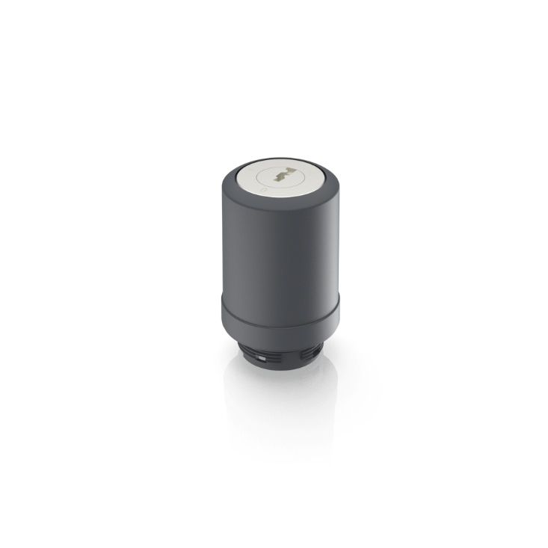
Caption: Latching key-operated switches in E2, E7 and E22 format with a locking mechanism for PCB or tool-free plug-in contacting

Image/s: | rafix22fs_schluesselschalter_2000.jpg | Characters: | 910
File name: | 202502011_pm_rafix22-schlueschalter_en.docx | Date: | 03-11-2025
Tags: | RAFI, RAFIX, RAFIX 22FS, latching key switch, key-operated switch

About the RAFI group
Founded in 1900, the company develops and produces electromechanical components and systems for human-machine communication. These include buttons, switches, touchscreens and operating systems as well as electronic assemblies. RAFI products are employed in many industries including automation, medical technology, machine and plant engineering, road and railway vehicles, household appliances and telecommunication. The RAFI group operates internationally with more than 2,000 employees at sites in Germany, Europe, China, and the USA. The headquarters of the RAFI Group is located in Berg near Ravensburg.

Contact:
RAFI GmbH & Co. KG

Patrick Müller
Product Marketing Manager

Ravensburger Straße 128-134
88276 Berg
Germany

Phone: +49 751 89-1634
Email: patrick.mueller@rafi-group.com
Web: www.rafi-group.com

