Press Release

Intra-logistics innovations at Chicago PROMAT 2025

At the PROMAT tradeshow in Chicago from March 17 to 20, the German intra-logistics specialist LOSYCO (North Hall, Booth N6054) will present its LOXrail system solutions for machine feeding and production and warehouse logistics on rails. LOSYCO offers the complete technology package from a single source: rail tracks, customized transport trolleys and drive, control, communication and automation technology. The functional modular system allows for adaptable, application-specific configurations. The manufacturer can implement transport concepts with different degrees of complexity, including completely automated production logistics with autonomous transport trolleys, wireless communication and induction powering. Solutions for high-precision feeding of robot cells or machine feeding are available from manually operated to fully automated solutions with integration in the plant control system. Features include aligned resting points and end position sensors. Patented AllRounder wheelsets and curve-going trolleys enable a particularly flexible line layouts with changes of direction, cornering and turning directly on the track. The LOXrail tracks, which are available in two variants, are designed for payloads up to 60 tons.

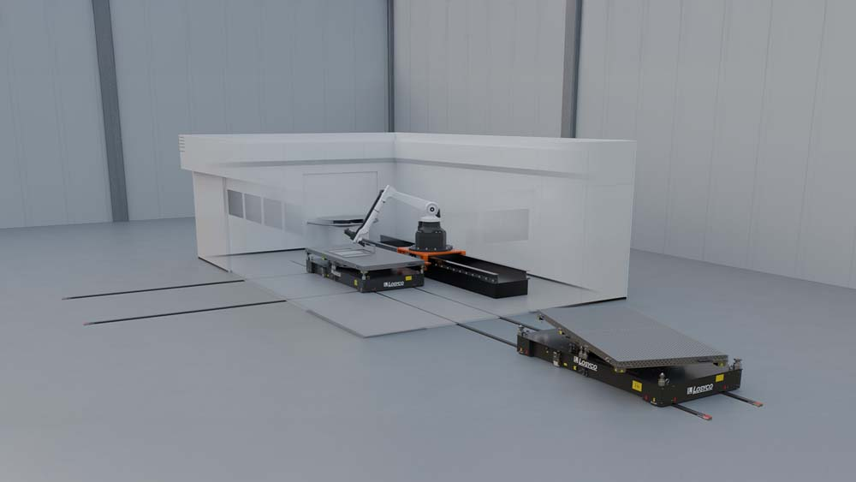
Caption 1: LOSYCO implements high-precision rail-based machine feeding systems with integration in the plant control system

Image: LOSYCO GmbH

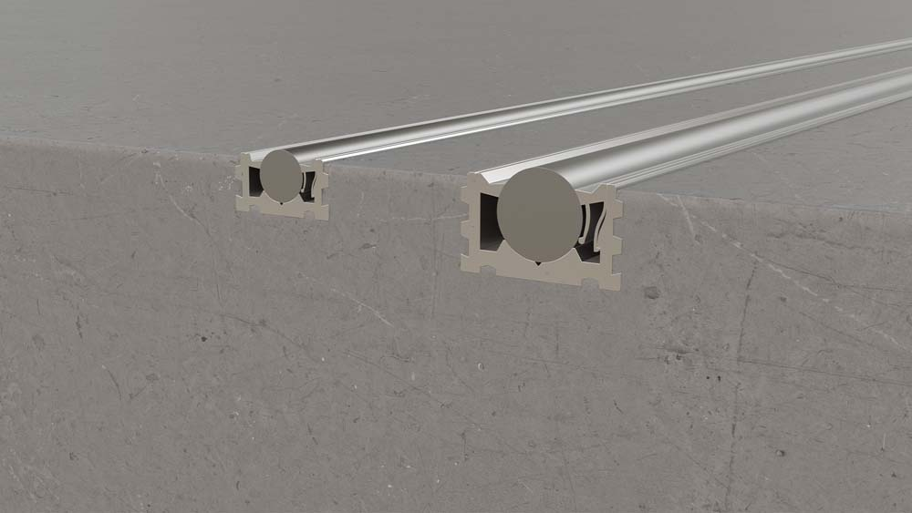
Caption 2: The floor-level LOXrail tracks are designed for easy transport of heavy loads

Image: LOSYCO GmbH

Image/s: | loxrail_beschickungssystem  loxrail_25-40_mm_querschnitt | Characters: | 1239
File name: | 202502012_pm_promat_chicago_en | Date: | 03-05-2025
Tags: | LOSYCO, Loxrail, Allrounder, Promat Chicago, tradeshow, intra-logistics
About Losyco
LOSYCO designs, builds, and installs intra-logistics systems for the manufacturing industry. The company based in Bielefeld, Germany, was founded by experienced engineers in 2016. LOSYCO’s core product is the LOXrail® floor rail system for easy transport and precise positioning of loads weighing several tons. LOXrail transport platforms can be operated manually or with auxiliary drives. LOSYCO also supplies handling equipment such as chain and roller conveyors, material management and storage systems, as well as sound-proof cabins and machine covers. LOSYCO supports customers wishing to transform their production processes to lean manufacturing and continuous flow production. LOSYCO is a member of the DRECKSHAGE Family.
Contact:  LOSYCO GmbH  Tim Schneider  Walter-Werning-Str. 7  33699 Bielefeld  Germany  Tel.: +49 . 521 . 945 643-0  Email: info@losyco.com  Internet: www.losyco.com |  | gii die Presse-Agentur GmbH  Christburger Str. 41  10405 Berlin  Germany  Tel.: +49 . 30 . 538 965-0  Email: info@gii.de  Internet: www.gii.de

