Press Release

Large robust pump motor built to withstand high operational axial thrusts for a Central American project

Menzel Elektromotoren has manufactured a large high-voltage motor in vertical construction type IM 3011 (IM V1) to drive a pump. Since the motor has to absorb high dynamic axial loads, it has a special bearing design. The upper thrust bearing is water-cooled; it runs in an oil sump and is subject to permanent oil level and temperature monitoring. The lower bearing is grease-lubricated and self-cooling. The entire motor and particularly the non-drive-end bearing plate were also reinforced for added strength. The flange and shaft dimensions were required to comply with exacting specifications. At the customer’s request, Menzel also configured the pump connection flange, with recesses through which the condition of the coupling can be checked at any time. The MEBKSL-type squirrel cage motor features 1100 kW rated power, 4160 V rated voltage and a rated torque of 20598 Nm at a speed of 509 rpm. It features an IP55 rating and IC 611 cooling, with a two-part air-to-air heat exchanger fitted on both sides of the motor for uniform cooling at Central American ambient temperatures.
More reference projects for large pump motors:
https://www.menzel-motors.com/pump-drive/

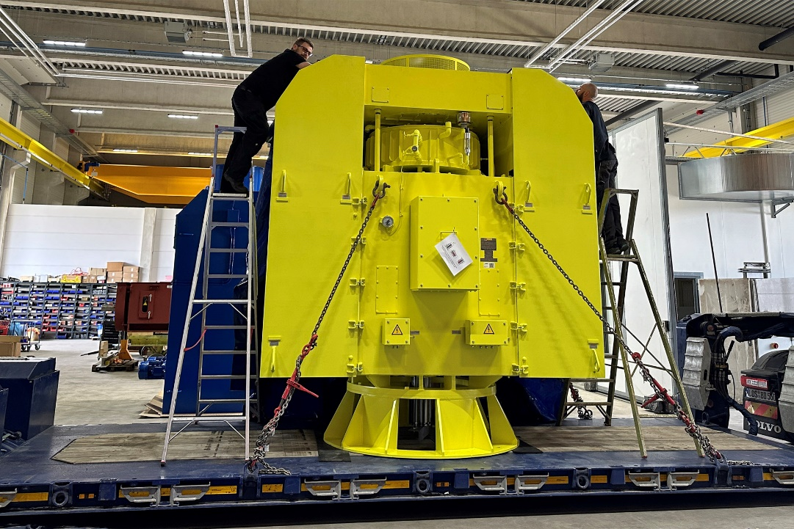
Caption: The vertical motor also supports the weight of the driven pump and therefore features an especially robust design

Image/s: | pump_motor_mebksl630-14_ic611 | Characters: | 1088
File name: | 202503002_pm_vertical_pump_motor_en | Date: | 03-11-2025
Tags: | pump motor, high-voltage motor, vertical motor, squirrel cage motor
About Menzel Elektromotoren
Menzel Elektromotoren GmbH has been manufacturing and distributing electric motors since 1927. The German family-run company based in Hennigsdorf near Berlin specializes in the delivery of large electric motors, including special models, within the shortest time possible. The product range comprises high and low voltage motors, DC motors, transformers, and frequency inverters. Services include motor production up to and beyond 25 MW and short-term adaptation of stock motors to application-specific requirements. In order to ensure short delivery times, Menzel maintains a large inventory with over 20,000 motors up to 15 MW. Qualified engineering, experienced staff, and state-of-the-art production and testing facilities help the manufacturer provide excellent reliability. Menzel operates subsidiaries in the UK, France, Italy, Spain, and Sweden, and cooperates with numerous partners worldwide.
Contact:  Menzel Elektromotoren GmbH  Anja Leipold  Corporate Communications  Am Alten Walzwerk 2  16761 Hennigsdorf  Germany  Phone: +49 30 349 922-0  Email: info@menzel-motors.com  Internet: www.menzel-motors.com |  | gii die Presse-Agentur GmbH  Christburger Str. 41  10405 Berlin  Germany  Phone: +49 30 538 965-0  Email: info@gii.de  Internet: www.gii.de

