Press Release

Customized special sensors made in Germany

Even the largest sensor program cannot cover every particular need. Therefore, EGE-Elektronik flexibly answers a wide range of customer demands – from branded OEM versions to special materials for aggressive media and processes with high-pressure cleaning. The German company is established as a manufacturer of durable, precise sensors for extreme ambient conditions. Thanks to a high level of vertical integration and profound application know-how, the company can fulfill most requests quickly and at manageable costs, even in small production runs. This includes various certifications and approvals such as DNV (formerly Germanischer Lloyd), UL or 3-A. The portfolio includes measurement technology for flow monitoring and level and object detection. Virtually all sensor properties can be adapted to specific applications: measured value output, sensitivity, probe length, process and communication interfaces, connectors, cable length and material – such as oil-resistant, flame-retardant and halogen-free cables, silicone cables, shielded cables or cables with reinforced mechanical protection.

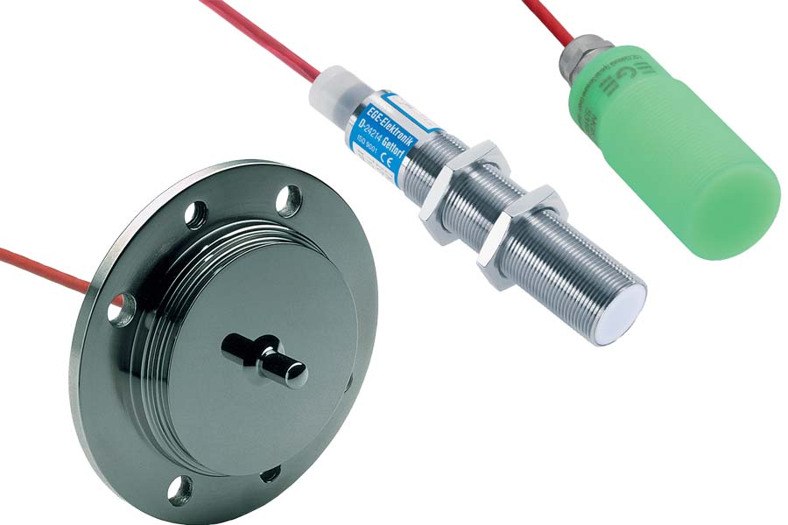
Caption: EGE tailors high-performance special sensors to particular applications – and to the customer’s budget (examples pictured: flow sensor, proximity switch, magnetic sensor)

The housing design and cable position can be adapted to installation sites with limited space. EGE also offers bespoke designs for extended temperature ranges and demanding environmental conditions. The manufacturer uses high-quality materials for sensors and gaskets and adapts them to particular media and processes. If required, special materials and coatings with high strength, corrosion resistance, chemical resistance, thermal shock resistance and permanent resistance to extreme temperatures are used. The sensors monitor various media. Data sheets provide information on sensor performance in representative media such as water or oil. On request, the manufacturer will test sensors with customer-specific media. Furthermore, EGE can implement tamper-proof measuring points, on-site measured value displays and remote parameterization solutions. 100 % of the production takes place in Germany.

Learn more and start an inquiry:
https://www.ege-elektronik.com/products/customer-specific-solutions/

Image/s: | flow_sensor__proximity_switch__magnetic_sensor_cryo |  | Characters: | 2000
File name: | 202503018_pm_special_sensors_en |  | Date: | 03-28-2025
Tags: | special sensors, customized, flow monitoring, level detection, object detection, aggressive media, high-pressure cleaning, corrosion resistance, chemical resistance, thermal shock resistance, extreme temperatures
About EGE
EGE-Elektronik Spezial-Sensoren GmbH has been developing and manufacturing special purpose sensors for automation applications since 1976. The company serves leading international producers from a wide range of industries. Its product portfolio includes flow controllers, infrared, opto and ultrasonic sensors, capacitive proximity switches, light barriers and inductive proximity switches. EGE also provides sensors for highly sensitive applications, e.g. hazardous areas. The development department's highly qualified staff cooperates closely with all customers, ensuring continuous product updates and enhancement. A total of 130 employees, including 20 engineers and technicians, generate gross sales of approx. 19.5 million Euros worldwide.
Contact:  EGE-Elektronik Spezial-Sensoren GmbH  Sven-Eric Hiss  Ravensberg 34  24214 Gettorf  Germany  Phone: +49 4346 4158-0  Email: info@ege-elektronik.com  Internet: www.ege-elektronik.com |  | gii die Presse-Agentur GmbH  Christburger Str. 41  10405 Berlin  Germany  Phone: +49 30 538 965-0  Email: info@gii.de  Internet: www.gii.de

