Press Release

Rugged level sensors for hazardous areas up to 180 °C

EGE-Elektronik manufactures intrinsically safe capacitive level controllers for hazardous areas with potentially explosive gas atmospheres. The compact KGFTa-series sensors feature a high temperature stability of -20 °C to 180 °C. They have the ATEX and IECEx approvals for installation in zone 0 and in partition walls between zone 0 and zone 1. The KKa 030 Ex external amplifier, which is also approved for zone 0 and zone 1, enables remote parameterization outside the high-temperature area. The system consisting of KGFTa and KKa 030 is connected to an IKMb 123... analysis device, which provides an intrinsically safe power supply. The series includes sensors with G1/4 and G1/2 threads. The level controllers made of stainless steel 1.4571 feature IP68 protection, a PEEK measuring tip and a PTFE cable. They are therefore also suitable for monitoring aggressive media. Typical applications include level monitoring of process fluids in chemical and pharmaceutical production.
More about capacitive level sensors for hazardous areas:
https://www.ege-elektronik.com/products/fill-level-sensors/capacitive-level-switches-for-hazardous-areas-high-temperature/

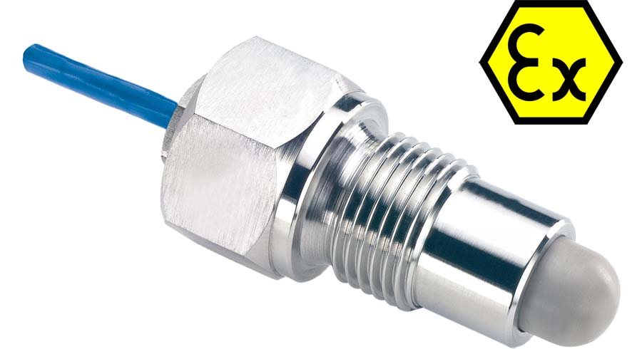
Caption: Level sensors from EGE designed for high temperatures monitor fill levels of tanks and containers in areas with gas hazards

Image/s: | kgfta_150_ex_p21244_ex_label | Characters: | 982
File name: | 202503019_pm_kgfta_ex_level_sensors_en | Date: | 05-06-2025
Tags: | level sensors, level controllers, intrinsically safe, capacitive, ATEX, IECEx, zone 0, zone 1, gas hazards, explosive, gas atmospheres, high temperature, chemical, pharmaceutical
About EGE
EGE-Elektronik Spezial-Sensoren GmbH has been developing and manufacturing special purpose sensors for automation applications since 1976. The company serves leading international producers from a wide range of industries. Its product portfolio includes flow controllers, infrared, opto and ultrasonic sensors, capacitive proximity switches, light barriers and inductive proximity switches. EGE also provides sensors for highly sensitive applications, e.g. hazardous areas. The development department's highly qualified staff cooperates closely with all customers, ensuring continuous product updates and enhancement. A total of 130 employees, including 20 engineers and technicians, generate gross sales of approx. 19.5 million Euros worldwide.
Contact:  EGE-Elektronik Spezial-Sensoren GmbH  Sven-Eric Hiss  Ravensberg 34  24214 Gettorf  Germany  Phone: +49 4346 4158-0  Email: info@ege-elektronik.com  Internet: www.ege-elektronik.com |  | gii die Presse-Agentur GmbH  Christburger Str. 41  10405 Berlin  Germany  Phone: +49 30 538 965-0  Email: info@gii.de  Internet: www.gii.de

