Press Release

bauma tradeshow: SAB Bröckskes presents high-voltage cables and measurement technology

The German special cable manufacturer SAB Bröckskes will present wiring solutions for construction machinery and agricultural and special vehicles at the bauma trade fair in Munich, Germany, 7 to 13 April 2025, at booth A2-441A. The exhibition shines a spotlight on double EMC-shielded high-voltage (HV) cables from the HV 1000 C series with single core (SC) and multi-core (MC) versions. The HV 1000 C SC line is ideal, amongst others, for the electrical connection of inverters and electric motors and includes nine sizes with nominal cross-sections from 4 mm² to 95 mm². The MC range comes in versions from 2 x 4.00 mm² to 5 x 6.00 mm² with applications as connecting cables to the cabin heating, the electric compressor or the HV heat pump in electric and hybrid vehicles, for example. The SC and MC cables feature high mechanical strength and resistance to environmental influences as well as very good oil and temperature resistance from -50 °C to 90 °C. The extremely tensile, abrasion and shear-resistant outer sheaths enable tight bending radii. The portfolio provides high robustness by default, with flame-retardant and self-extinguishing materials in accordance with IEC 60332-1-2 as well as high mud, UV, ozone and salt water resistance. In addition to the standard versions, SAB Bröckskes also manufactures other cross-sections and sheaths in other colors and assembles cables with matching connectors on request. The offer for HV measurement technology includes connection cables for acceleration sensors (IEPE) and strain gauges, HV measuring cables for DC and AC voltage measurement as well as highly flexible HV cables for temperature measurement. The overall portfolio furthermore includes type K single- and multi-channel HV sensors, Pt100/Pt1000 HV sensors and HV test adapters. In addition, SAB Bröckskes and its technology partner CSM have developed measurement modules for the safe testing of HV components in vehicles and test benches.

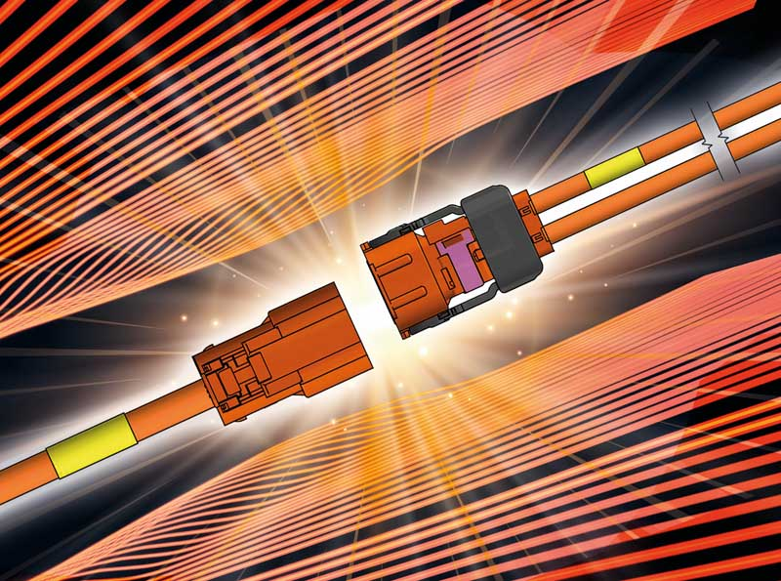
Caption 1: SAB Bröckskes manufactures robust, process-reliable high-voltage cables for mobile machinery, on request also with customized assembly

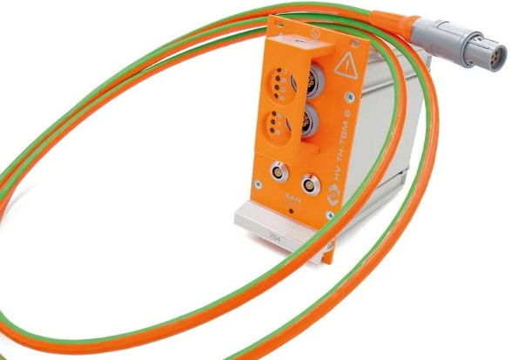
Caption 2: Measurement module for the safe testing of high-voltage components in vehicles and test benches

Image/s: | HV_Kabel_konfektioniert_2000.jpg  csm-messmodul_2000.jpg | Characters: | 1960
File name: | 202504010_pm_bauma_preview_en | Date: | 04-03-2025
Tags: | SAB Bröckskes, special cable, HV cables, HV measuring cables, HV 1000 C, high-voltage, voltage measurement, construction machinery, agricultural vehicles, special vehicles, mobile machinery, electric vehicles, hybrid vehicles
About SAB Bröckskes
Founded in Viersen, Germany, in 1947 by Peter Bröckskes as a one-man operation for electrical system design, SAB Bröckskes GmbH & Co. KG has grown into one of the world’s leading special cable manufacturers, now employing a staff of more than 550 who generate a turnover of over €134 million euros in over 100 countries. The portfolio includes cables and wires manufactured from a wide variety of materials as well as cable assembly and measurement solutions. All products are developed and manufactured exclusively at the Viersen headquarters. The company supplies various industries from industrial automation and communication technology to manufacturers of construction and agricultural machinery, railway and shipping technology and medical technology. SAB Bröckskes has a global presence with international subsidiaries and sales offices.
Contact:  SAB BRÖCKSKES GmbH & Co. KG  Sacir Adrovic  Grefrather Str. 204 – 212b  41749 Viersen  Germany  Phone: +49 2162 898-146  Email: s.adrovic@sab-cable.com  Internet: www.sab-cable.com |  | gii die Presse-Agentur GmbH  Christburger Str. 41  10405 Berlin  Germany  Phone: +49 30 538 965-0  Email: info@gii.de  Internet: www.gii.de

