Press Release

Mill motor for gold mine at 4200 meters high

Menzel Elektromotoren has fitted a stock motor for operation at an altitude of 4200 meters AMSL and shipped it to a gold mine in the Andes. This was an urgent order due to the failure of the existing mill motor. The new motor had to be modified so it could smoothly replace the old one. Menzel adapted the performance characteristics and cooling type to the high altitude, changing the cooling to IC 06 with external fans. The motor features a weatherproof design (IP24W / NEMA WPII). Further works included the changeover to double-delta, 4160 V, 60 Hz, shortening the NDE shaft, re-milling the drive shaft and building base plates to adapt the foot holes and shaft height to the existing connections on site. The squirrel cage motor also had to be equipped for ramp-up on a frequency converter. The motor features 2980 kW rated output, 894 rpm rated speed and a rated torque of 31833 Nm. Menzel won the contract due to its fast delivery capability. The internationally active Berlin-based manufacturer also supplies the mining industry with custom configurations of fan and conveyor motors etc. The current project came in through Menzel’s Peruvian sales partner, who also travelled to Berlin with the user for final testing and acceptance and who supervised the commissioning.
More reference projects: https://www.menzel-motors.com/mining-motors/

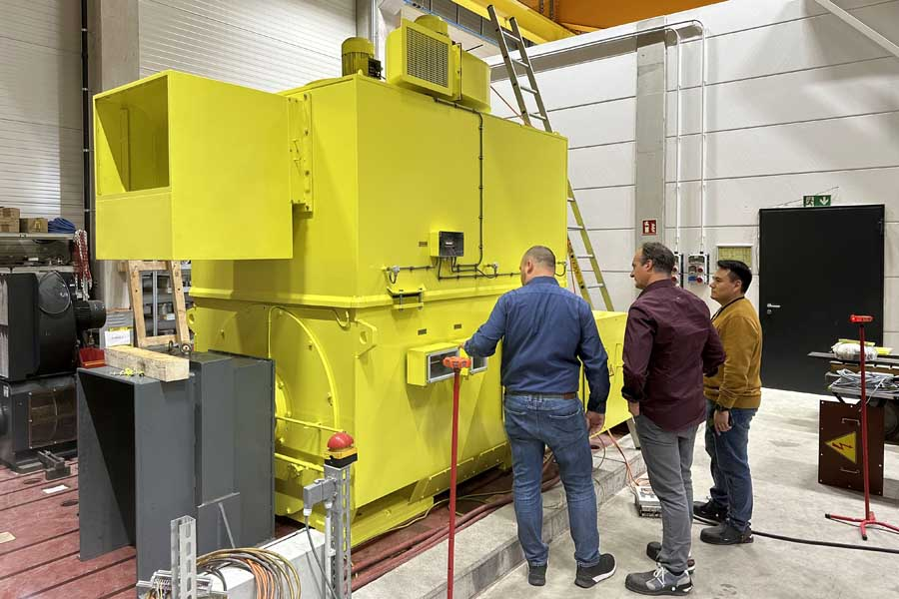
Caption: Menzel Elektromotoren thoroughly tests all motors before shipping; pictured: test engineer, sales partner and customer with the new mill motor in the load test field

Image/s: | mill_motor_peru_gold_mine | Characters: | 1279
File name: | 202504011_pm_mill_motor_gold_mine_en | Date: | 04-08-2025
Tags: | mill motor, gold mine, high altitude, mining industry, squirrel cage motor, IPW24, WPII
About Menzel Elektromotoren
Menzel Elektromotoren GmbH has been manufacturing and distributing electric motors since 1927. The German family-run company based in Hennigsdorf near Berlin specializes in the delivery of large electric motors, including special models, within the shortest time possible. The product range comprises high and low voltage motors, DC motors, transformers, and frequency inverters. Services include motor production up to and beyond 25 MW and short-term adaptation of stock motors to application-specific requirements. In order to ensure short delivery times, Menzel maintains a large inventory with over 20,000 motors up to 15 MW. Qualified engineering, experienced staff, and state-of-the-art production and testing facilities help the manufacturer provide excellent reliability. Menzel operates subsidiaries in the UK, France, Italy, Spain, Sweden, and Romania, and cooperates with numerous partners worldwide.
Contact:  Menzel Elektromotoren GmbH  Anja Leipold  Corporate Communications  Am Alten Walzwerk 2  16761 Hennigsdorf  Germany  Phone: +49 30 349 922-0  Email: info@menzel-motors.com  Internet: www.menzel-motors.com |  | gii die Presse-Agentur GmbH  Christburger Str. 41  10405 Berlin  Germany  Phone: +49 30 538 965-0  Email: info@gii.de  Internet: www.gii.de

