Press Release

Control tradeshow preview:
All-round protection for camera technology

autoVimation showcases its products for the effective protection of machine vision technology at the 2025 Control tradeshow in Stuttgart, Germany, as part of the Fraunhofer Vision special show (Hall 7, Booth 7401). Various camera enclosure series not only achieve high IP protection ratings, but also passively cool the installed components by 25 K. For applications with particularly low or high ambient temperatures, the manufacturer also offers high-performance, cost-efficient heating and cooling solutions. The autoVimation portfolio includes enclosures in many sizes and formats for all common camera types, including rugged aluminum dovetail enclosures as well as hygienic designs that are suitable for processes in the food and pharmaceutical industries with regular high-pressure cleaning. A trade fair premiere in this product group, the Chameleon M, is a brand-new hygienic enclosure especially designed for right-angled cameras. There are also demo setups of the robust standard Machine Vision Building Kit with aluminum dovetail profiles and the new award-winning Hygienic Building Kit in an EHEGD-compliant design made of stainless-steel tubes. The accessory range includes various viewing windows, wind curtains, protective flaps and the Meganova LED ring light featuring a smart control. A further exhibit demonstrates the performance of this illumination with crisp images of a fan rotating at 50 km/h.
autoVimation at the Control show
Stuttgart, Germany, 6 – 9 May 2025
Fraunhofer Vision special show – Hall 7, Booth 7401

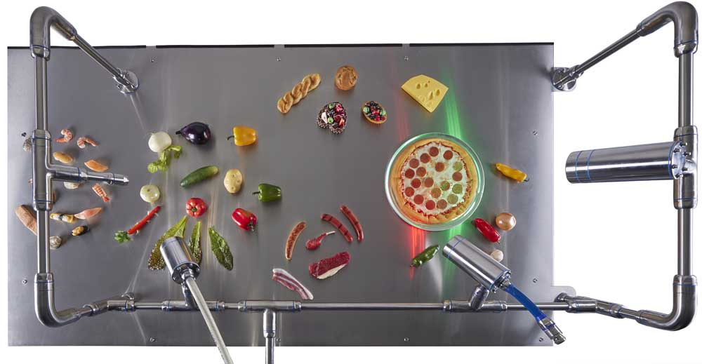
Caption: autoVimation products protect machine vision technology in industrial and hygienically demanding applications (here: the EHEGD-compliant Hygienic Building Kit)

Image/s: | hygienic_machine_vision_building_kit | Characters: | 1419
File name: | 202504014_pm_control_show_preview_en | Date: | 04-08-2025
Tags: | machine vision, camera enclosure, protective enclosures, hygienic enclosure, EHEGD, tradeshow preview, Control, Fraunhofer Vision
About autoVimation
Founded in 2008, autoVimation is a pioneer in the design and production of industrial-grade protective camera enclosures and a complete building kit for the simple, cost- and time-saving installation of image processing components. Vision system integrators, OEMs, plant manufacturers and operators worldwide find the German manufacturer a trusted source for enclosures in various sizes as well as a huge modular range of dovetail profiles, clamps and brackets for flexible positioning and adjustment of cameras, lasers and other components above production lines and in all kinds of industrial and other settings. Once aligned, all connectors ensure permanently stable fixation, resisting linear displacement with up to 2000 N and torsion with up to 90 Nm. The patented Quick-Lock/Heat-Guide camera mount provides excellent heat dissipation and enables flexible camera positioning inside the protective enclosure. autoVimation’s powerful LED ring lighting with a flash controller also stays cool thanks to good heat coupling to the outer enclosure and, mounted directly behind the window, is protected according to IP67. An extensive range of accessories enables camera technology to be used under challenging conditions: protective flaps and wind curtains for particularly dirty installation environments and temperature control solutions for ambient temperatures from -40 °C to 250 °C. A complete hygienic modular building kit in accordance with strict EHEDG specifications enables the legally compliant installation of image processing components in food or pharmaceutical processes.
autoVimation is a member of the Exaktera Group.
Contact:  autoVimation GmbH  Peter Neuhaus  Roemerweg 1  76287 Rheinstetten  Germany  Phone: +49 . 721 . 627 6756  Email: sales@autovimation.com  Internet: www.autovimation.com |  | gii die Presse-Agentur GmbH  Christburger Str. 12  10405 Berlin  Germany  Phone: +49 . 30 . 538 9650  Email: info@gii.de  Internet: www.gii.de

