Press Release

Hygienic enclosure for right-angled cameras

autoVimation presents a protective enclosure for right-angled cameras and vision sensors in hygienically demanding applications. The Chameleon M features a hygienic design and meets protection class IP69k. All side walls are inclined at 5 degrees to allow cleaning water to drain easily. The corresponding hose system allows for protected and hygienic routing of several cables into the control cabinet. The manufacturer offers hygienic spacers for wall mounting of the enclosure. The new Chameleon M for cameras with the lens angled at 90 degrees is available in 80 mm and 110 mm heights, allowing cameras with built-in optics and illumination to be installed directly behind the enclosure window. The double-sealed window lid was designed to be extra flat for this purpose. The available space for C-mount lenses can be increased by adding 30 mm front lid extensions. As with all of its protective camera enclosures, autoVimation has implemented good heat dissipation, so that additional cooling is not necessary in many applications.
autoVimation at the Control show
Stuttgart, Germany, 6 – 9 May 2025
Fraunhofer Vision special show – Hall 7, Booth 7401

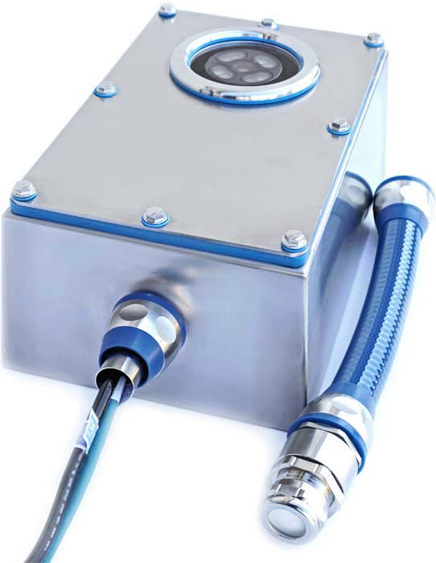
Caption: autoVimation expands its range for the hygienic installation of machine vision technology, adding a protective housing for right-angled cameras

Image/s: | chameleon_m_hygienic |  | Characters: | 1036
File name: | 202504015_pm_chameleon_hygienic_enclosure_en |  | Date: | 04-22-2025
Tags: | machine vision, protective housing, protective enclosure, protective camera enclosures, hygienic enclosure, right-angled cameras, hygienic design, IP69k
About autoVimation
Founded in 2008, autoVimation is a pioneer in the design and production of industrial-grade protective camera enclosures and a complete building kit for the simple, cost- and time-saving installation of image processing components. Vision system integrators, OEMs, plant manufacturers and operators worldwide find the German manufacturer a trusted source for enclosures in various sizes as well as a huge modular range of dovetail profiles, clamps and brackets for flexible positioning and adjustment of cameras, lasers and other components above production lines and in all kinds of industrial and other settings. Once aligned, all connectors ensure permanently stable fixation, resisting linear displacement with up to 2000 N and torsion with up to 90 Nm. The patented Quick-Lock/Heat-Guide camera mount provides excellent heat dissipation and enables flexible camera positioning inside the protective enclosure. autoVimation’s powerful LED ring lighting with a flash controller also stays cool thanks to good heat coupling to the outer enclosure and, mounted directly behind the window, is protected according to IP67. An extensive range of accessories enables camera technology to be used under challenging conditions: protective flaps and wind curtains for particularly dirty installation environments and temperature control solutions for ambient temperatures from -40 °C to 250 °C. A complete hygienic modular building kit in accordance with strict EHEDG specifications enables the legally compliant installation of image processing components in food or pharmaceutical processes.
autoVimation is a member of the Exaktera Group.
Contact:  autoVimation GmbH  Peter Neuhaus  Roemerweg 1  76287 Rheinstetten  Germany  Phone: +49 . 721 . 627 6756  Email: sales@autovimation.com  Internet: www.autovimation.com |  | gii die Presse-Agentur GmbH  Christburger Str. 12  10405 Berlin  Germany  Phone: +49 . 30 . 538 9650  Email: info@gii.de  Internet: www.gii.de

