Press Release

New radio modules boost energy data acquisition

Camille Bauer Metrawatt AG, a member of the GMC-Instruments Group, extends the functionality of its mains analyzers, introducing the new PME radio modules 3P and 3PN, which make full-fledged energy centers out of all SINEAX AM, SINEAX DM5000, CENTRAX CU or LINAX PQ units. The radio modules transmit over 10 meters on 2.4 GHz as default frequency. They feature sensors based on Rogowski coils, which are powered by batteries or via USB-C. Sensor registration via QR code ensures quick commissioning. Typical application areas are highly exact load measurements in transformer stations and power distribution in industrial plants or building complexes. Up to 100 currents, divided between the PME sensors for 3 or 4 conductors each, can be recorded without any additional wiring effort, secured by AES encryption. In addition to second-by-second current value measurements, the devices also gather comprehensive performance data by synchronization with the mains analyzer’s voltage measurements. They derive average loads, load profile data and energy meter values from these data and can save them as a timeline. Users can access the data centrally via the base unit’s communication interface or with an automated export of the averaged data in CSV format to an SFTP server. Anti-collision detection allows the operation of up to five PME systems with a total of up to 500 current channels at the same location. The transmission power and frequency of sensor queries can be adjusted according to the local conditions.

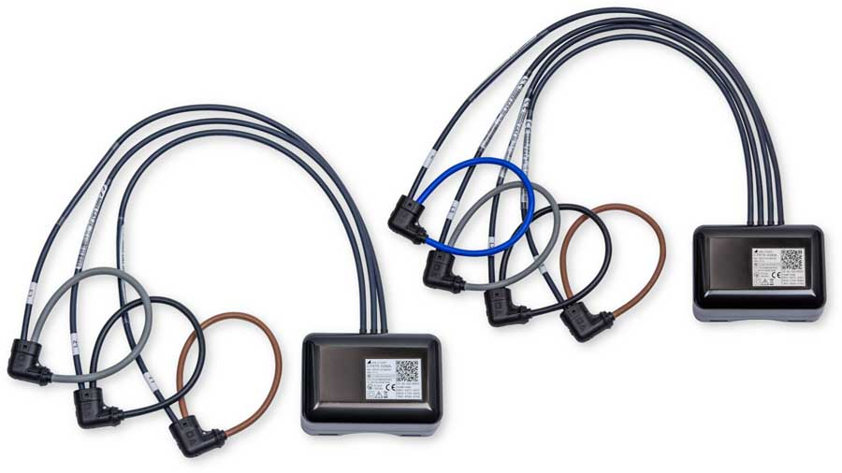
Caption: The new 3P and 3PN PME radio modules make selected Camille Bauer mains analyzers into full-fledged energy centers

Image/s: | pme-modul-3p-3pn_2000.jpg | Characters: | 1517
File name: | 202504021_pm_pme_radio_modules_en | Date: | 04-28-2025
Tags: | energy data acquisition, mains analyzers, load measurements, transformer stations, power distribution
About Gossen Metrawatt
Gossen Metrawatt, one of the world’s leading suppliers of measurement systems, develops and distributes a wide range of high-quality measuring and test devices for electrical trade, various industries and the public sector.
The Gossen Metrawatt brand has been synonymous with safety and quality “Made in Germany” for decades. Its product range includes measurement and test technology for the electrical safety of plants, devices and machines as well as for the e-mobility and medical technology industries. Additional key areas of interest are power quality, battery testing technology, multimeters, calibrators, power supply technology and energy management systems. For a truly comprehensive electrical safety portfolio, Gossen Metrawatt also offers a continuously growing range of digital services and cloud services and supports its customers with a versatile training program and a wide range of after-sales services.
Gossen Metrawatt is part of the GMC Instruments Group, which also includes other specialized manufacturers for measurement and testing technology – notably, Camille Bauer Metrawatt, Dranetz, Prosys, Seaward and Rigel and Kurth Electronic. The Camille Bauer and Rigel brands add to the portfolio various transducers, display instruments and detection systems for heavy-current engineering as well as special measuring, testing and functional testing devices for the medical sector. The GMC-I Group runs its own DAkkS-certified calibration center that performs DAkkS, ISO and factory calibrations for virtually all electrical measured quantities. The GMC-I Group has development and production sites in Germany, Switzerland, England and the USA and a worldwide sales network of its own companies as well as sales partners.
Contact:  Gossen Metrawatt GmbH  Christian Widder  Head of Marketing Communication  Suedwestpark 15  90449 Nuremberg  Germany  Phone: +49 . 911 . 8602-572  Email: christian.widder@gossenmetrawatt.com  Internet: www.gossenmetrawatt.com |  | gii die Presse-Agentur GmbH  Christburger Str. 41  10405 Berlin  Germany  Tel.: +49 . 30 . 538 9650  Email: info@gii.de  Internet: www.gii.de

