Press Release

Empty mould check system for flexible integration

The German machine vision expert Bi-Ber has expanded its portfolio for the confectionery industry, adding a new space-saving inspection system for empty mould checks. Plant manufacturers can integrate the module individually into their production lines. Bi-Ber has over 25 years of experience in manufacturing plant-specific empty mould check systems and offers a sophisticated multilingual Windows-based analysis software, which it continuously expands by new functions. There are currently five standard hardware models for mould widths up to 1100 mm. In addition, Bi-Ber also implements customer-specific designs. One or more megapixel colour cameras are installed in a stainless-steel housing. Shielded from the process, they are mounted above the conveyor belt where they check polycarbonate, metal or silicone moulds for product residues during operation. The associated panel PC transmits inspection results and prompts to discharge contaminated moulds to the system control. The latest model, P(anel), features a terminal box for communication and power lines on the machine side of the camera housing. The panel PC is supplied separately, without a control cabinet, for flexible integration. The food-grade inspection system is optionally designed with IP67 protection.

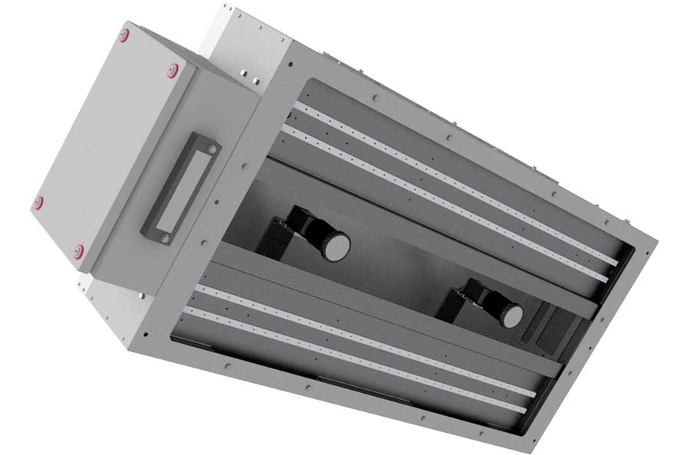
Caption: Food-safe and compact: Bi-Ber has designed its latest optical inspection system for empty mould checks in the confectionery industry specifically for flexible integration by plant manufacturers

Overview of the five standard models:
The B(asic) model combines cameras, lighting, and a touch panel PC in a stainless-steel cabinet that is placed directly onto the conveyor system, with a signal light mounted on top. Good ambient light shielding through the control cabinet ensures high, repeatable image quality. The use of multiple cameras allows for a wide field of view at short working distances. Doors on both sides of the control cabinet provide good access to the system.
The S(eparate) model offers all the advantages of the basic system in terms of accessibility and ambient light shielding. However, the imaging technology and the computer are installed in two separate enclosures. The cabinet with the operating panel and signal light can be freely positioned so that it is clearly visible and accessible.
The F(lexible) model with a slim camera and lighting module also features a separate control cabinet and was developed especially for enclosed lines and low-height surroundings. It is also available as a multi-camera version for wide moulds.
The new P(anel) model is a modification of the F(lexible) model without PC control cabinet or signal light.
The C(ompact) model is condensed to include only the minimum necessary equipment and does not contain a signal light, either. The control box with a touchscreen is attached directly to the camera housing. The compact model is particularly cost-effective and also suitable for lines with limited space.

The documentation for all standard variants is available at https://www.bilderkennung.de/download.html#suesswarenindustrie.

Image/s: | formenleerkontrolle_p | Characters: | 2868
File name: | 202504025_pm_empty_mould_check_en | Date: | 04-29-2025
Tags: | empty mould check, confectionery industry, inspection system, food-grade, food-safe
About Bi-Ber
Founded in 1997 and based in Wildau, near Berlin, Bi-Ber develops and manufactures image processing systems for in-production quality control. The service range includes the construction of hardware components, on-site installation, commissioning, and adjustment of systems, as well as the development of application-specific software solutions. Bi-Ber currently employs a staff of seven and several freelancers. In addition to sweets manufacturers and OEMs working in the sweets industry, Bi-Ber supplies solutions for medical technology companies, printing industry, automotive suppliers, and electronics manufacturers.
Contact:  Bi-Ber GmbH & Co. Engineering KG  Ronald Krzywinski  Freiheitstr. 124/126  15745 Wildau  Germany  Phone: +49 . 30 . 810 322 260  Email: sales@bilderkennung.de  Internet: www.bilderkennung.de |  | gii die Presse-Agentur GmbH  Christburger Str. 41  10405 Berlin  Germany  Phone: +49 . 30 . 538 9650  Email: info@gii.de  Internet: www.gii.de

